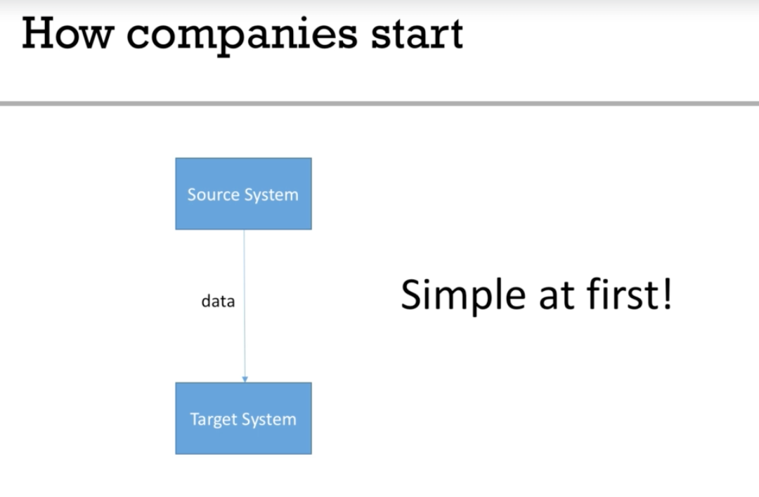

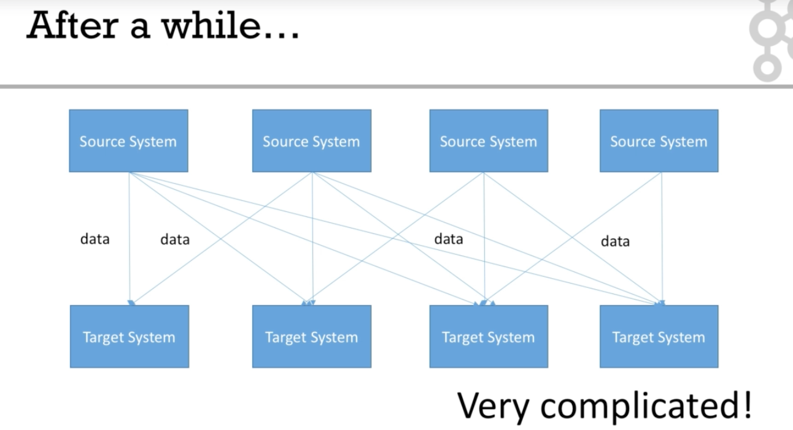

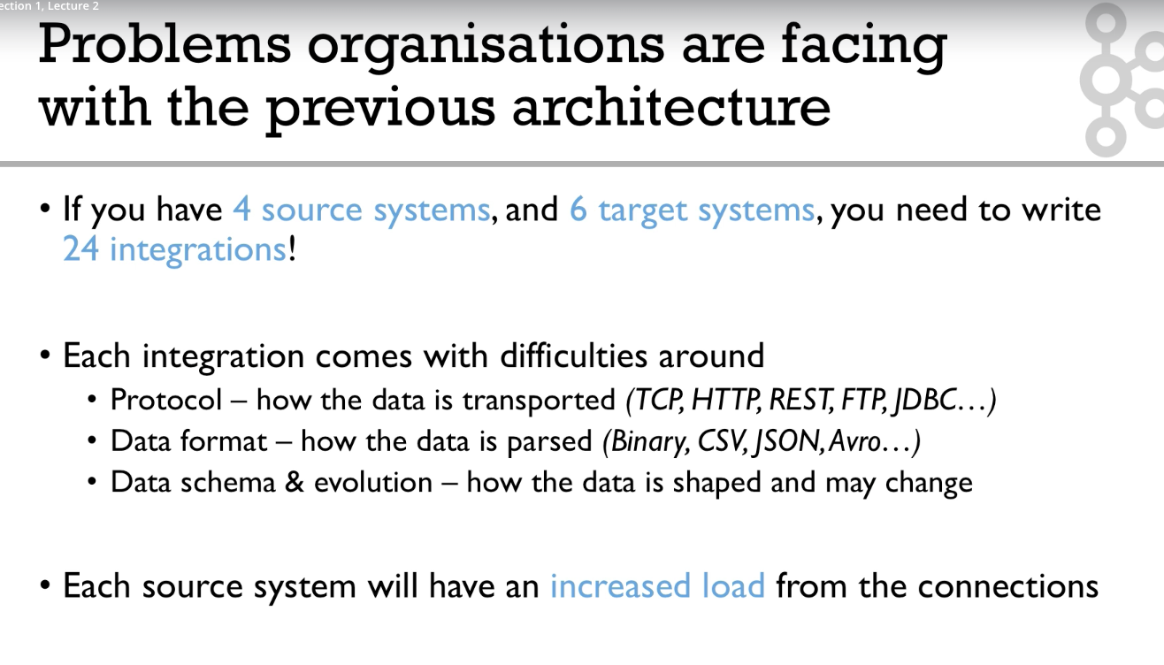

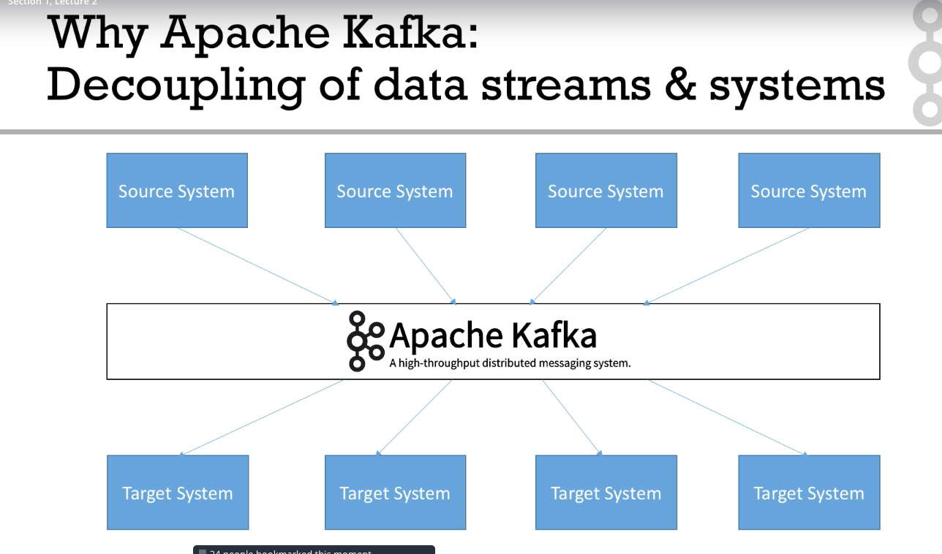

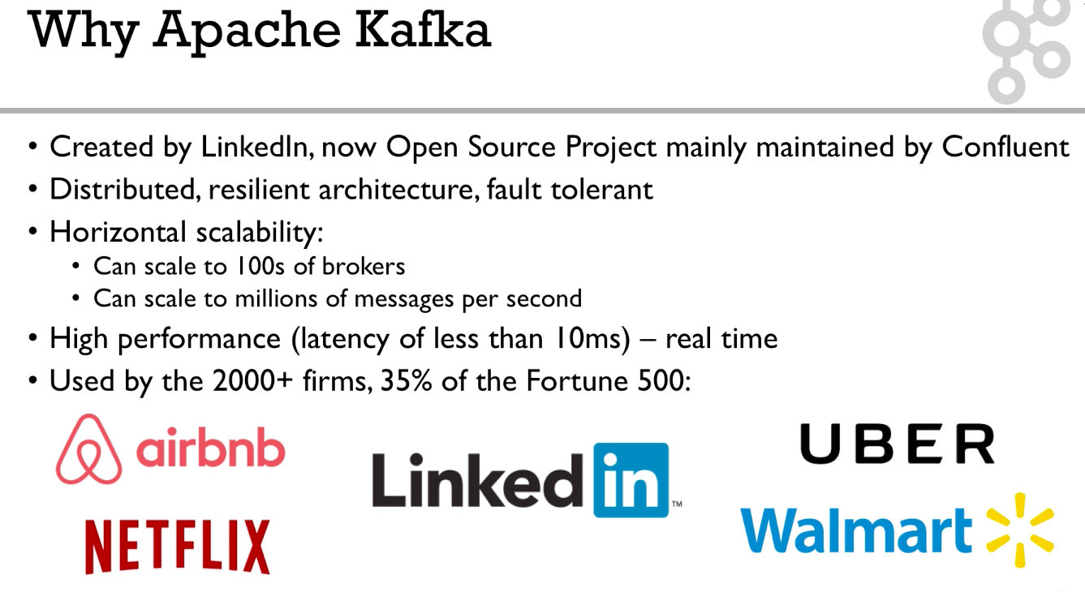

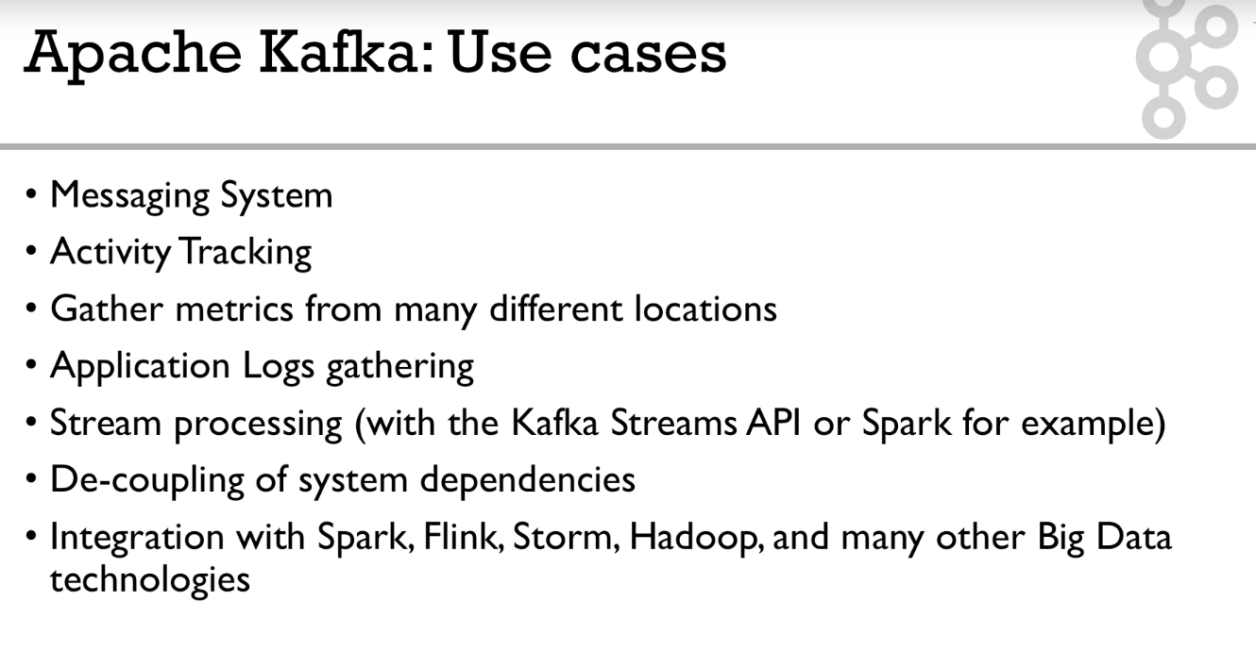

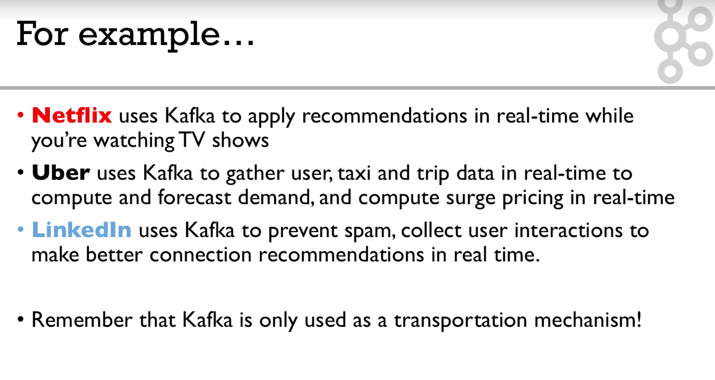

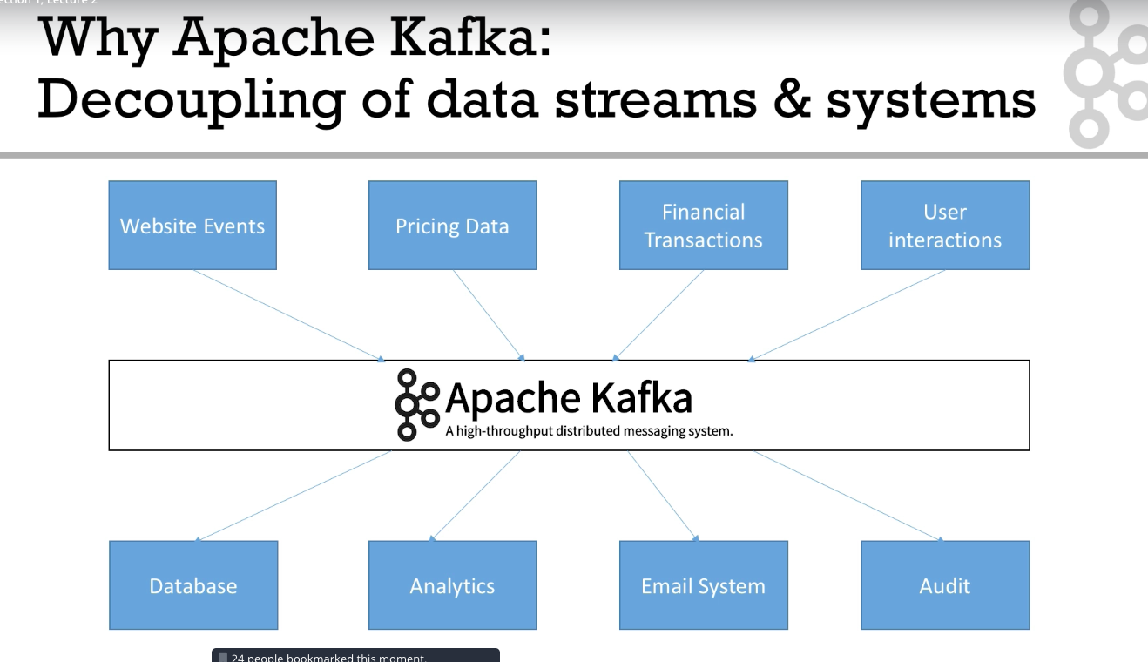

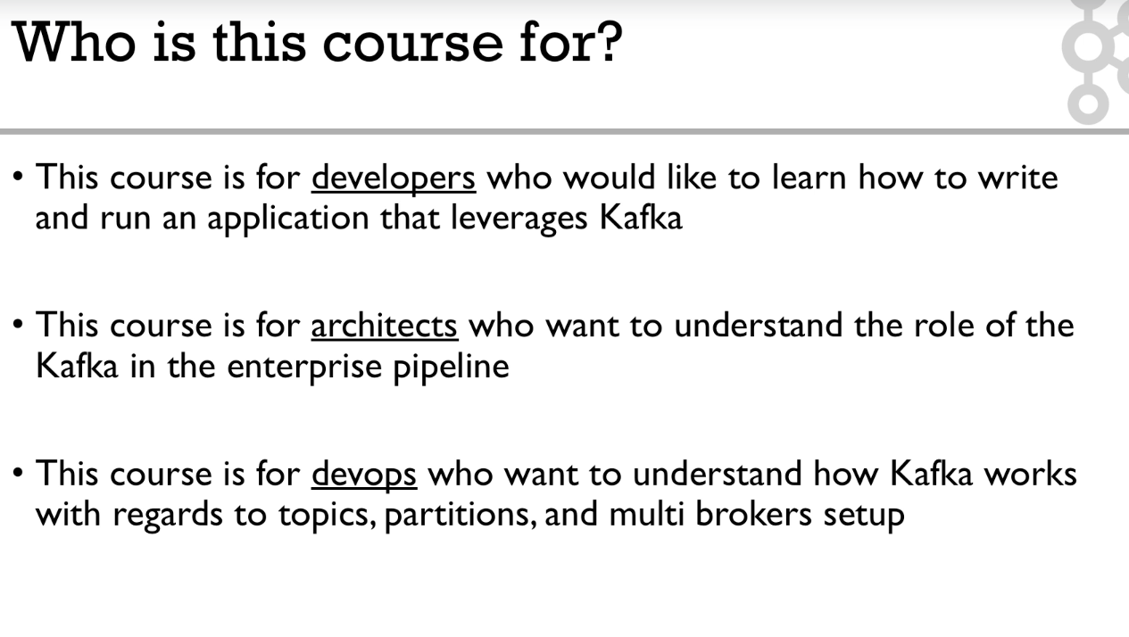

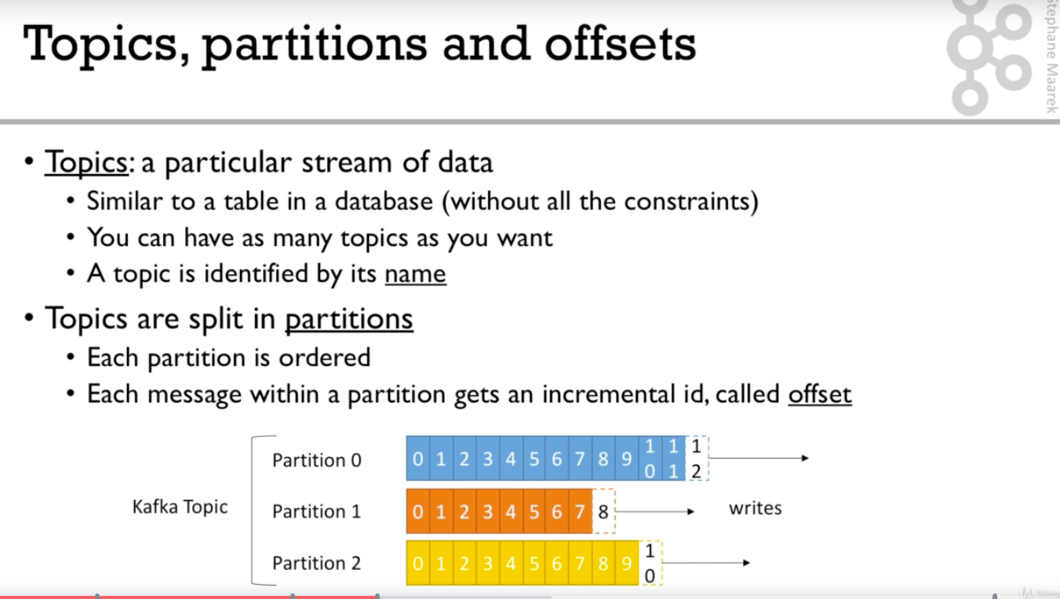

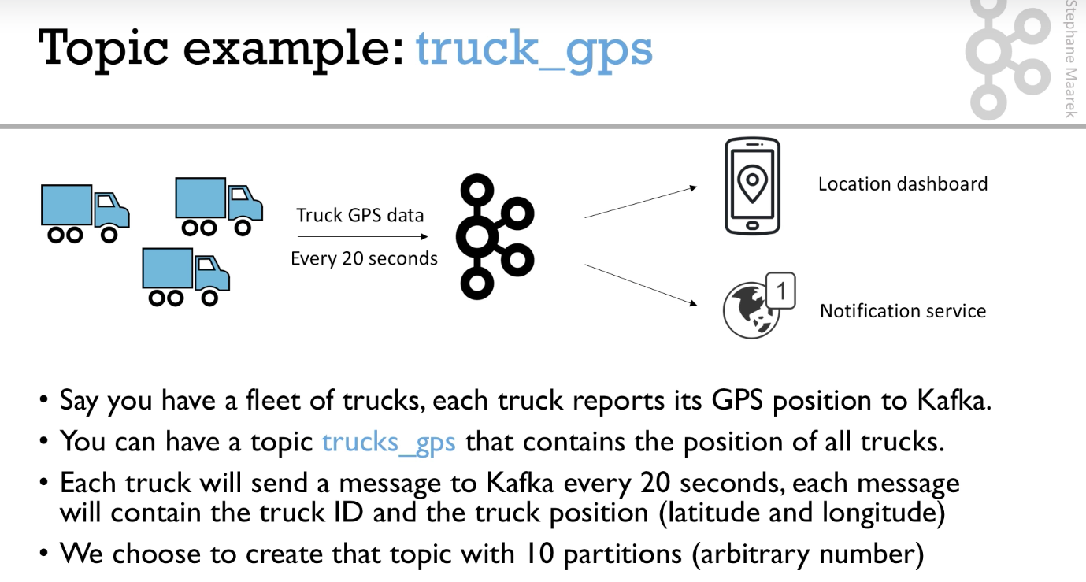

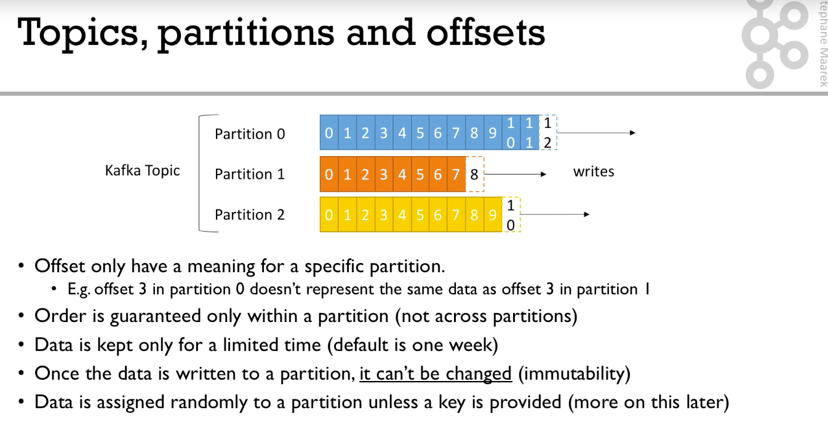

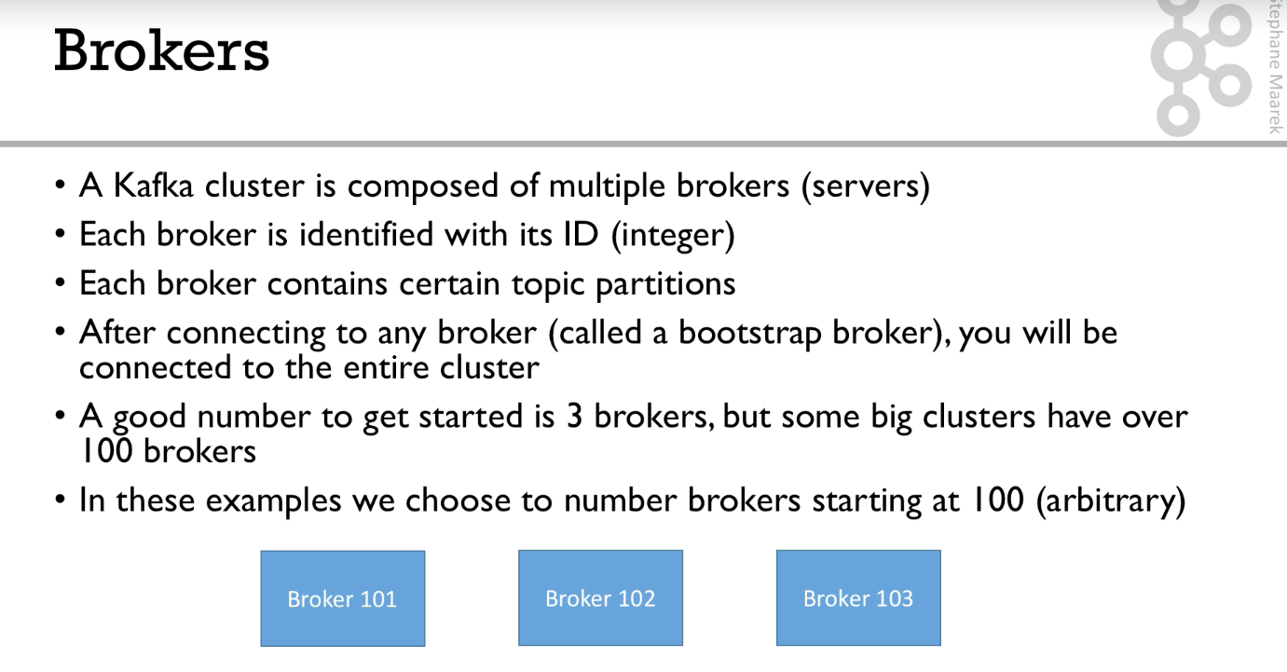

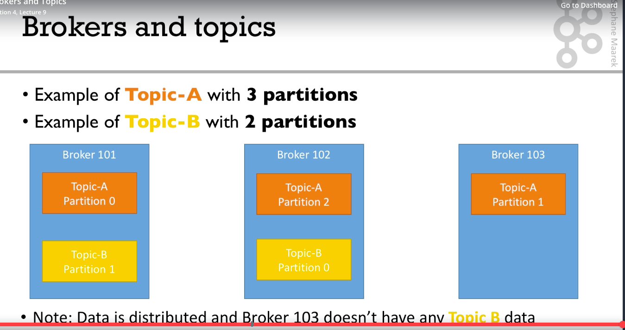

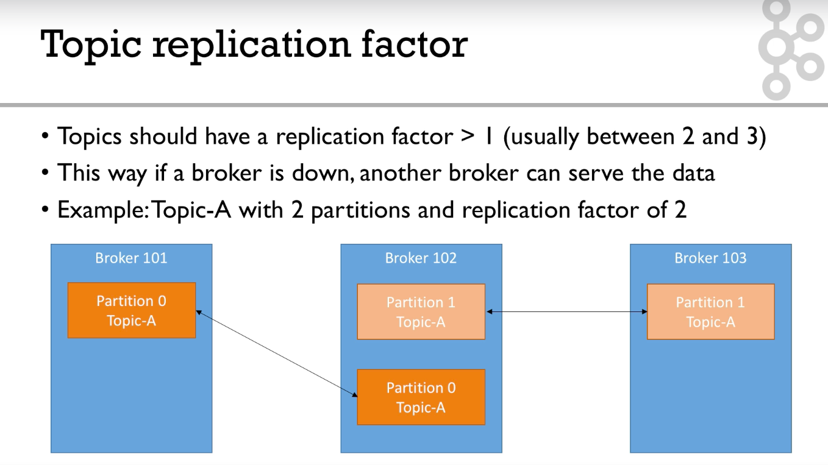

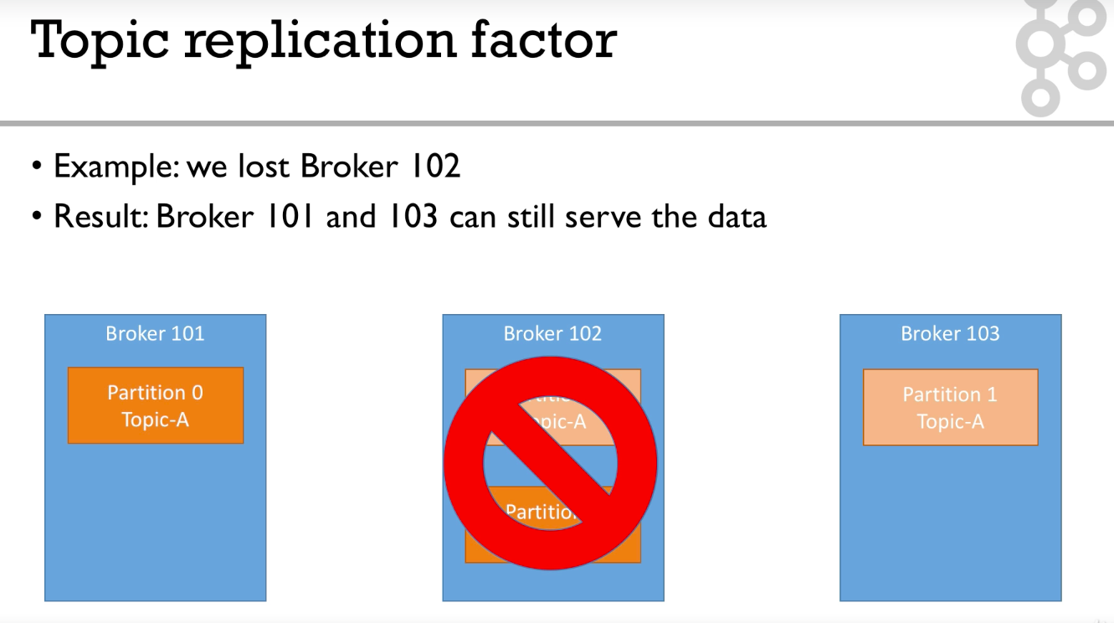

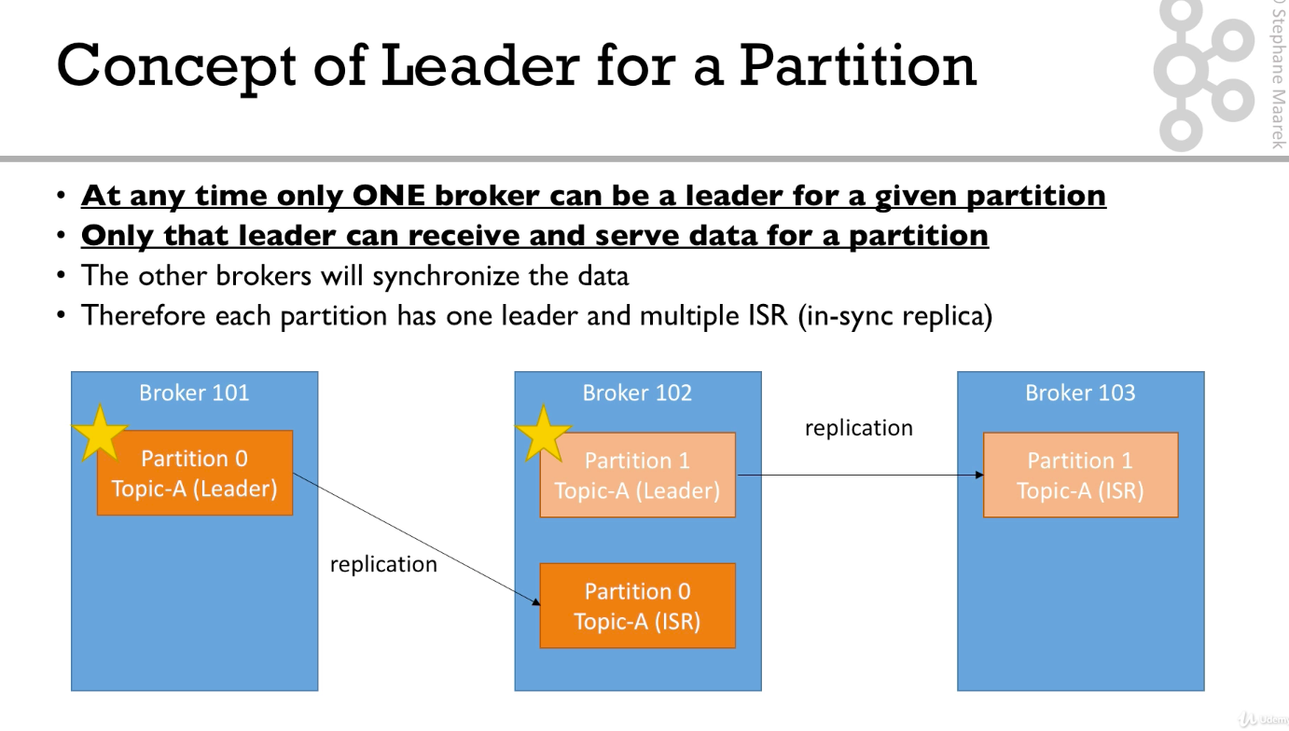

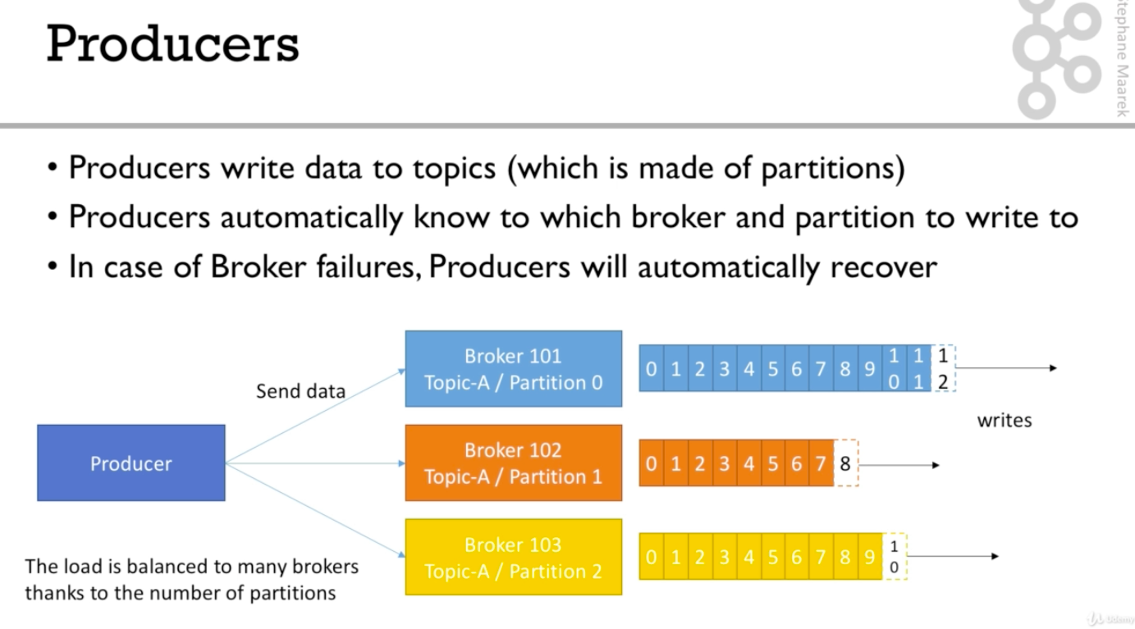

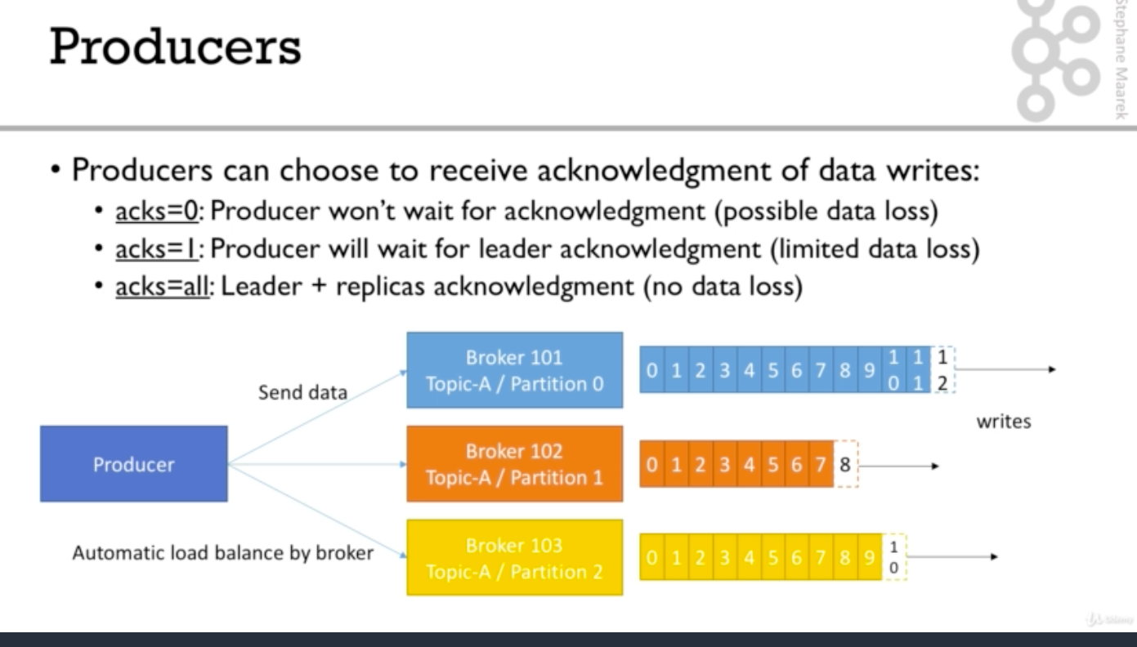

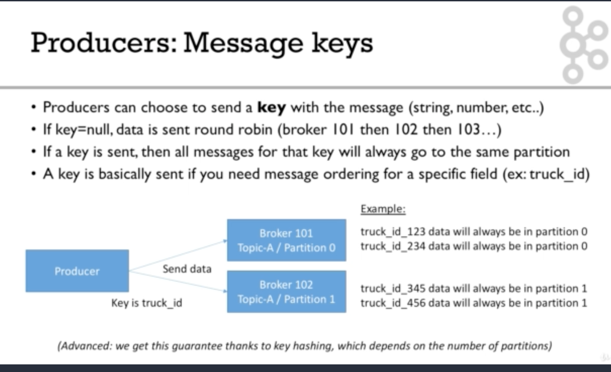

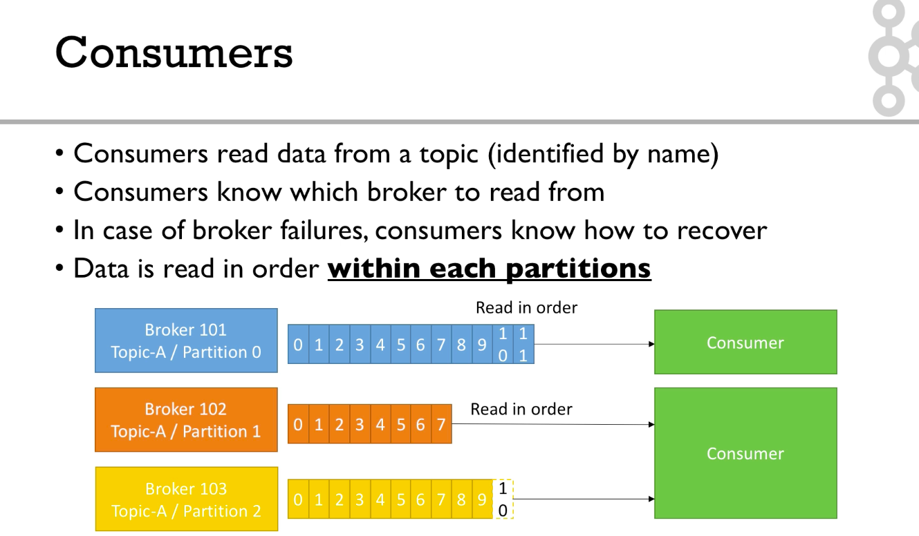

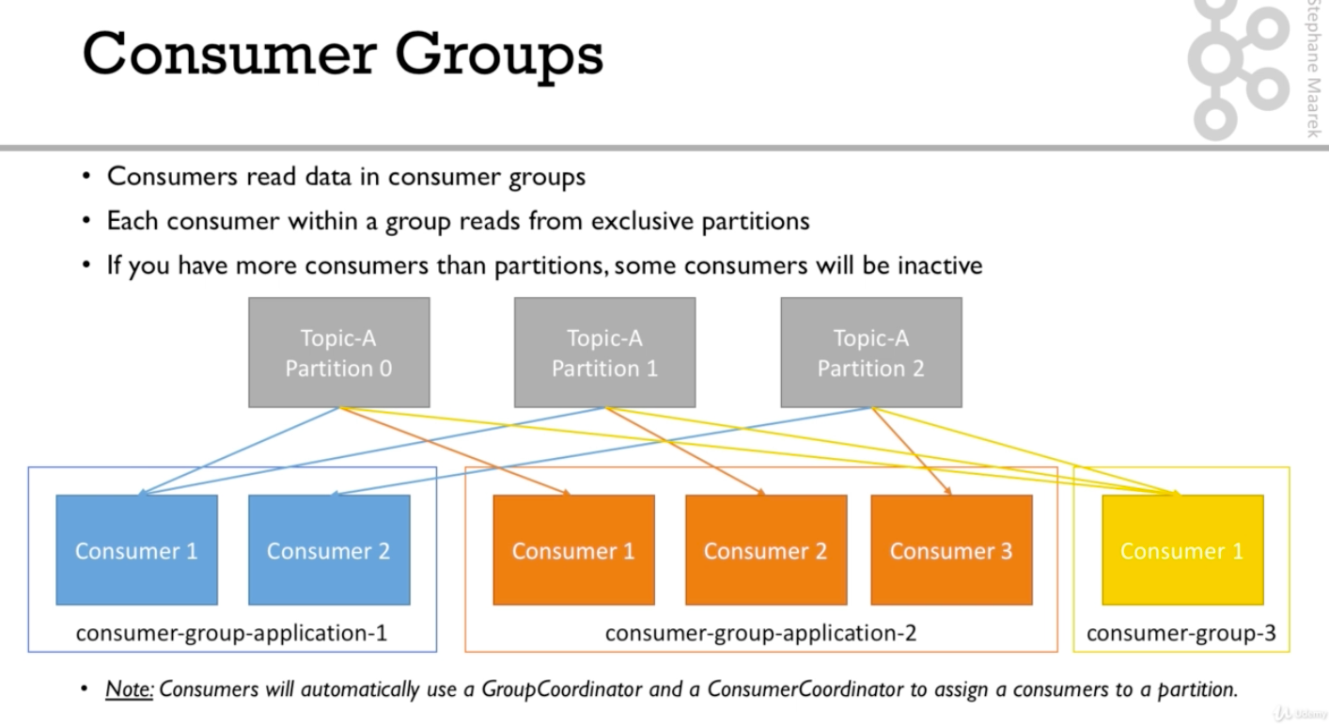

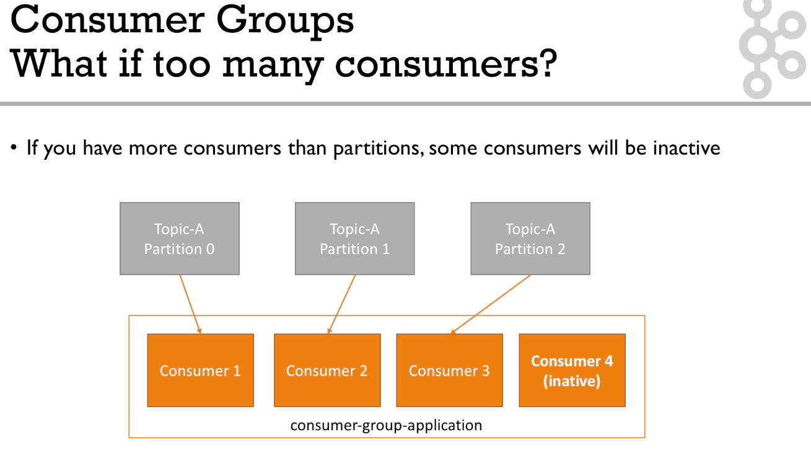

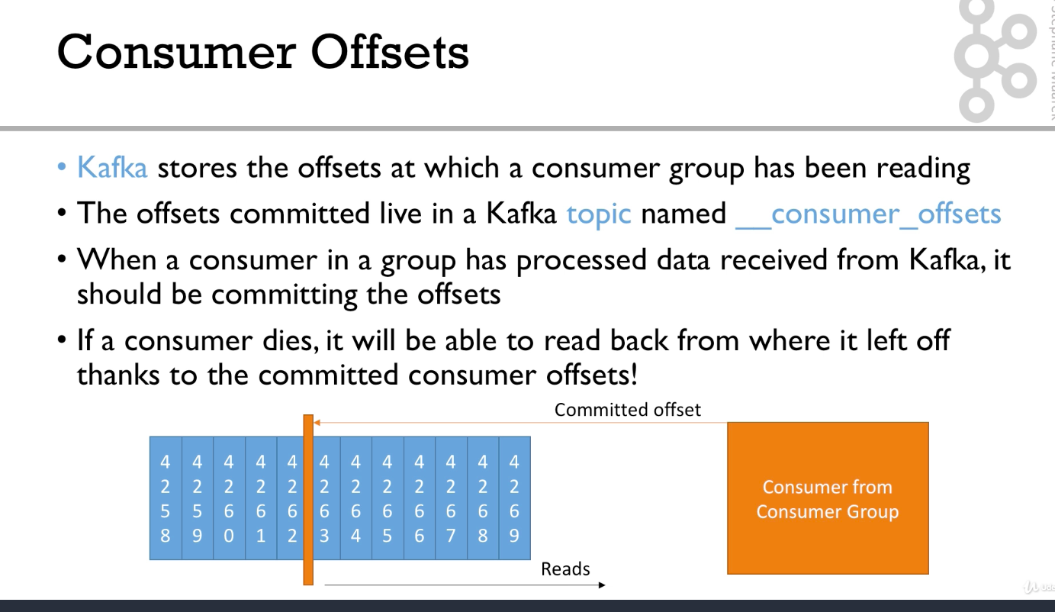

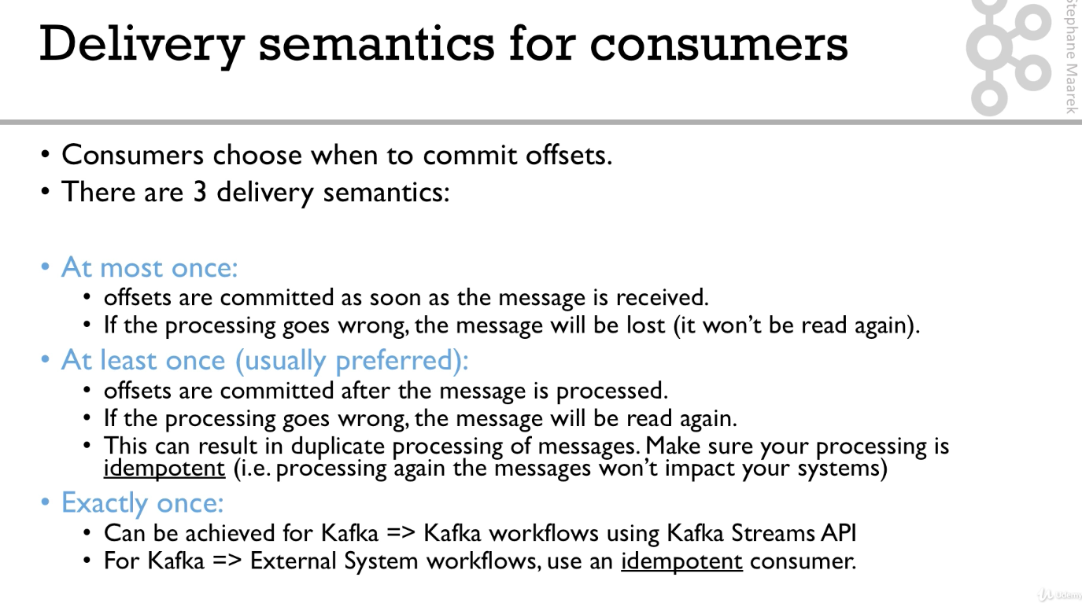

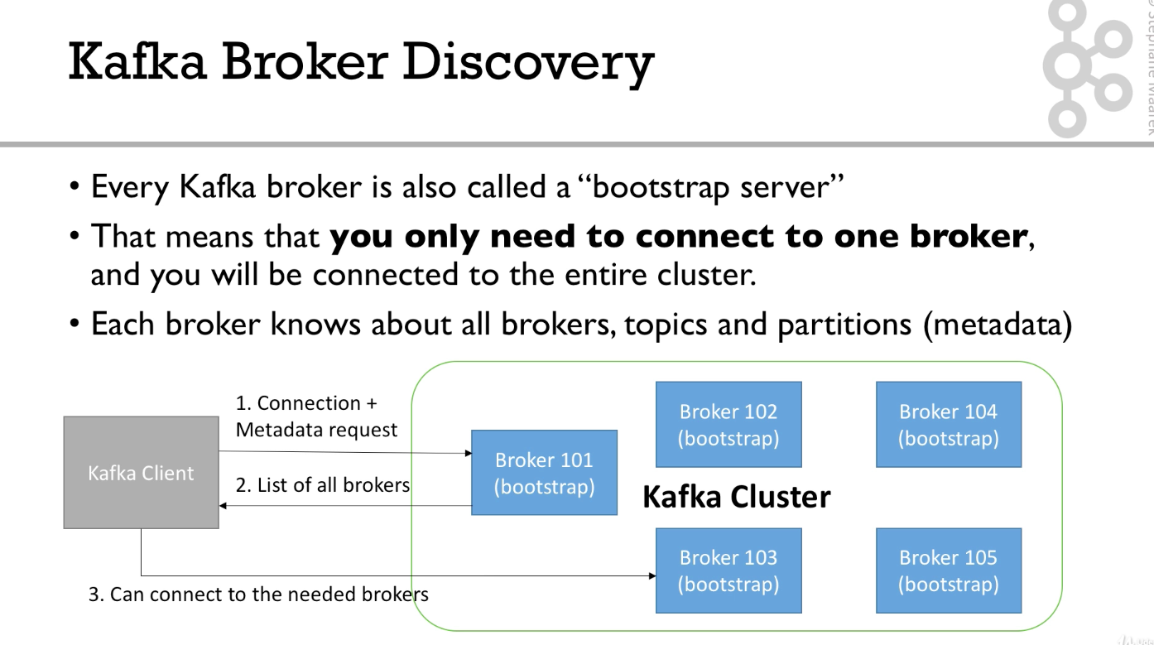

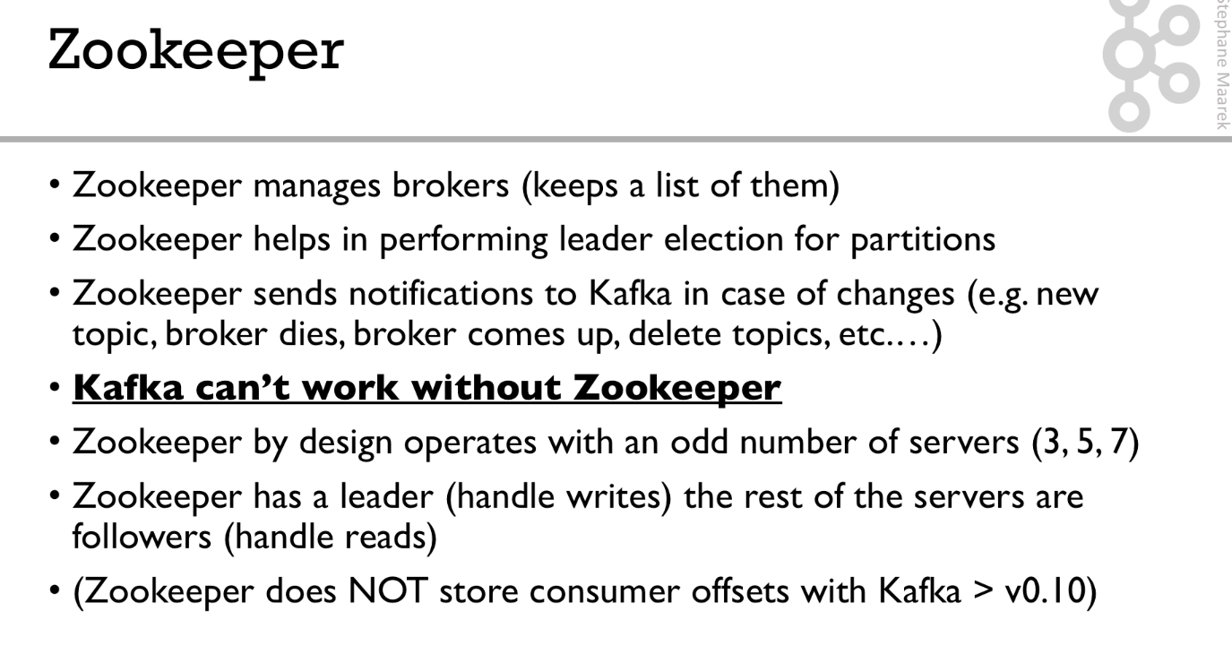

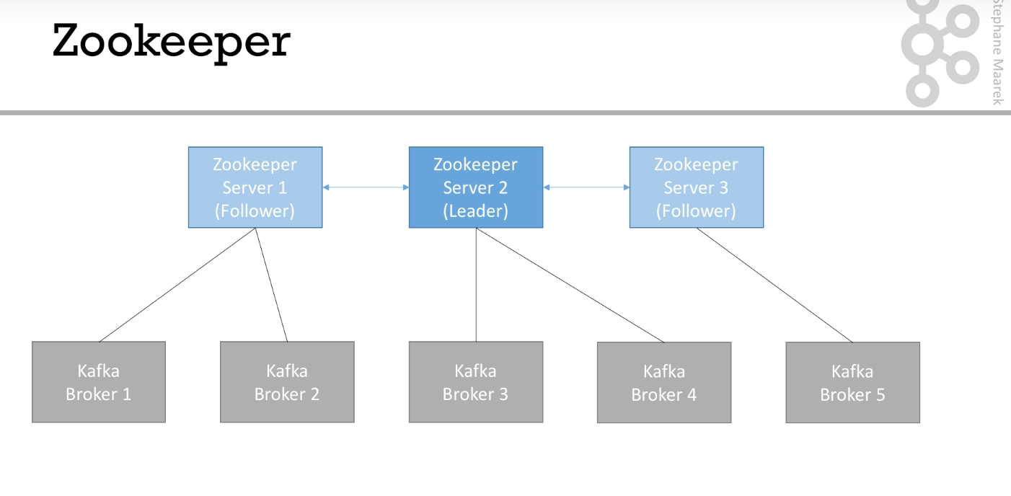

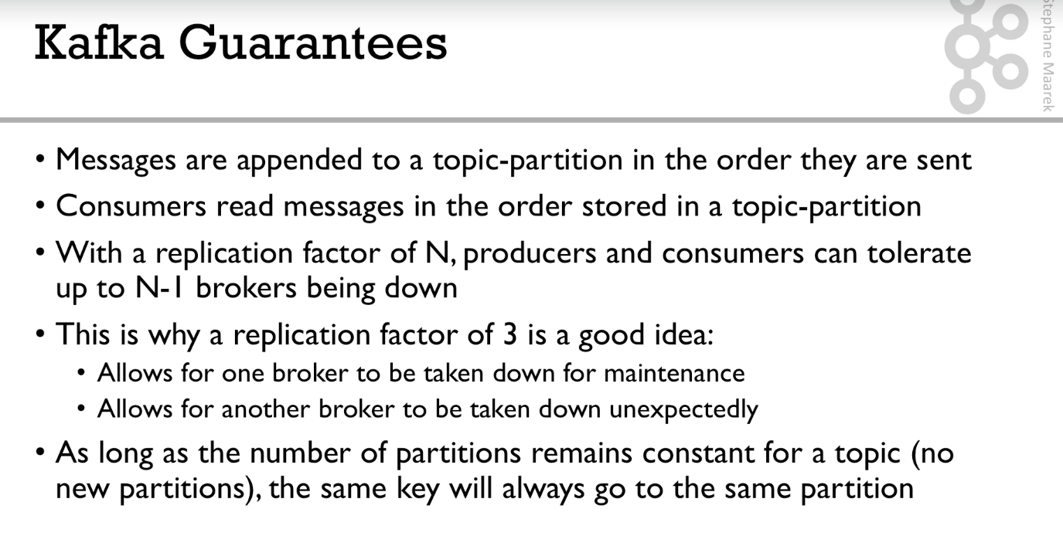

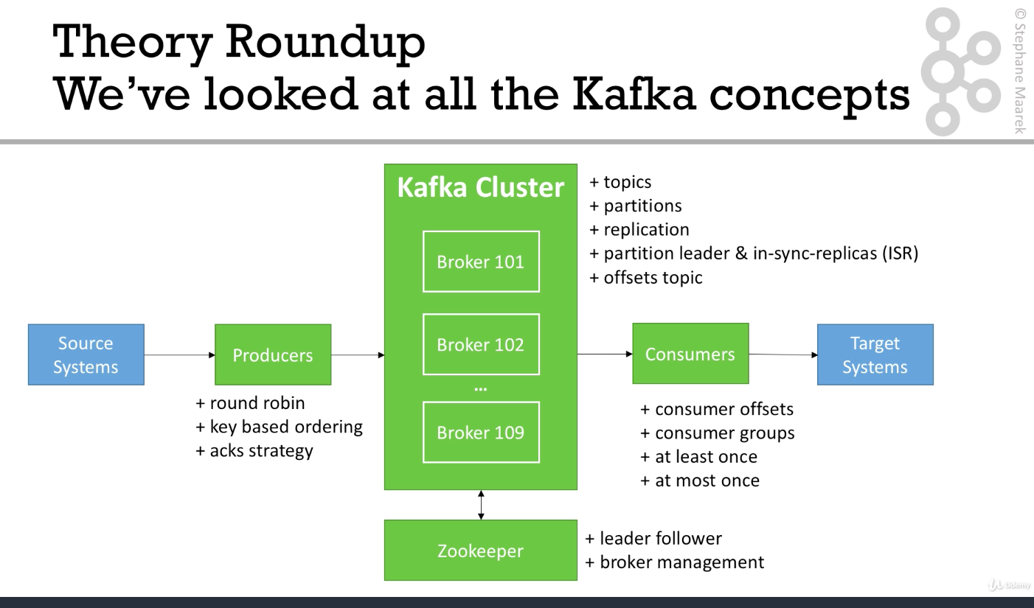

1)Google apache-kafka and go to the 1st link.

2)Go to downloads section:- <https://www.apache.org/dyn/closer.cgi?path=/kafka/2.1.1/kafka_2.12-2.1.1.tgz>

3)Then click on the given link and download.

4)Check java is installed or not.

5) Run the commands :-

brew tap caskroom/versions

brew search java

brew cask install java8

6)kafka-topics – command to look at all the topics

7)easy way to install kafka is :-

brew install kafka

Now 2 things to do :-

**Starting zookeeper must :-**

zookeeper-server-start config/zookeeper.properties

change the config file(/config/zookeeper.properties) location of dataDir from

dataDir=/tmp/zookeeper

To

dataDir=/Users/vibhanshu/kafka\_2.12-2.1.0/data/zookeeper

Similarly for kafka logs we need to change the config file (/config/server.properties)

log.dirs=/tmp/kafka-logs

to

log.dirs==/Users/vibhanshu/kafka\_2.12-2.1.0/data/kafka

#### ****In summary, for Mac OS X****

1. Install brew if needed: /usr/bin/ruby -e "$(curl -fsSL https://raw.githubusercontent.com/Homebrew/install/master/install)"

2. Download and Setup Java 8 JDK:

brew tap caskroom/versions

brew cask install java8

3. Download & Extract the Kafka binaries from https://kafka.apache.org/downloads

4. Install Kafka commands using brew: brew install kafka

5. Try Kafka commands using kafka-topics (for example)

6. Edit Zookeeper & Kafka configs using a text editor

zookeeper.properties: dataDir=/your/path/to/data/zookeeper

server.properties: log.dirs=/your/path/to/data/kafka

7. Start Zookeeper in one terminal window: zookeeper-server-start config/zookeeper.properties

8. Start Kafka in another terminal window: kafka-server-start config/server.properties

**Command line interface :-**

**Kafka-topics**

**1)kafka-topics** --zookeeper 127.0.0.1:2181 --list

will list all the topics in the kafka cluster

2)kafka-topics --zookeeper 127.0.0.1:2181 --topic first\_topic --create --partitions 3 --replication-factor 2

create a topic with the name first\_topic having 3 partitions and 2 replication factor.

3)kafka-topics --zookeeper 127.0.0.1:2181 --topic first\_topic –describe

4)kafka-topics --zookeeper 127.0.0.1:2181 --topic second\_topic –delete

**kafka-conosle-producer**

1)kafka-console-producer --broker-list 127.0.0.1:9092 --topic first\_topic

2)kafka-console-producer --broker-list 127.0.0.1:9092 --topic first\_topic --producer\_property acks=all

Kafka produces topic automatically :-

kafka-console-producer --broker-list 127.0.0.1:9092 --topic new\_topic

>this topic does not exist

[2018-12-25 15:36:22,975] WARN [Producer clientId=console-producer] Error while fetching metadata with correlation id 1 : {new\_topic=LEADER\_NOT\_AVAILABLE} (org.apache.kafka.clients.NetworkClient)

>second message

>third message

As you can see above you get error first time but not again as Kafka fixes its no leader by the time you push 2nd message.

kafka-topics --zookeeper 127.0.0.1:2181 --topic new\_topic —-describe

Topic:new\_topic PartitionCount:1 ReplicationFactor:1 Configs:

Topic: new\_topic Partition: 0 Leader: 0 Replicas: 0 Isr: 0

As you can see if we use the command Kafka-console-producer and try to produce into a topic which does not exist then

Kafka will produce it by default . But as we can see the default values as 1 partition and 1 replication factor which

is not good . Hence we should avoid this .First create a new topic and only then use Kafka producer to write to this topic.

But you can change the default values by updating server.properties file.

num.partitions=3

**Commands related to Kafka console consumer :-**

1)kafka-console-consumer --bootstrap-server 127.0.0.1:9092 --topic first\_topic

2)kafka-console-consumer --bootstrap-server 127.0.0.1:9092 --topic first\_topic --from-beginning

**consumer groups commands:-**

1)kafka-console-consumer --bootstrap-server 127.0.0.1:9092 --topic first\_topic --group my\_first\_group

2)kafka-console-consumer --bootstrap-server 127.0.0.1:9092 --topic first\_topic --group my\_second\_group --from-beginning

**Very important Points To Note :-**

1)If you run the above command the consumer group commits the offsets . Hence if you run the above command again you will not get everything from beginning.

2)Instead the individual consumer does not update offsets. Hence if you run start-from begging again you will again get all the data from beginning.

3)Also if you start consumer group, then you will get all the messages which were not read till now . It doesn’t happen the same with consumer . With consumer its only real time messages which are getting produced at that instant .

1)kafka-consumer-groups --bootstrap-server localhost:9092 --list

2) kafka-consumer-groups --bootstrap-server localhost:9092 --describe --group my\_first\_group

updating offsets :-

1)kafka-consumer-groups --bootstrap-server localhost:9092 --describe --group my\_second\_group

2) kafka-consumer-groups --bootstrap-server localhost:9092 --group my\_second\_group --execute --reset-offsets --to-earliest --topic first\_topic

3) kafka-consumer-groups --bootstrap-server localhost:9092 --group my\_second\_group --execute --reset-offsets --shift-by -3 --topic first\_topic

if any consumer is on then above command will throw error :-

Error: Assignments can only be reset if the group 'my\_second\_group' is inactive, but the current state is Stable.

**Some special commands :-**

1)kafka-console-producer --broker-list 127.0.0.1:9092 --topic first\_topic --property parse.key=true --property key.separator=,

2) kafka-console-producer --broker-list 127.0.0.1:9092 --topic first\_topic --property parse.key=true --property key.separator=,

Hands on – code is there in intellij ,please go through them to revise .

Configuring Producers and Consumers,Section 7, Lecture 53

**Client Configurations**

There exist a lot of options to:

configure producer: <https://kafka.apache.org/documentation/#producerconfigs>

configure consumers:  <https://kafka.apache.org/documentation/#consumerconfigs>

The most important options are discussed in the real-world project section, coming next

Happy learning!

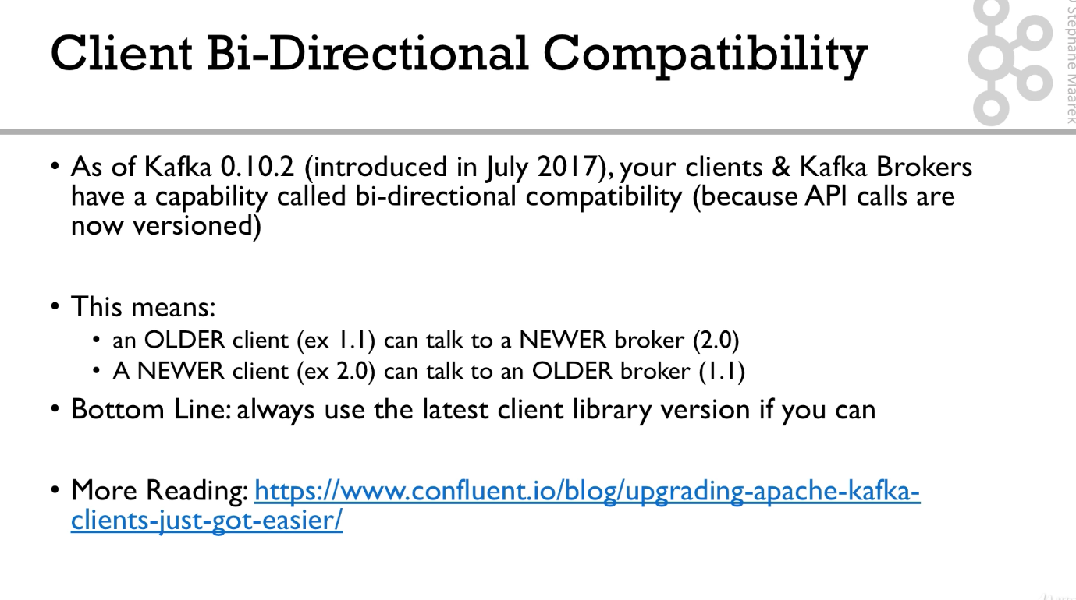

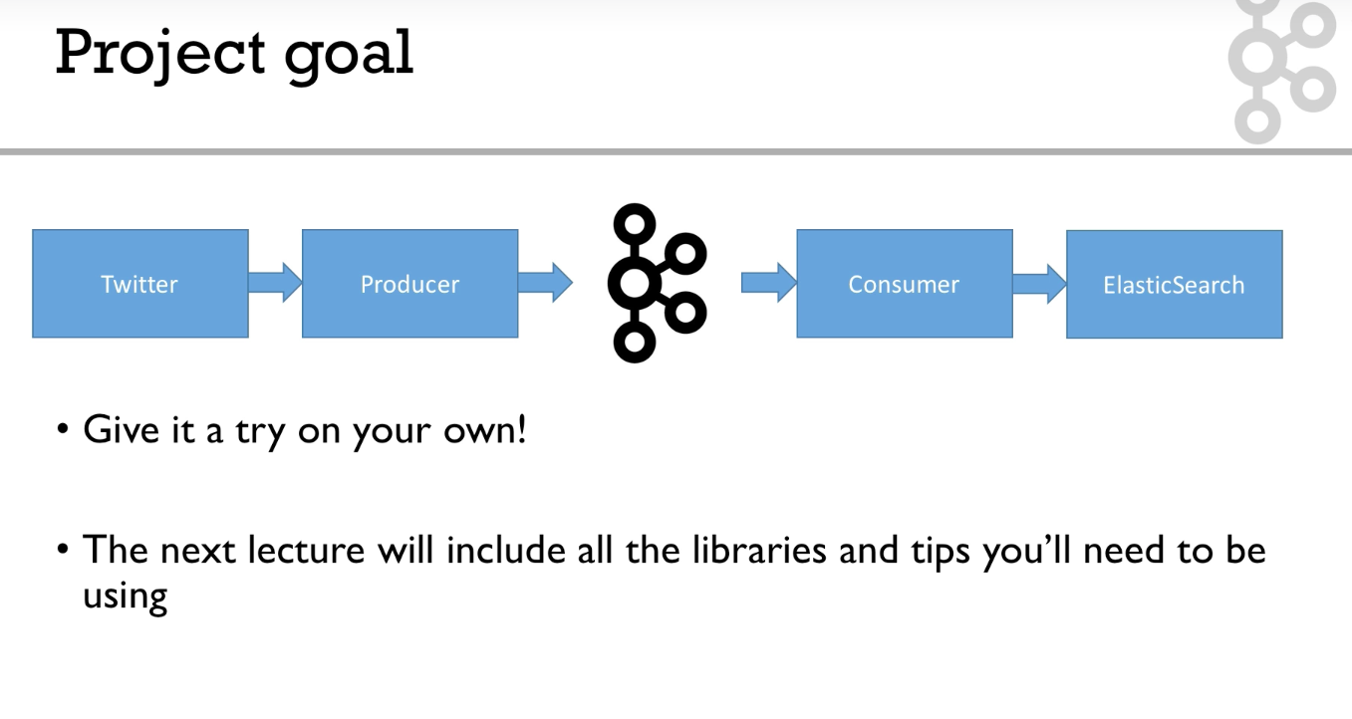

*Real World Exercise,Section 8, Lecture 55*

#### *Real-World Exercise:*

*Before jumping to the next section for the solution, here are some pointers for some exercises:*

***Twitter Producer***

The Twitter Producer gets data from Twitter based on some keywords and put them in a Kafka topic of your choice

*Twitter Java Client:*[*https://github.com/twitter/hbc*](https://github.com/twitter/hbc)

*Twitter API Credentials:*[*https://developer.twitter.com/*](https://developer.twitter.com/)

**ElasticSearch Consumer**

*The ElasticSearch Consumer gets data from your twitter topic and inserts it into ElasticSearch*.ElasticSearch Java Client: <https://www.elastic.co/guide/en/elasticsearch/client/java-rest/6.4/java-rest-high.html>

ElasticSearch setup:

* + [https://www.elastic.co/guide/en/elasticsearch/reference/current/setup.html](https://www.elastic.co/guide/en/elasticsearch/reference/current/setup.html" \t "_blank)
  + OR <https://bonsai.io/>

Steps TO create Safe Producer .

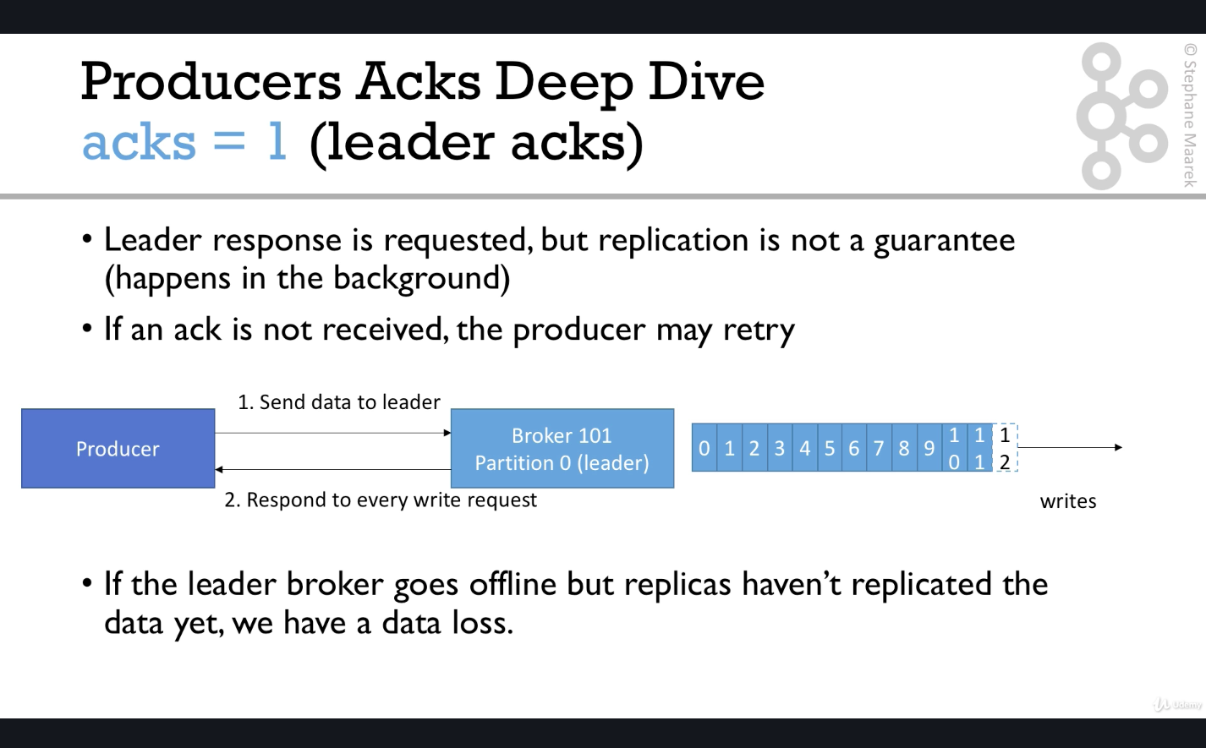

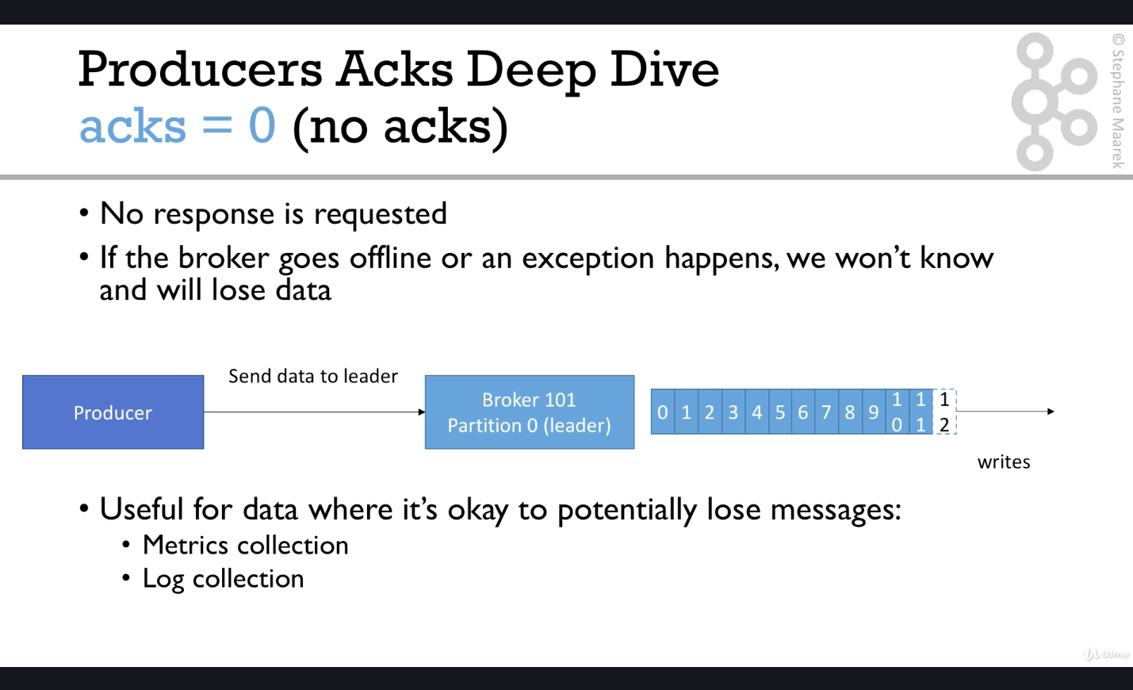

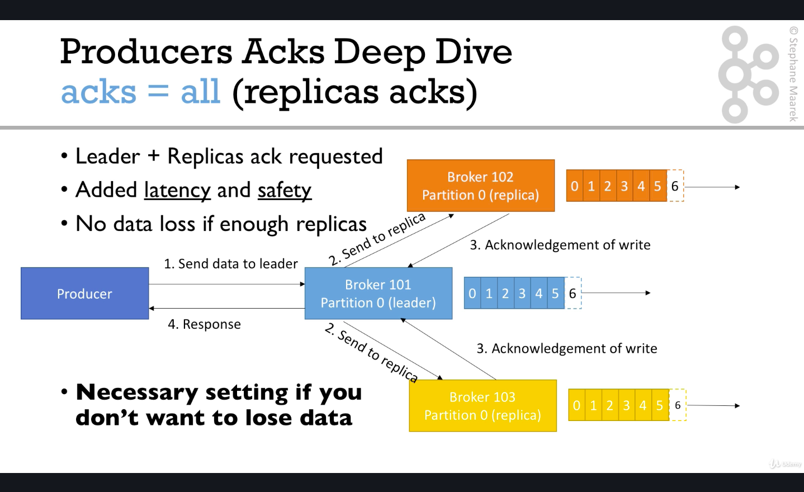

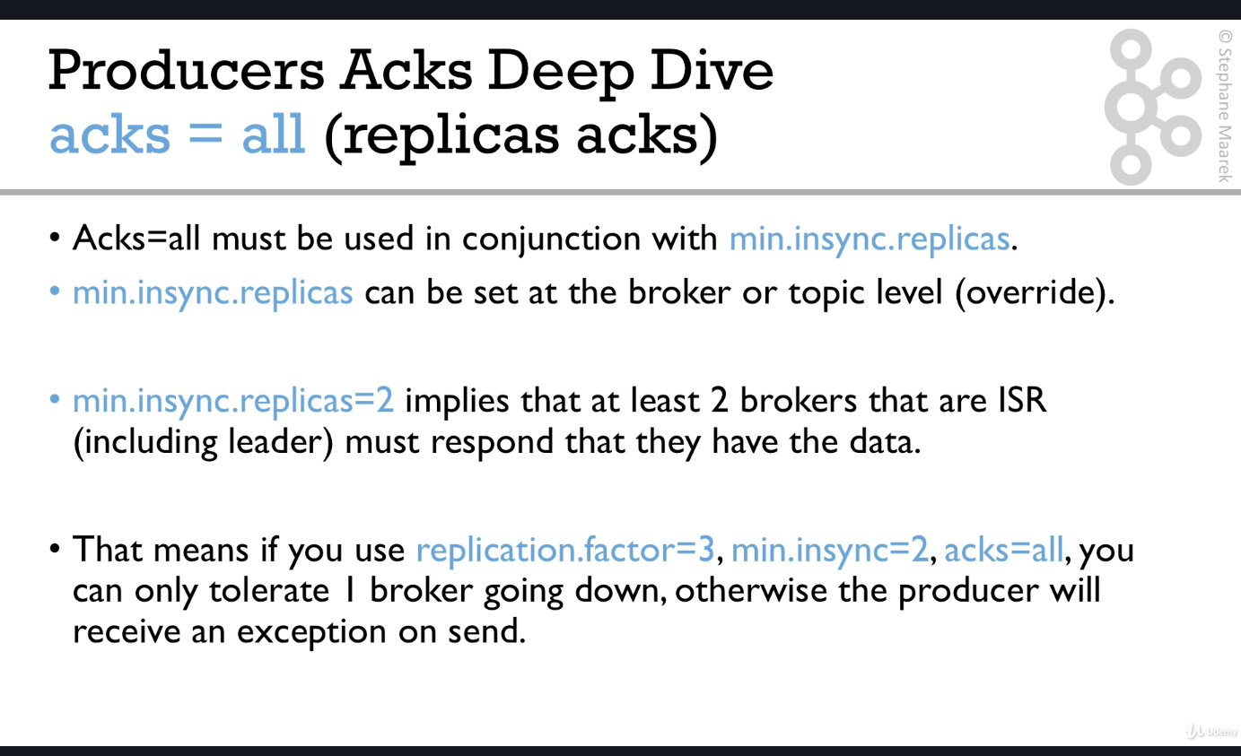

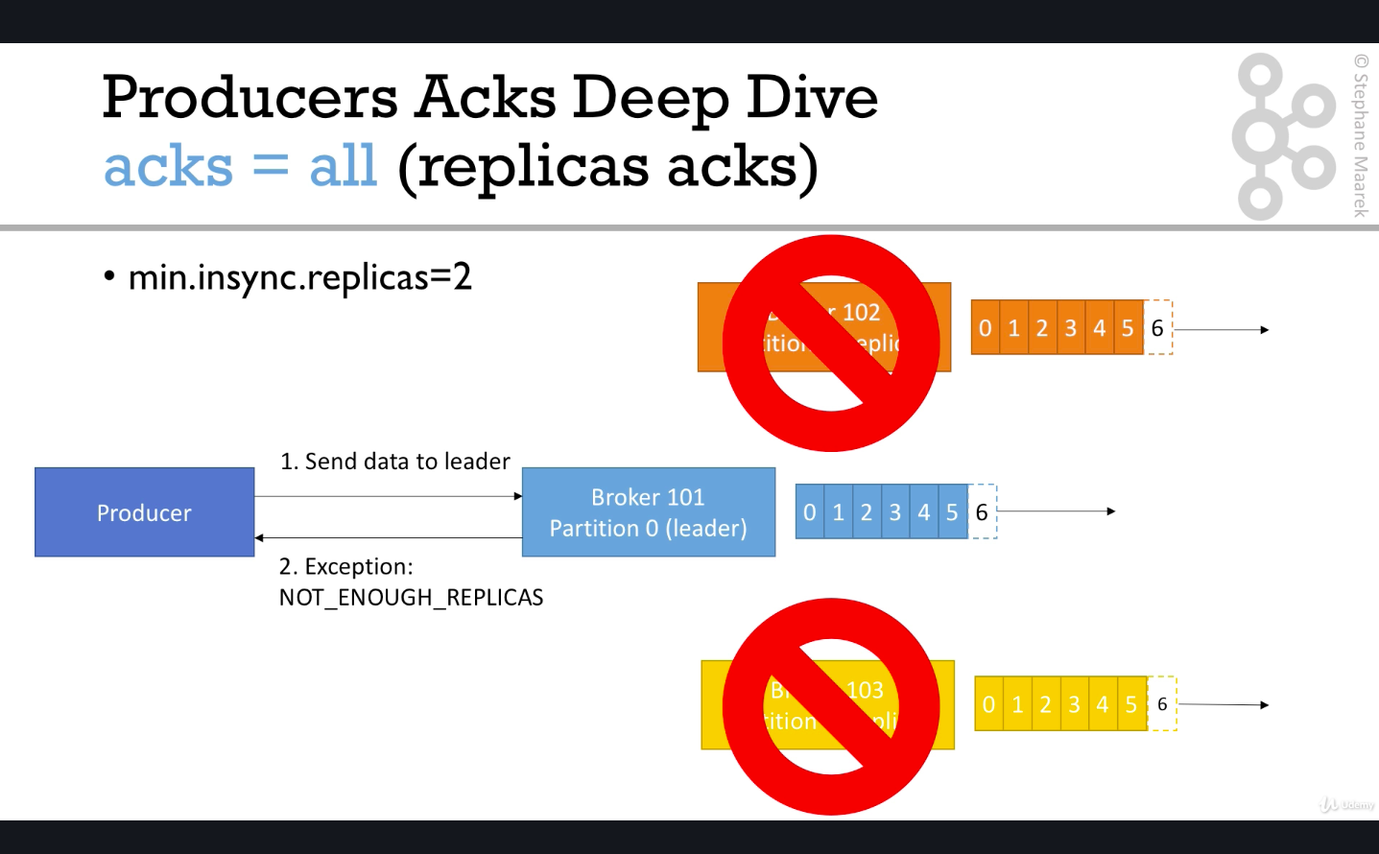

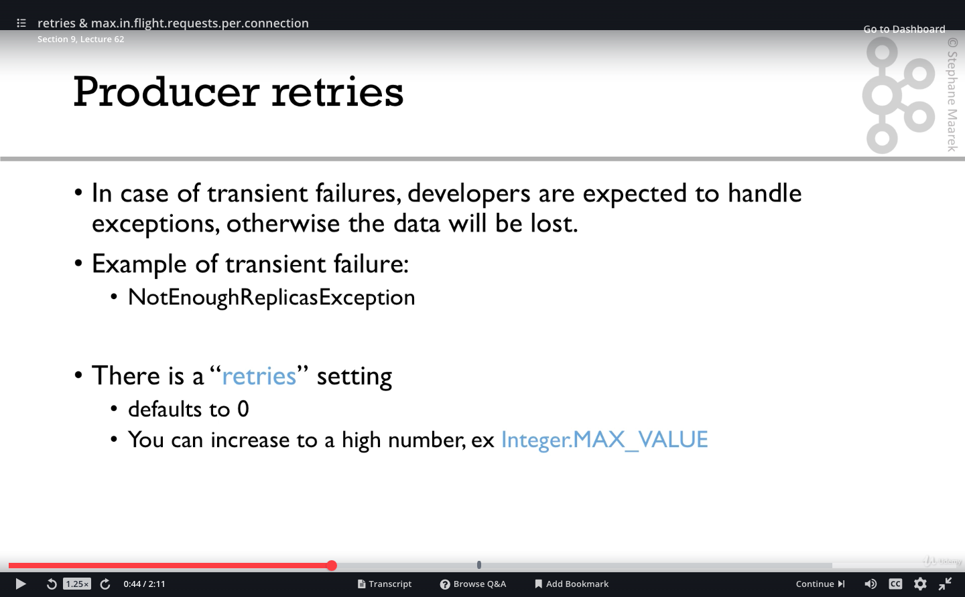

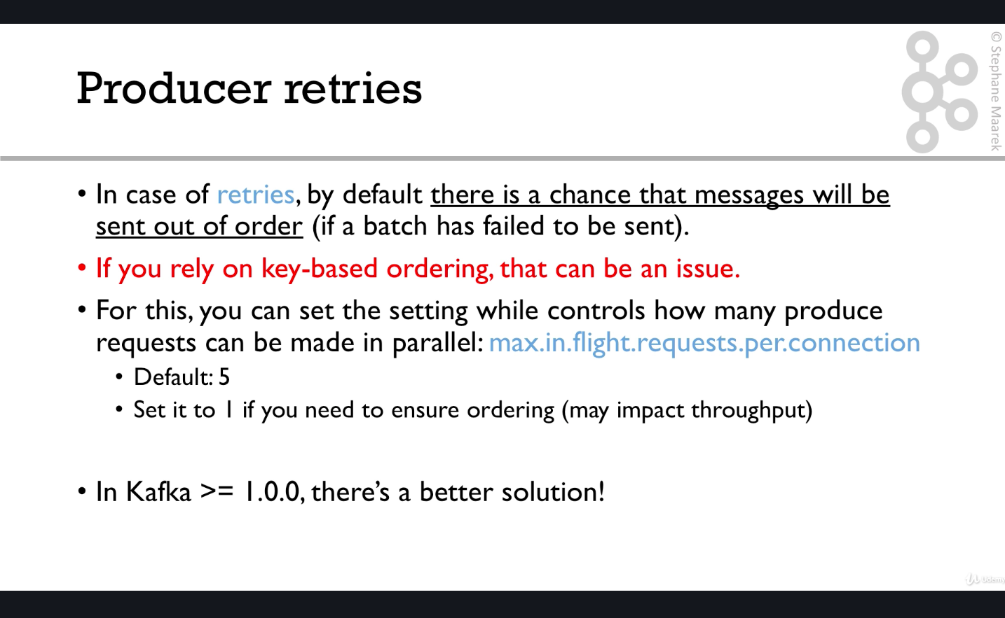

The better solution is using Idempotent Producer

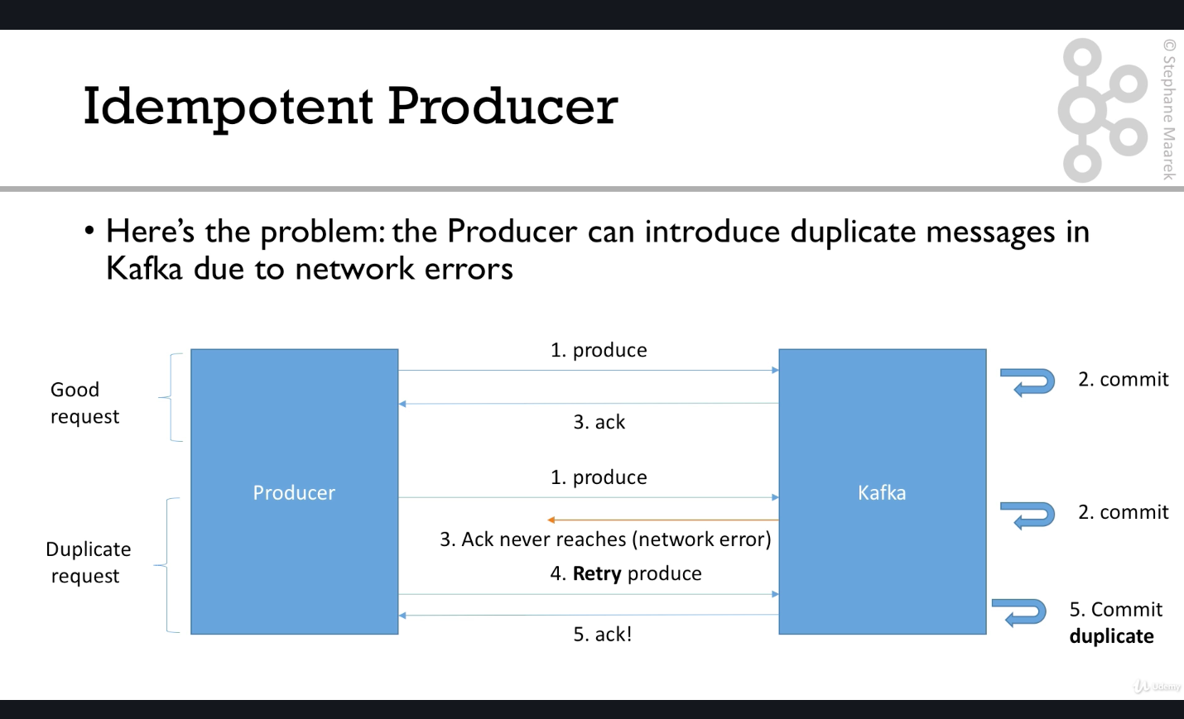

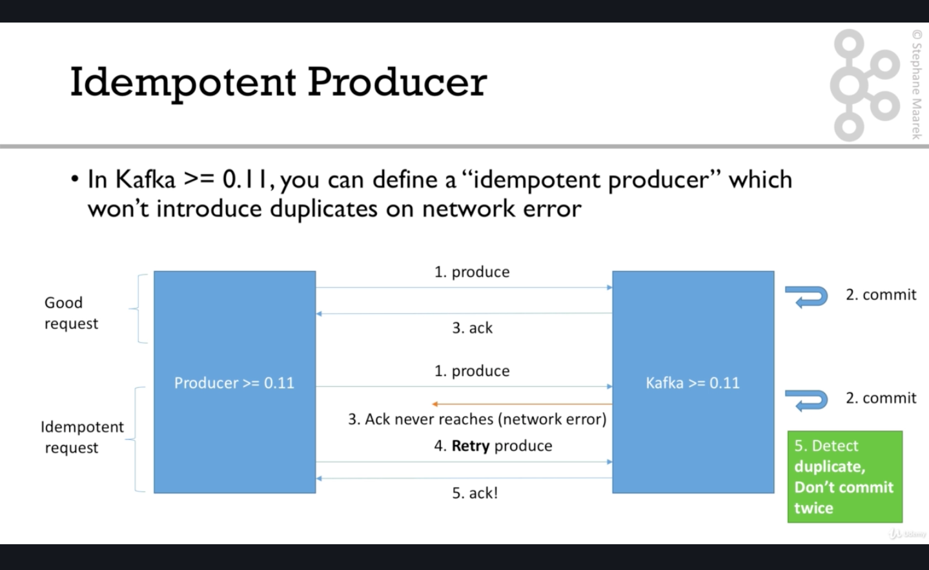

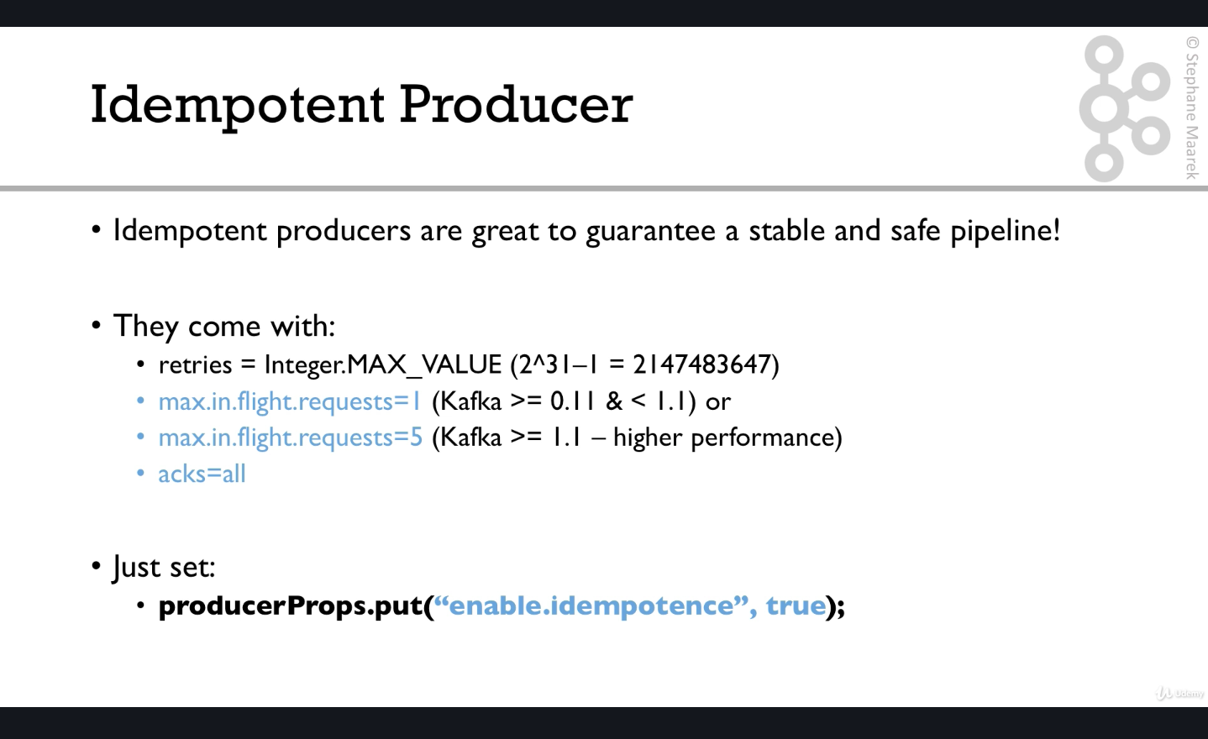

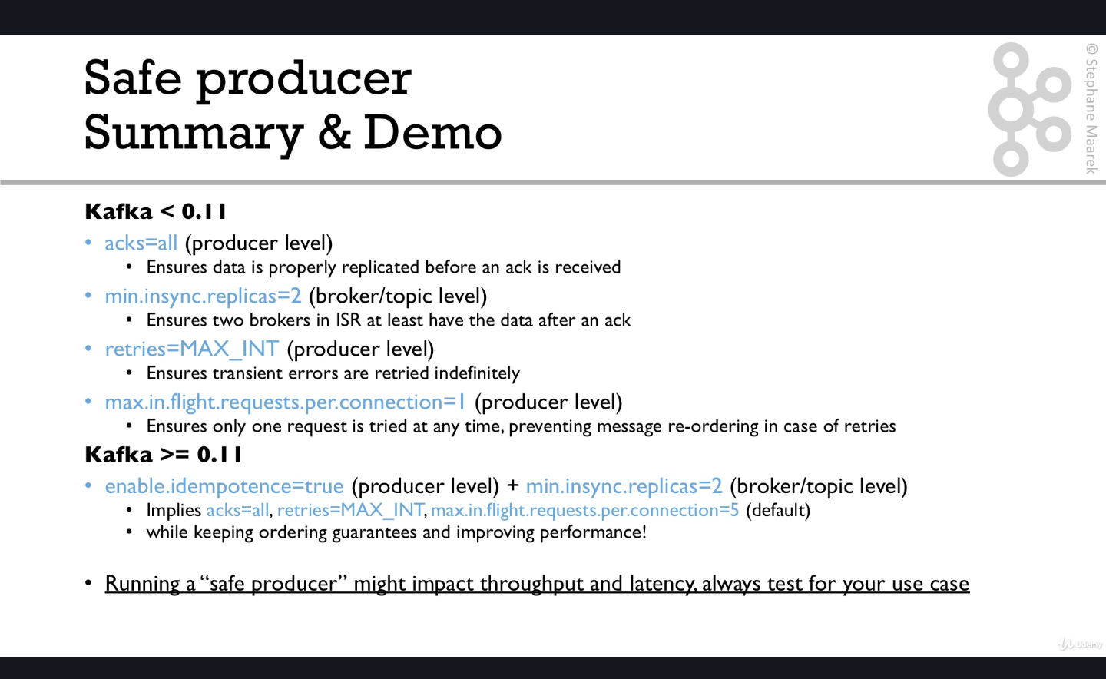

In code :-

*//Create Safe producer*props.setProperty(ProducerConfig.***ENABLE\_IDEMPOTENCE\_CONFIG***,**"true"**);  
props.setProperty(ProducerConfig.***ACKS\_CONFIG***,**"all"**); *//(Default is 1 if you set idempotence producer)*props.setProperty(ProducerConfig.***RETRIES\_CONFIG***,Integer.*toString*(Integer.***MAX\_VALUE***));*//Default*props.setProperty(ProducerConfig.***MAX\_IN\_FLIGHT\_REQUESTS\_PER\_CONNECTION***,**"5"**);*//KAFKA 2.0>=1.1SO  
//WE CAN KEEP THIS AS 5 , USE 1 OTHERWISE Default*

*Also set Min.in.sync.replicas , google about it to know the configurations .Default value is 1 . You can set it at broker level or topic level which overrides the broker level .So when you create topic through cli you can set this parameter.*

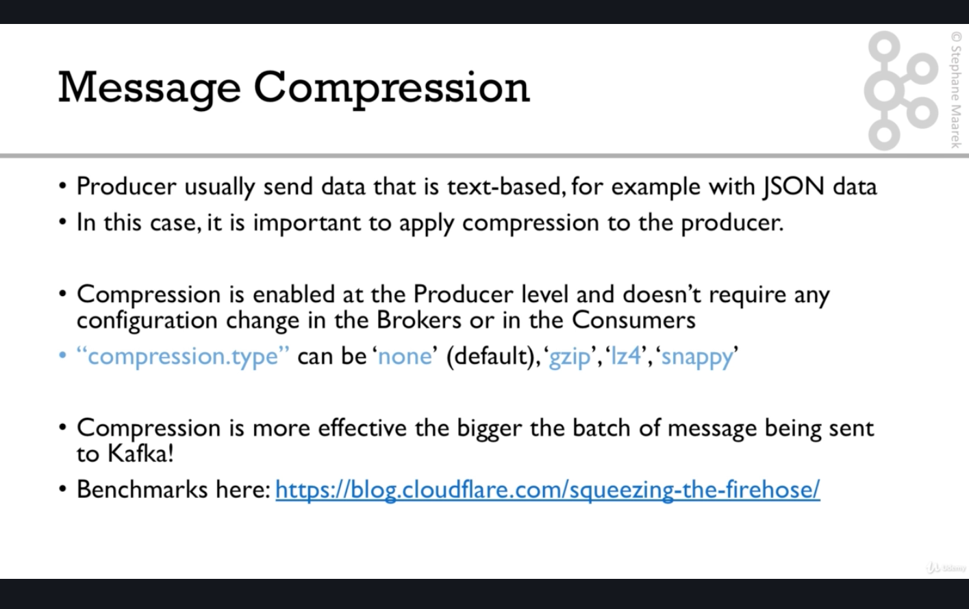

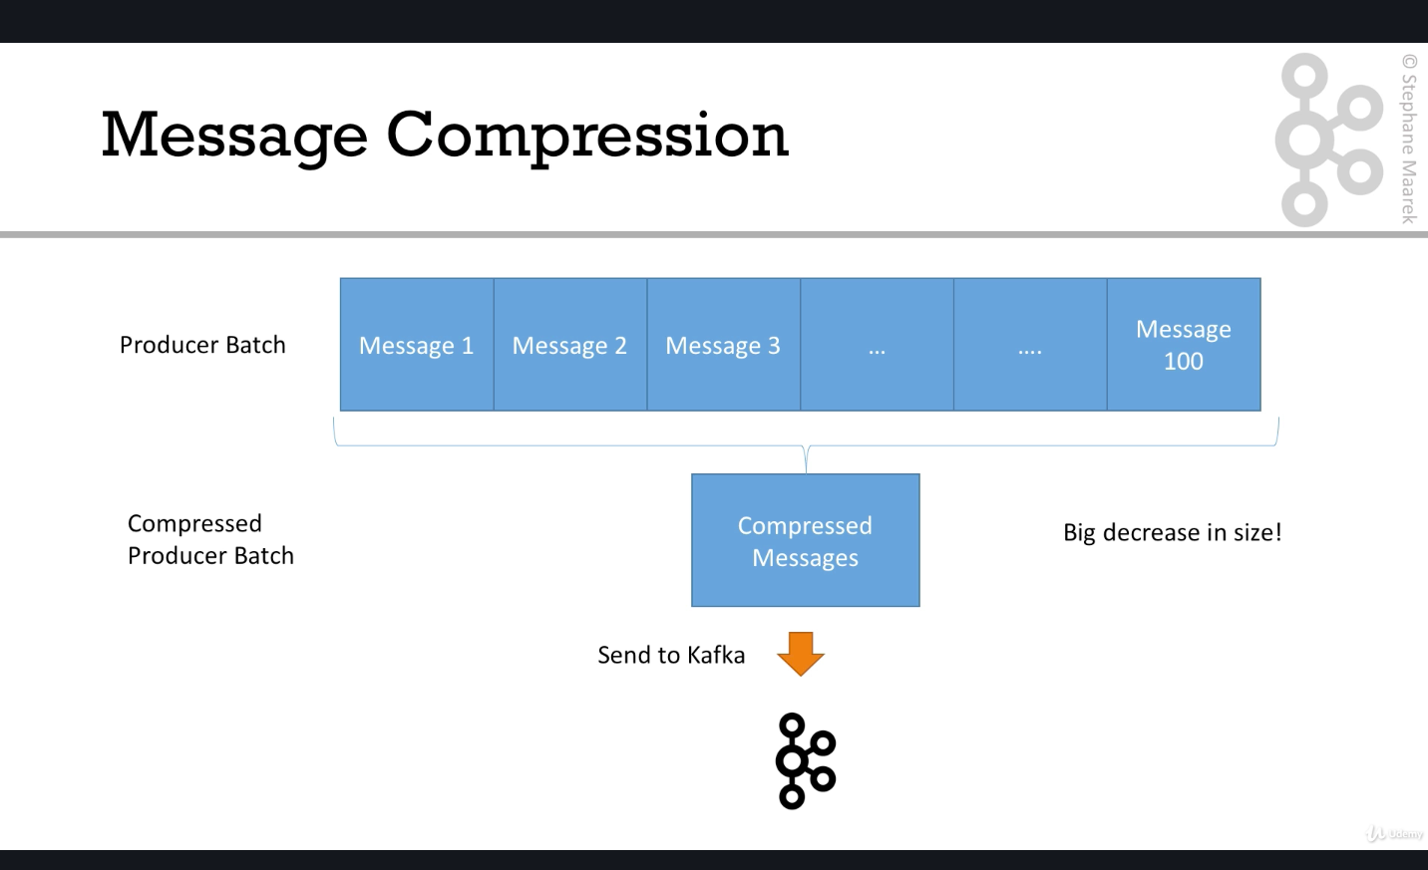

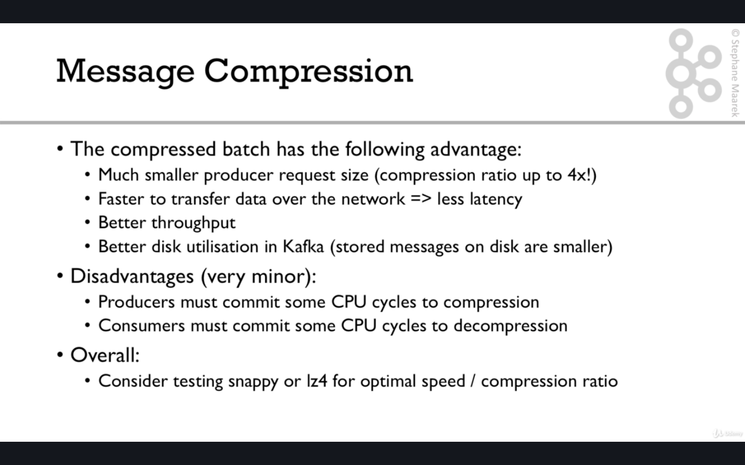

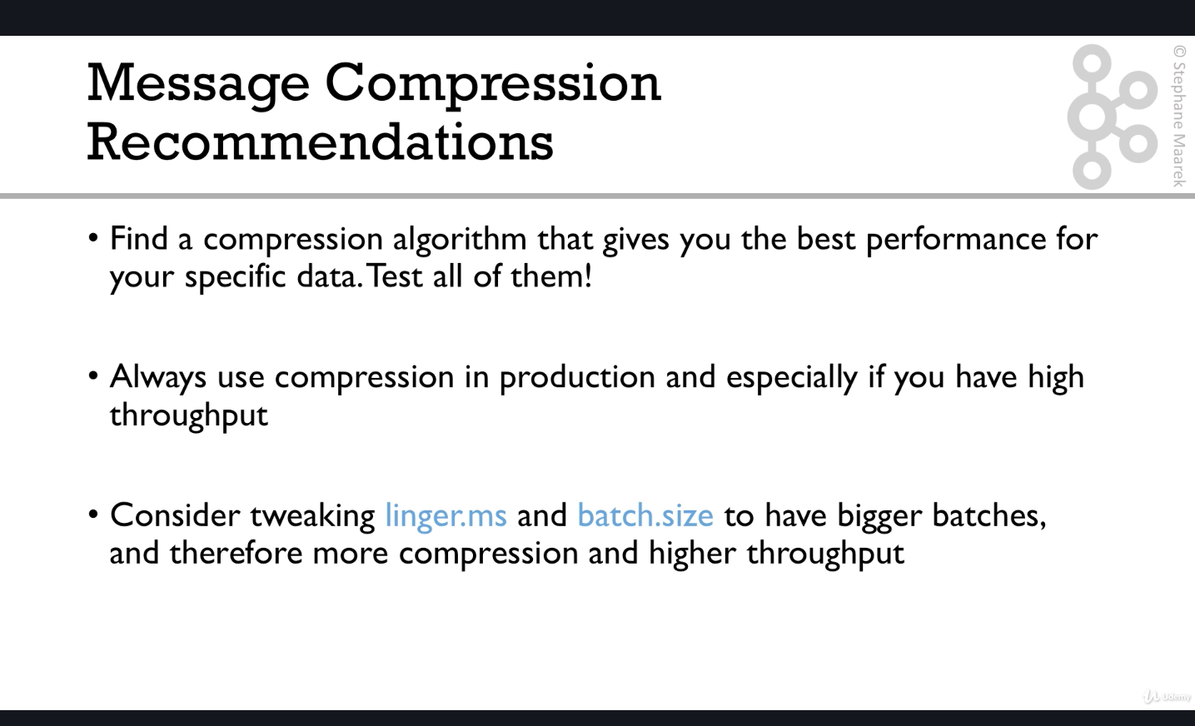

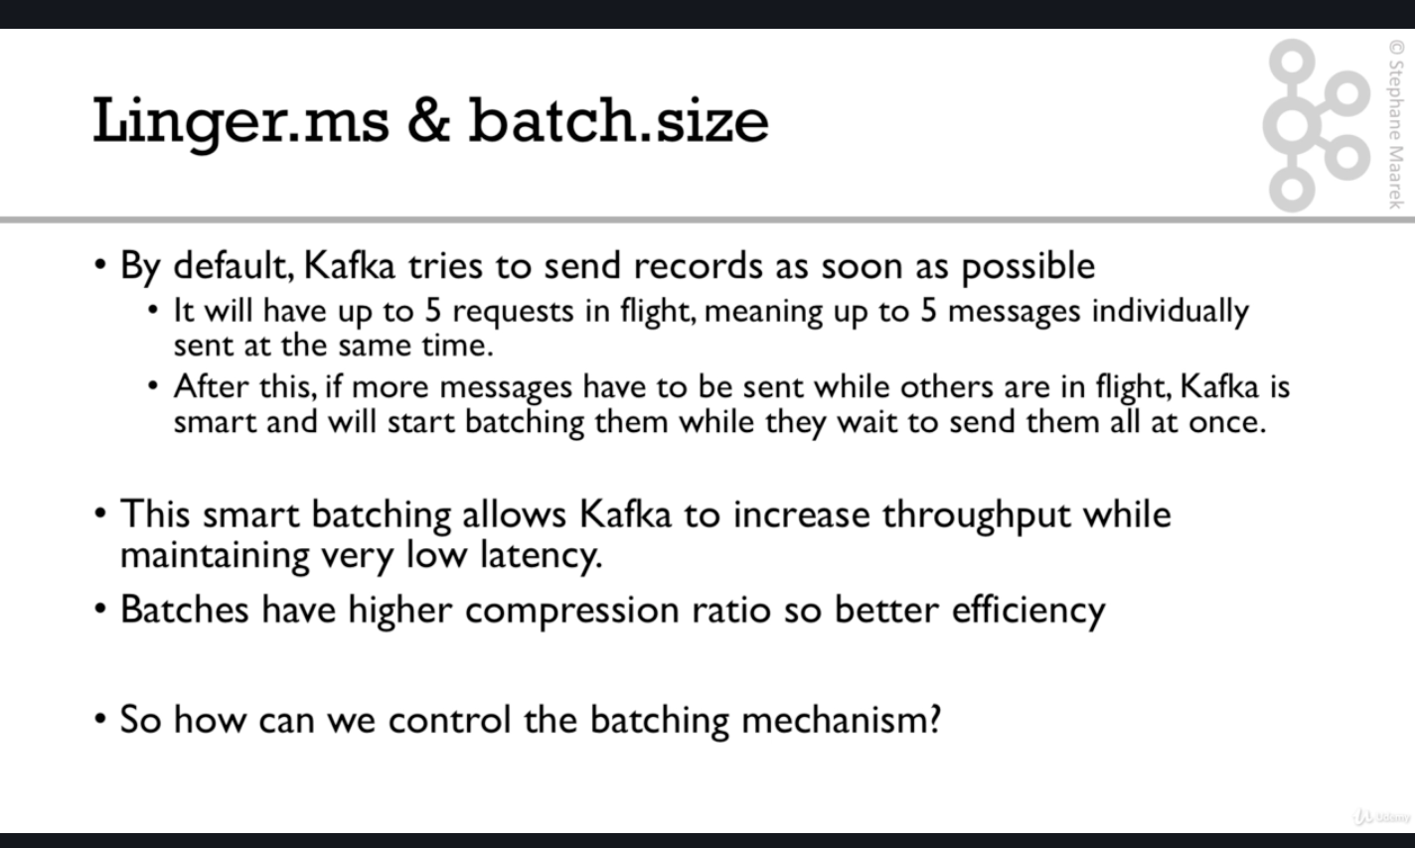

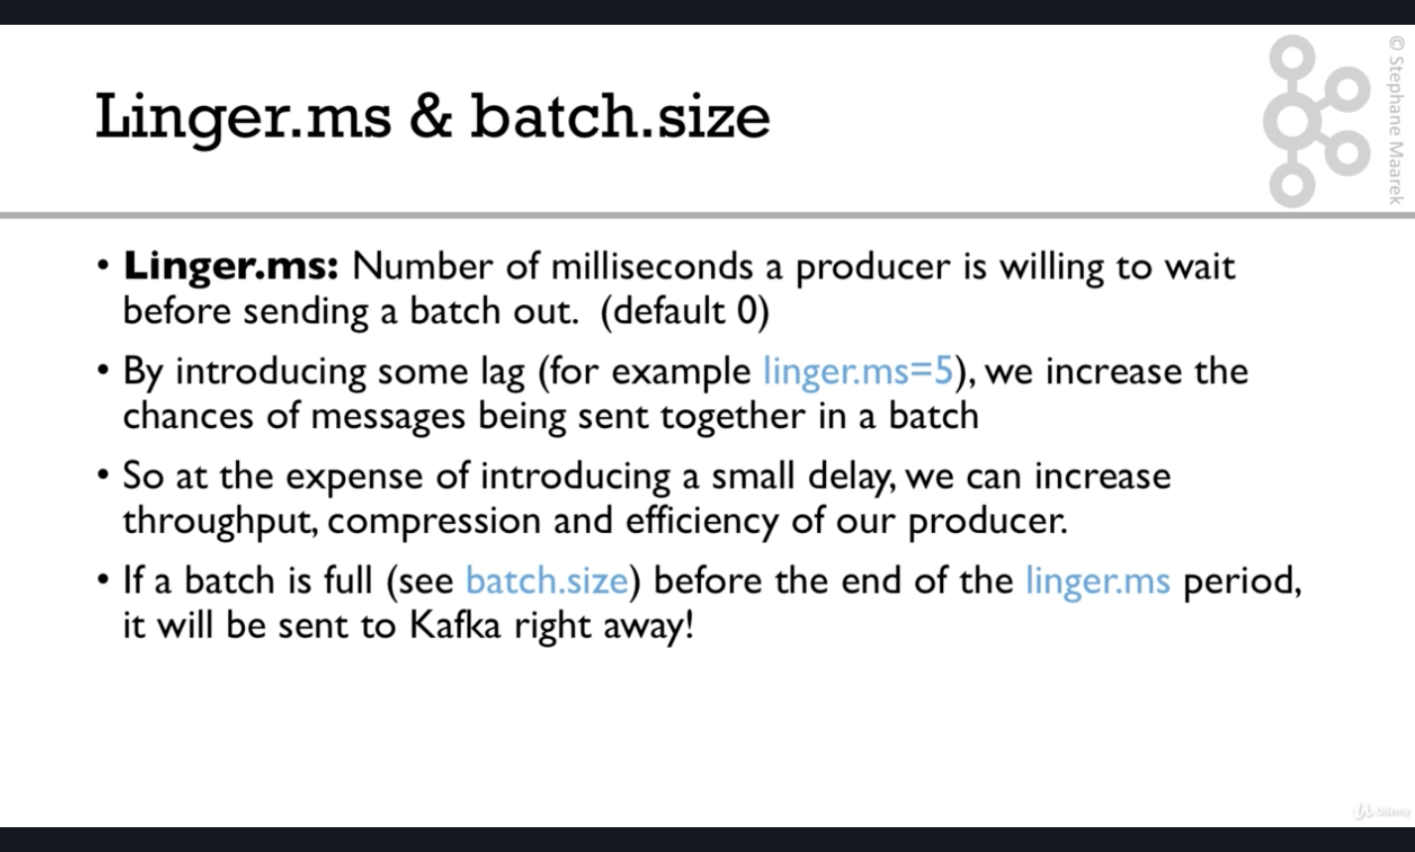

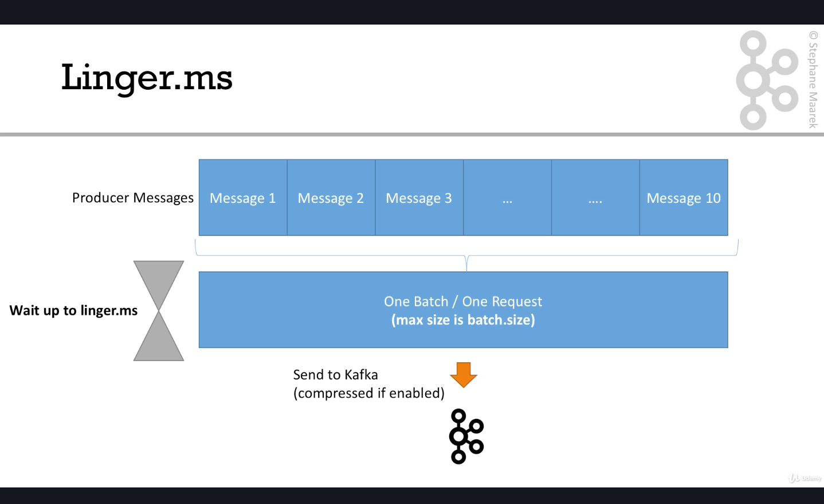

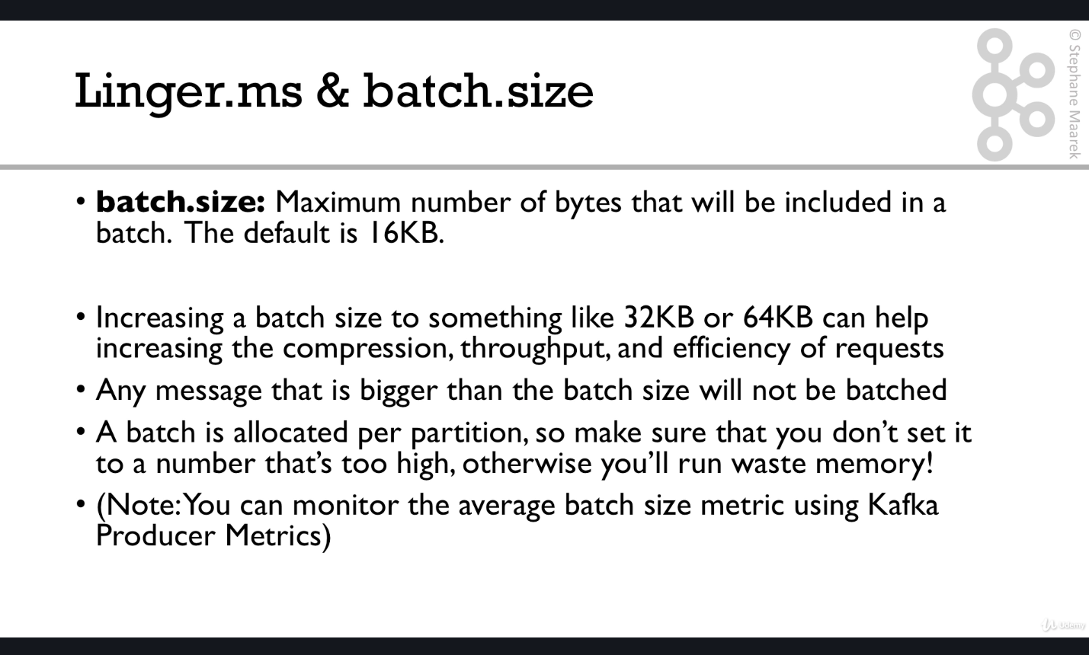

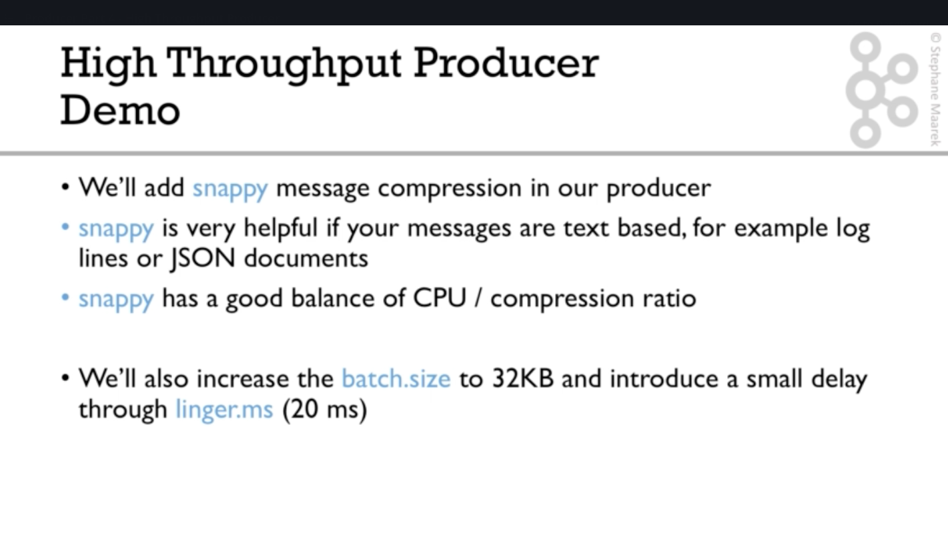

Snappy developed by Google so a lot of engineering has gone in its development , something worth trying and benchmarking.

*//high throughput producer at the expense of a bit of latency and CPU usage*props.setProperty(ProducerConfig.***COMPRESSION\_TYPE\_CONFIG***,**"snappy"**);  
props.setProperty(ProducerConfig.***LINGER\_MS\_CONFIG***,**"20"**);  
props.setProperty(ProducerConfig.***BATCH\_SIZE\_CONFIG***,Integer.*toString*(1024\*32));

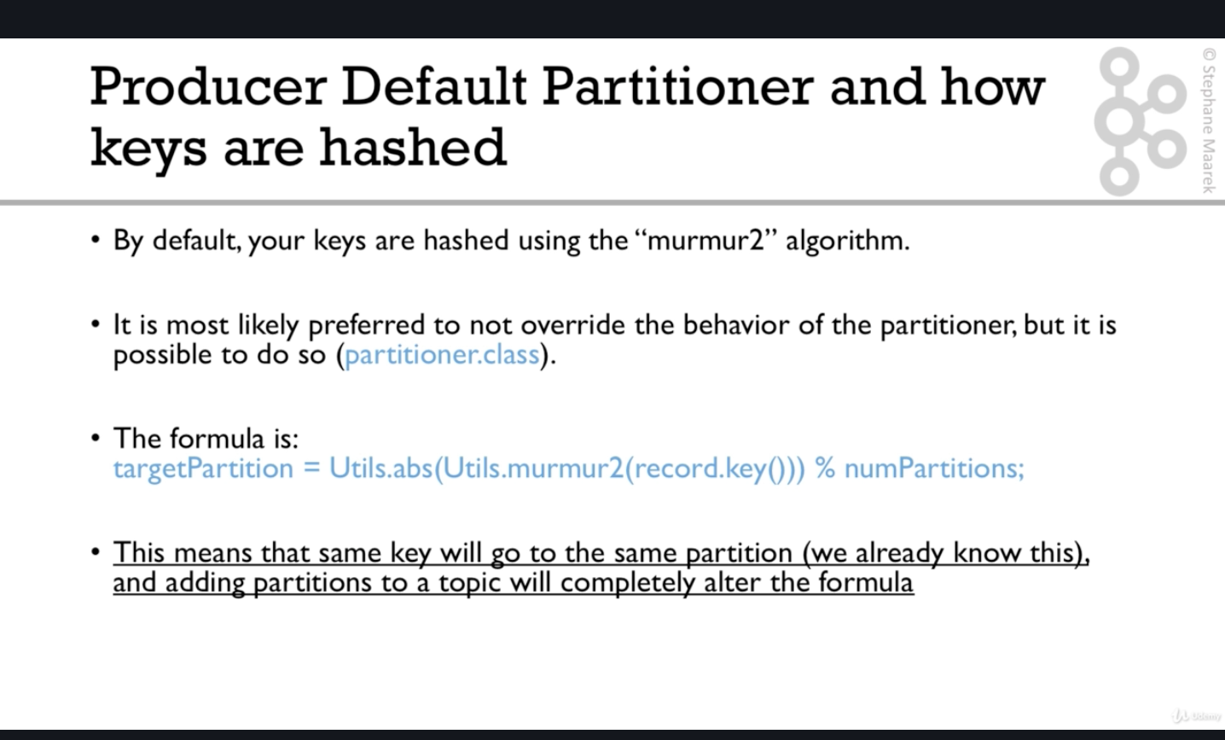

Super advanced Producer configuration when too much messages sent from producer and broker is not able to take that load.

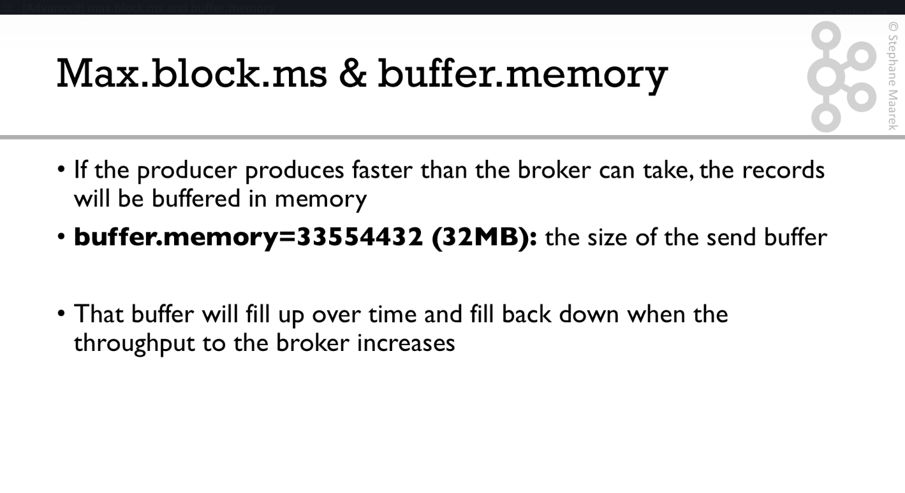

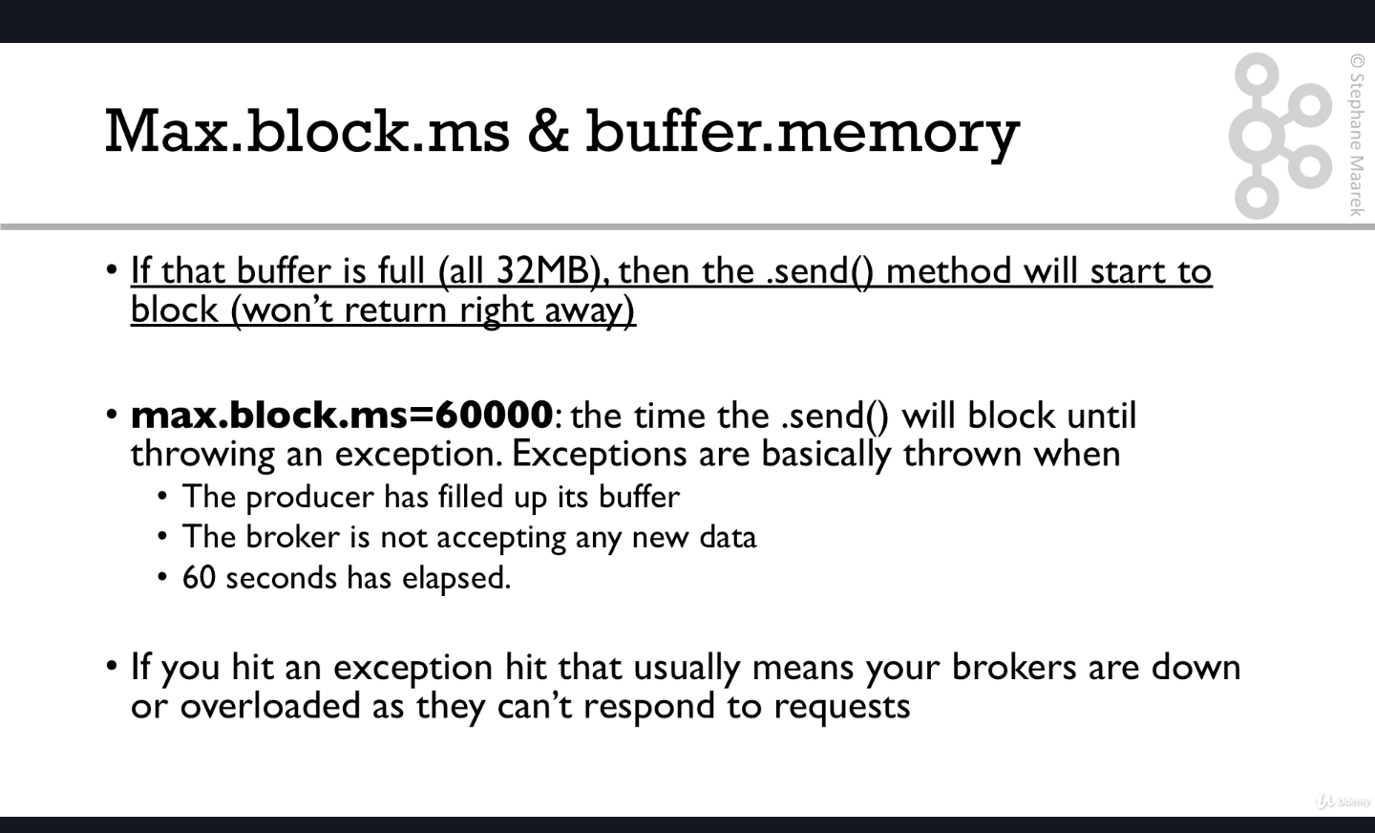

Now comes production quality consumer which will get data and push it to elastic search

After using bonsai to create the cloud elastic search cluster .Bonsai link is bookmarked in elastic search folder.

and then learning some stuffs in elastic search documentation :-

<https://www.elastic.co/guide/en/elasticsearch/reference/6.7/getting-started-cluster-health.html>

1. GET /\_cat/nodes?v
2. GET /\_cat/indices?v
3. DELETE /customer?pretty
4. GET /\_cat/indices?v

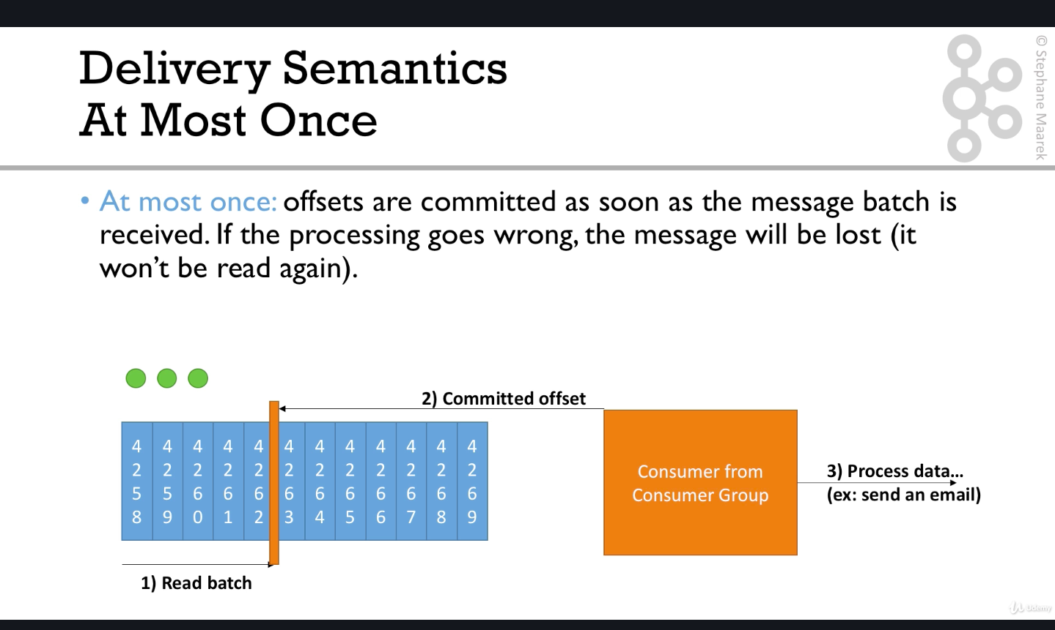

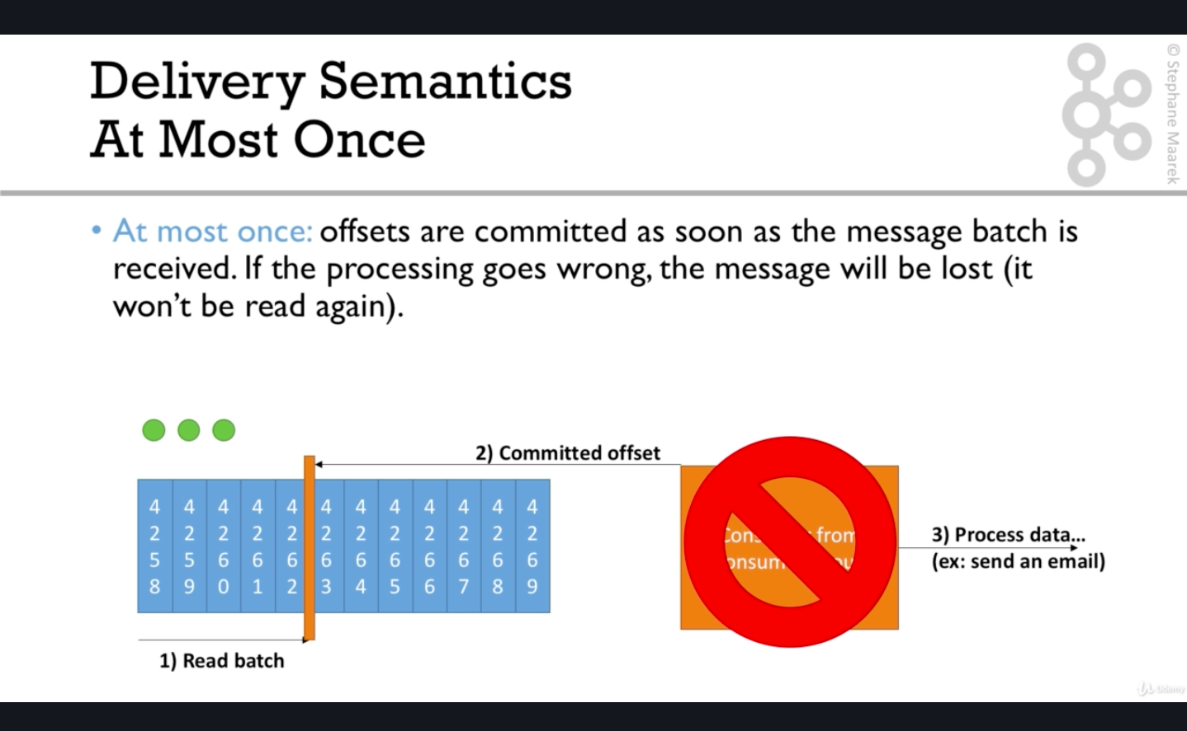

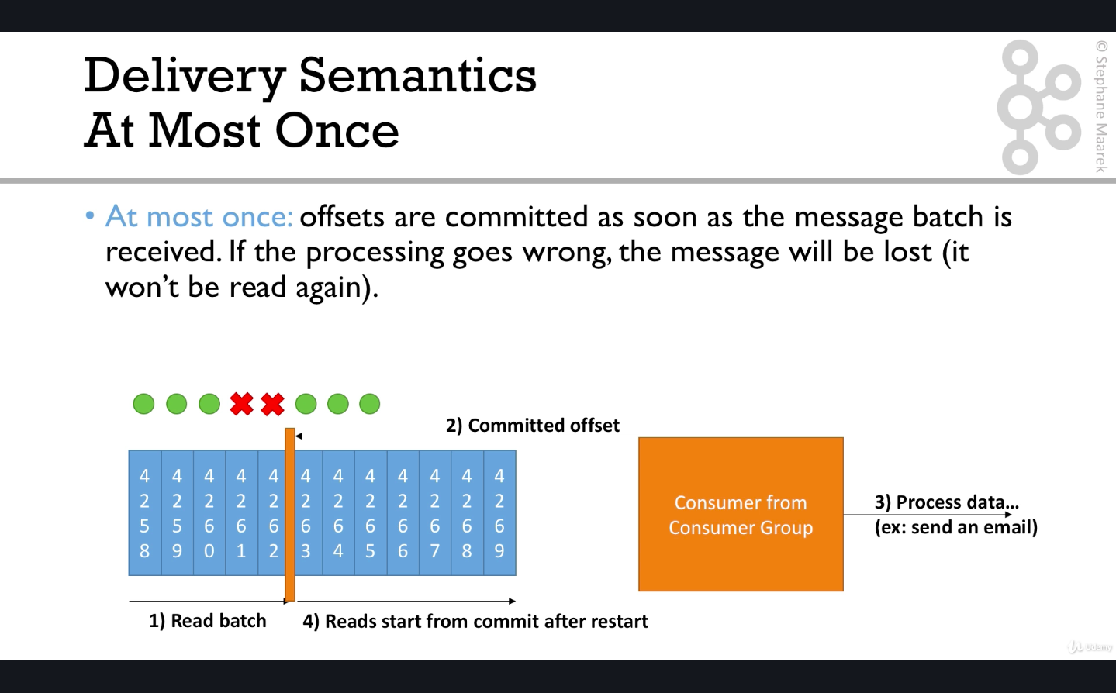

So here there is chance of lost messages .

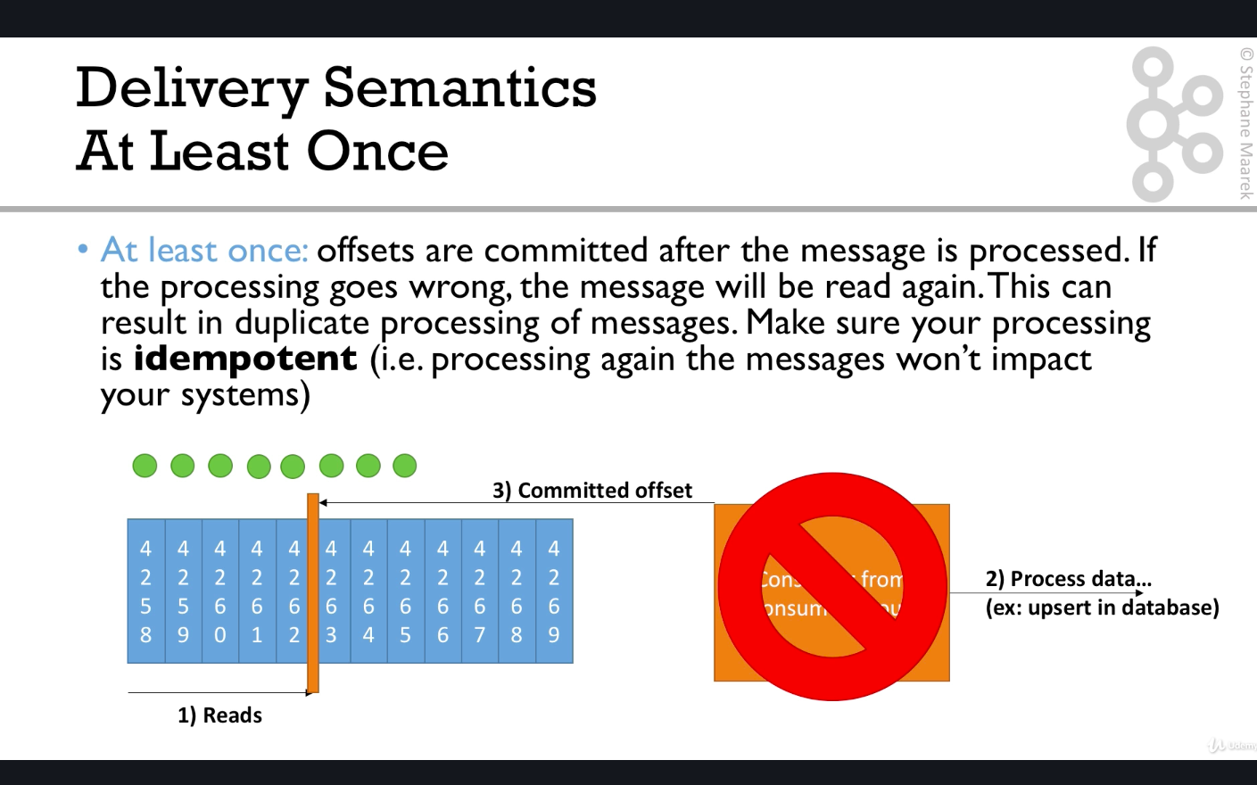

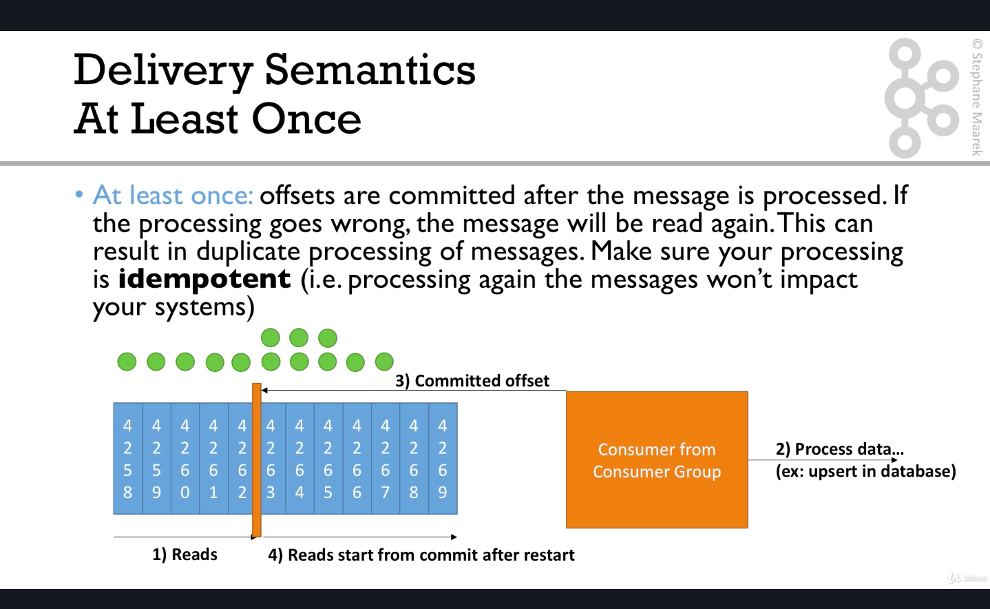

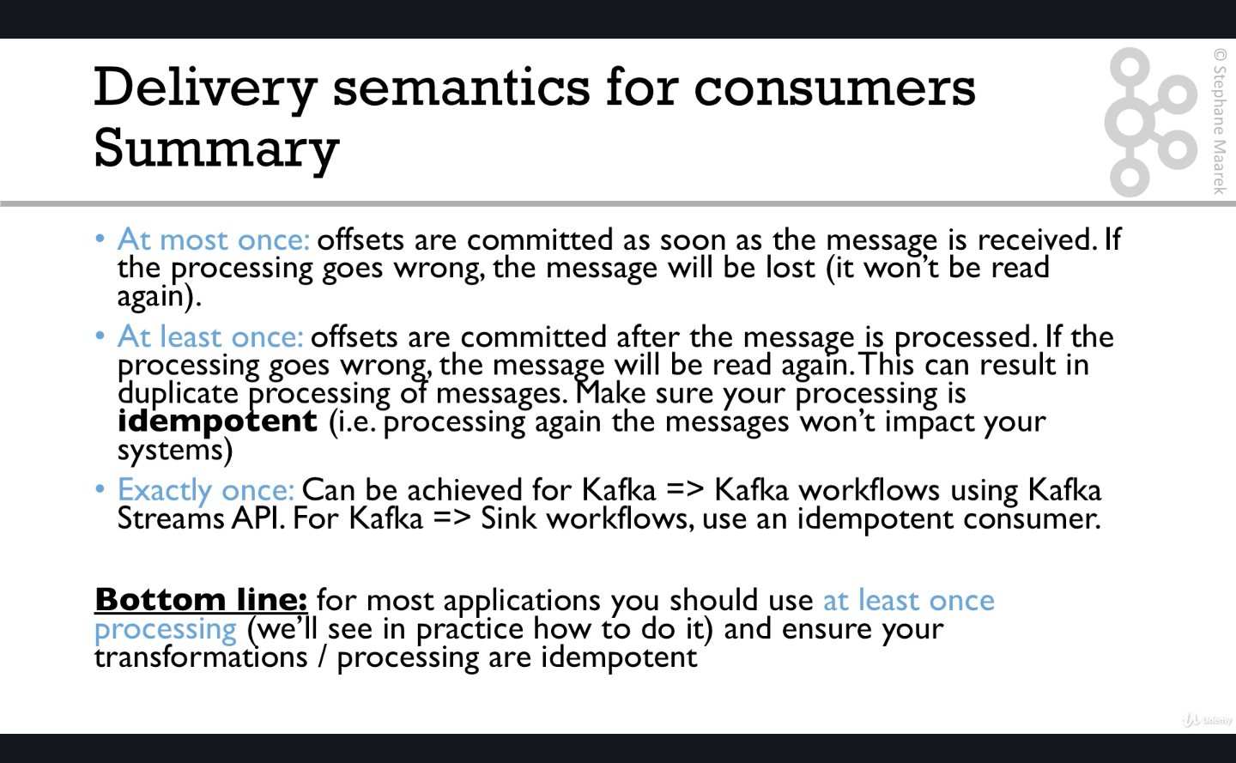

Si in code for creating idempotent consumer .Must for atleast once delivery sematincs consumer, we need to make sure that the id we are passing in case of elastic search is something which is unique :-

*//2 strategies for creating ids  
//kafka generic id*String id =consumerRecord.topic()+**"\_"**+consumerRecord.partition()+**"\_"**+  
 consumerRecord.offset();  
  
*//twitter feed specific id*String id1 = extractIdFromTweet(consumerRecord.value());

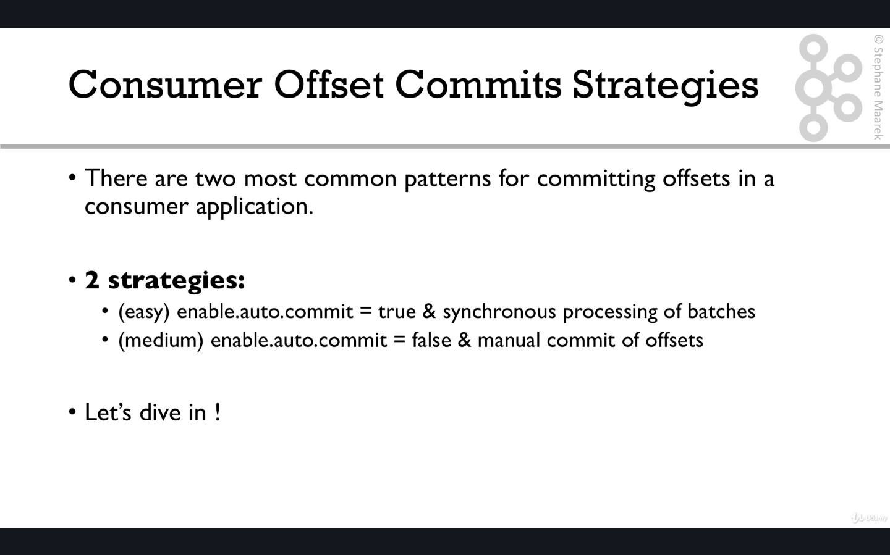

1st one is default behaviour , that is enable auto commit by default is true. Hence for a beginner he needs to know about this as , be default the delivery semantics of consumer is atmost once and some messages might be lost .

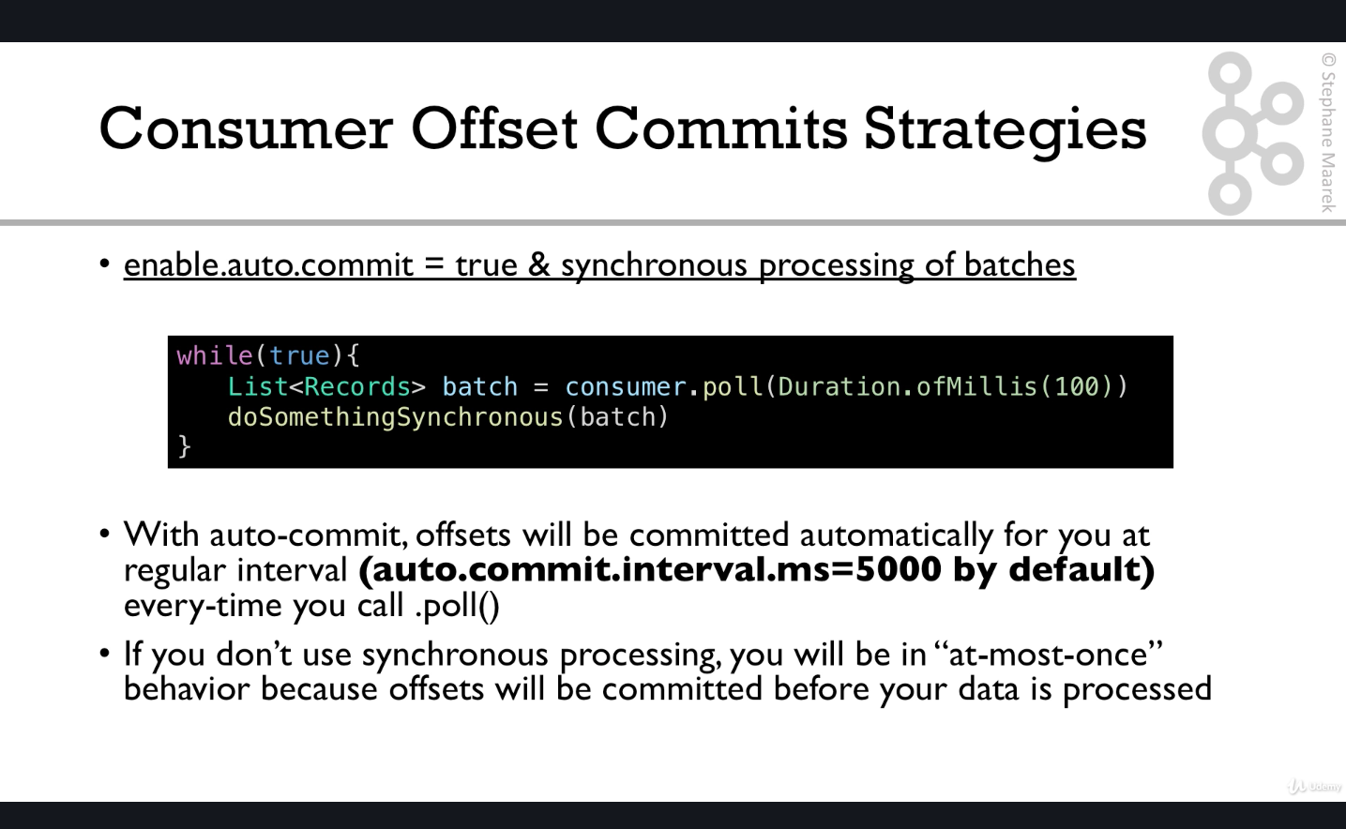

One very important observation about the default values :-

1. ConsumerConfig.***AUTO\_OFFSET\_RESET\_CONFIG***
2. auto.commit.interval.ms = 5000
3. enable.auto.commit = true

Though the default value for auto.commit.interval.ms is 5000 , it only works when poll is called continuously .In scenario where producer is compressing and sending data in a batch .It might happen that when you are calling poll , in a single poll you will get like 400 records all compressed in a single batch , so ony when next poll will happen , the auto commit interval and auto commit will come into play .So this should be considered .In fact manual offset setting should be always considered to keep this offset commits mechanism into your own control.

Otherwise , you can set props.setProperty(ConsumerConfig.***MAX\_POLL\_RECORDS\_CONFIG***,**"10"**);

This will make sure that single poll will only allow 10 records at a time .

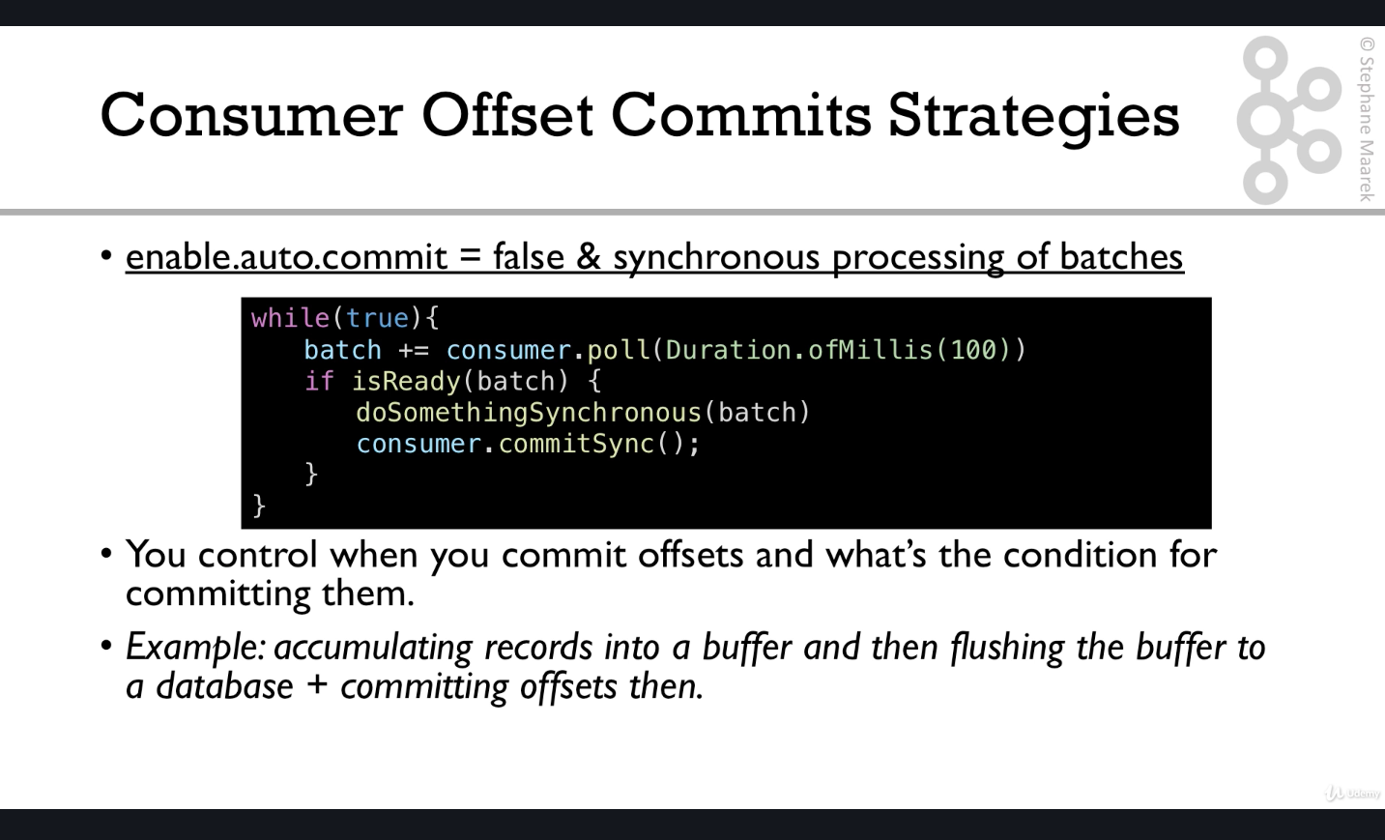

Hence the following config will make sure that offsets are committed every 10 offssets:-

props.setProperty(ConsumerConfig.***ENABLE\_AUTO\_COMMIT\_CONFIG***,**"false"**);*//disable auto commit of offsets*props.setProperty(ConsumerConfig.***MAX\_POLL\_RECORDS\_CONFIG***,**"10"**);

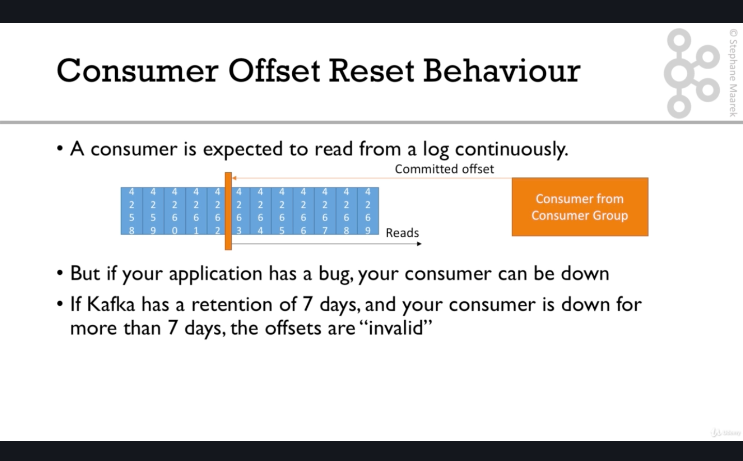

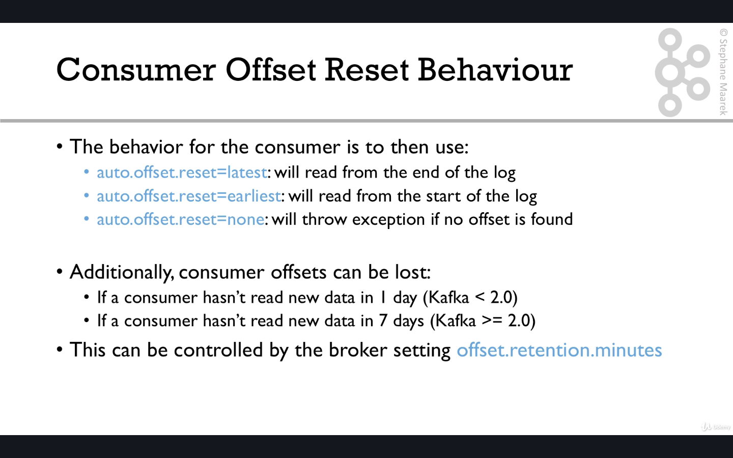

Either consumer has not read or consumer has not committed offset for the last 7 or 1 day.

Offset for a specific consumer group can be reset by the following command :-

1) kafka-consumer-groups --bootstrap-server localhost:9092 --group **twitter-consumer-elasticsearch2**

--execute --reset-offsets --to-earliest --topic twitter\_tweets

2) kafka-consumer-groups --bootstrap-server localhost:9092 --group **twitter-consumer-elasticsearch2**

--execute --reset-offsets --shift-by -3 --topic twitter\_tweets

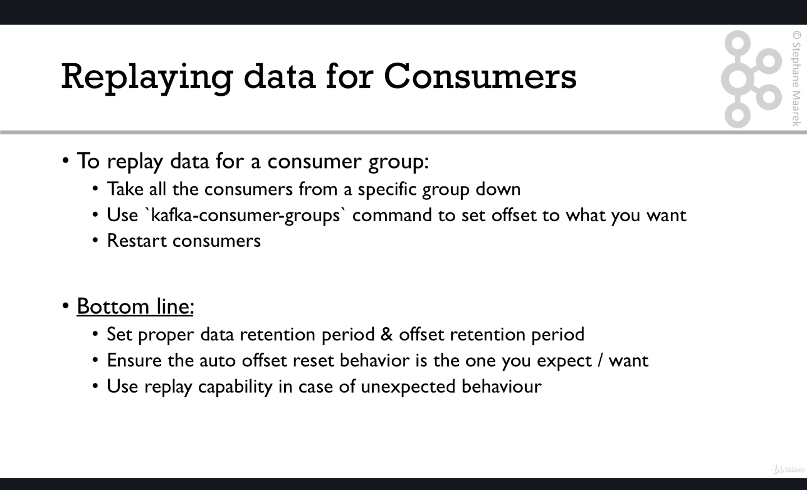

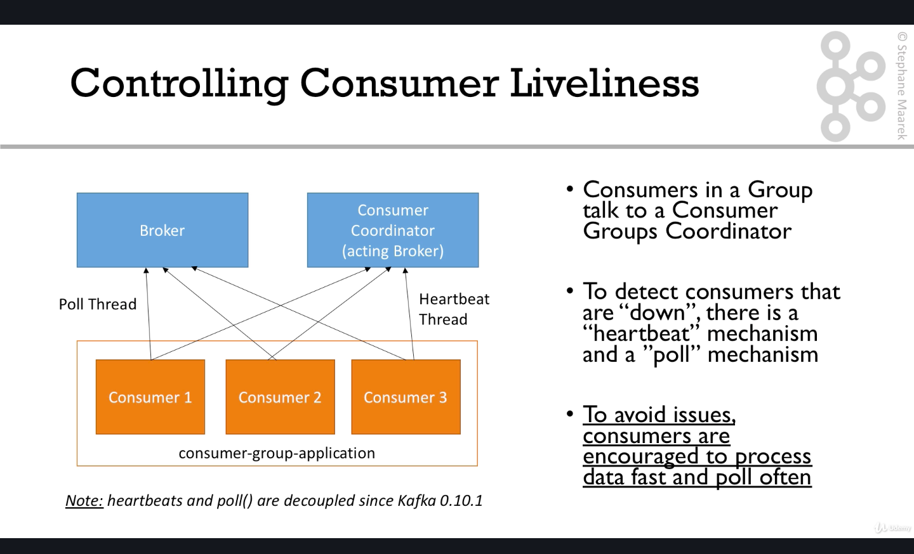

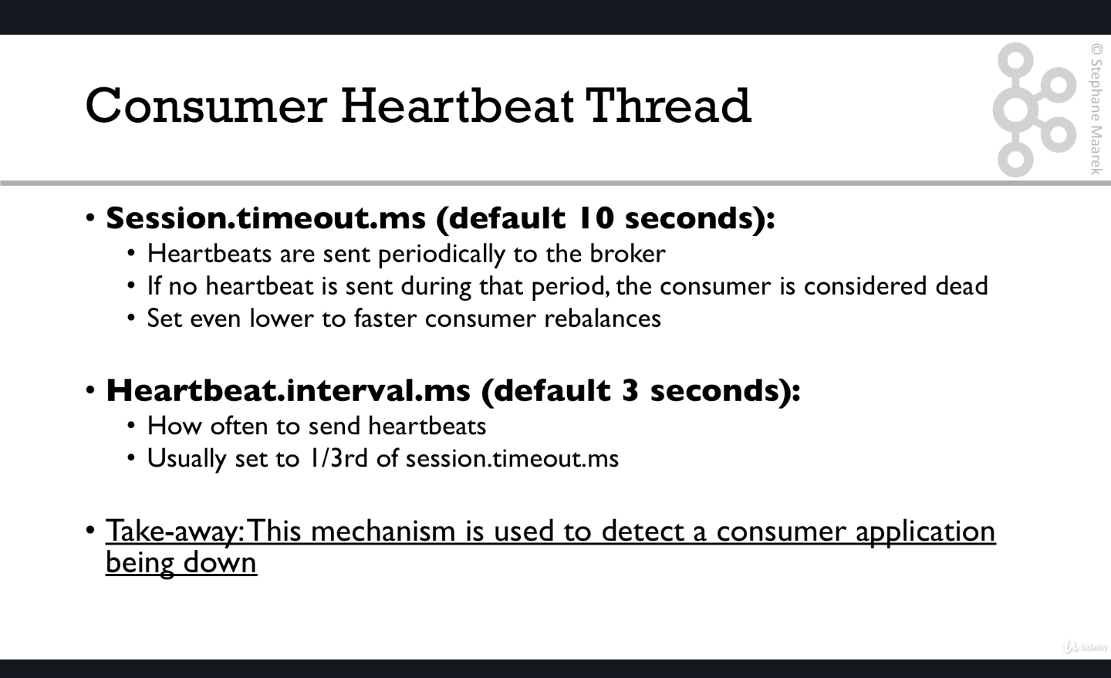

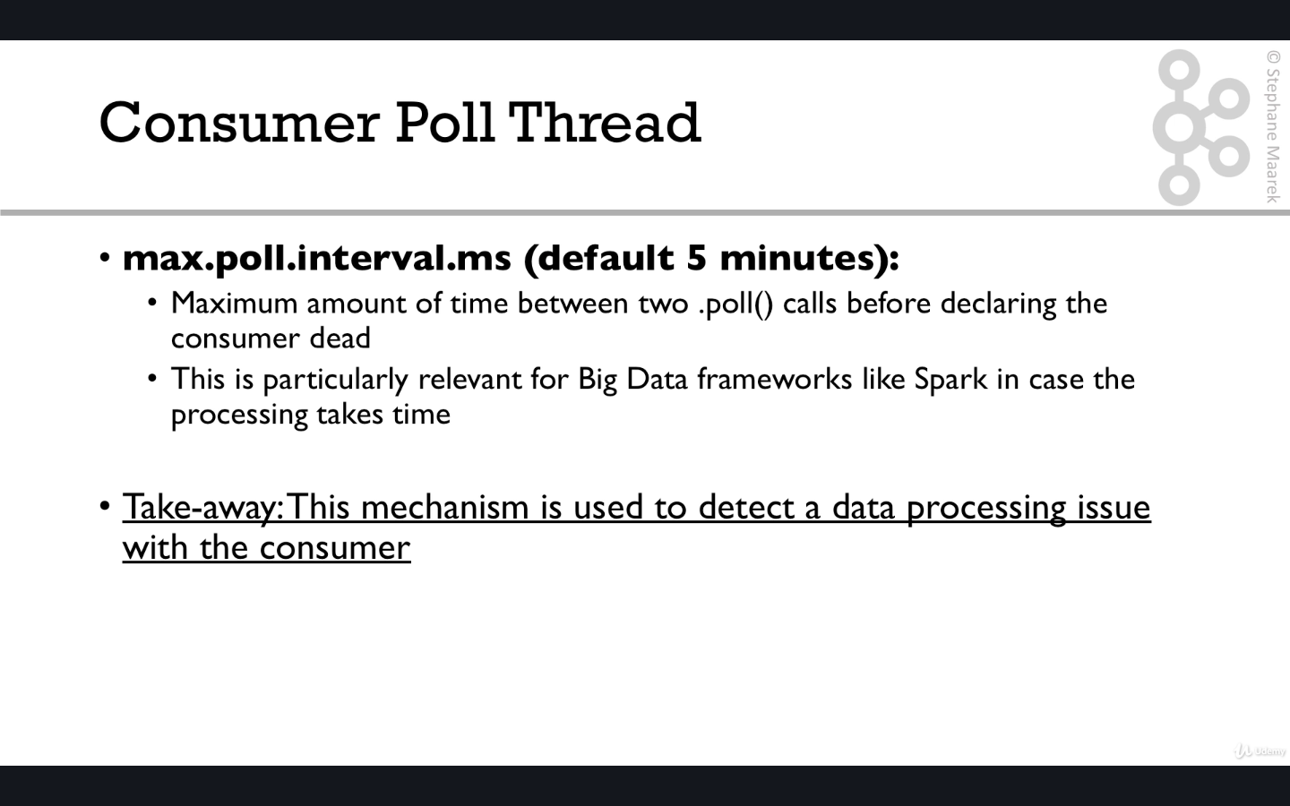

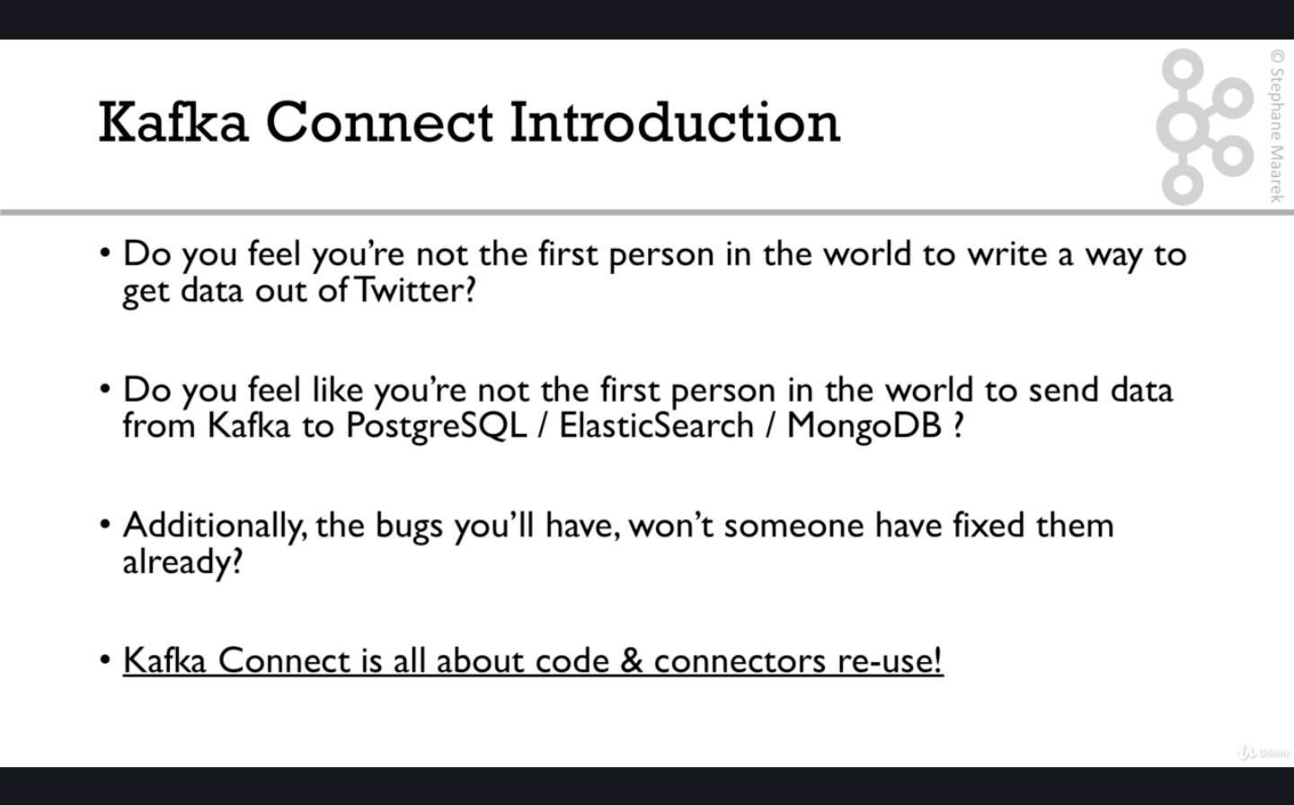

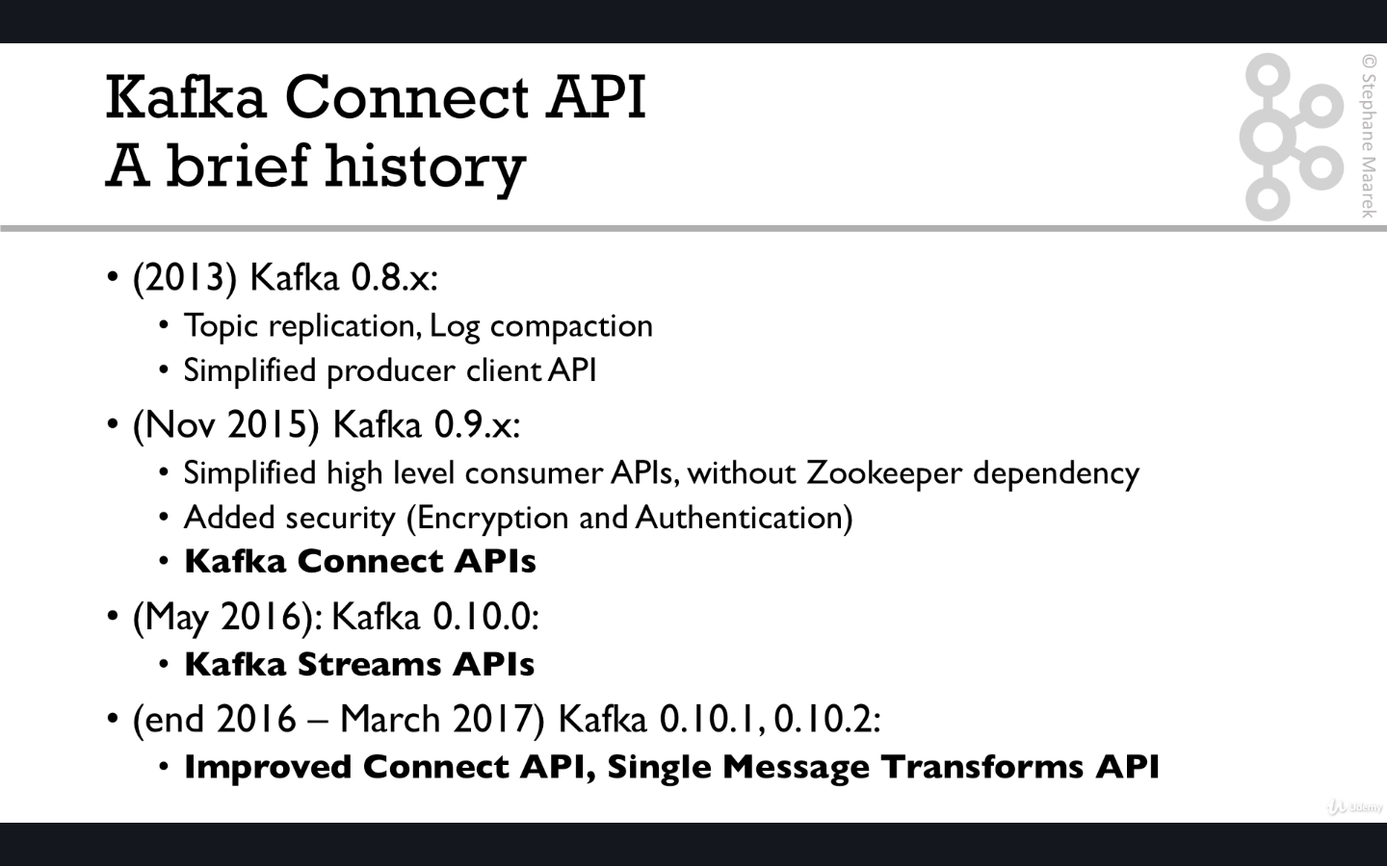

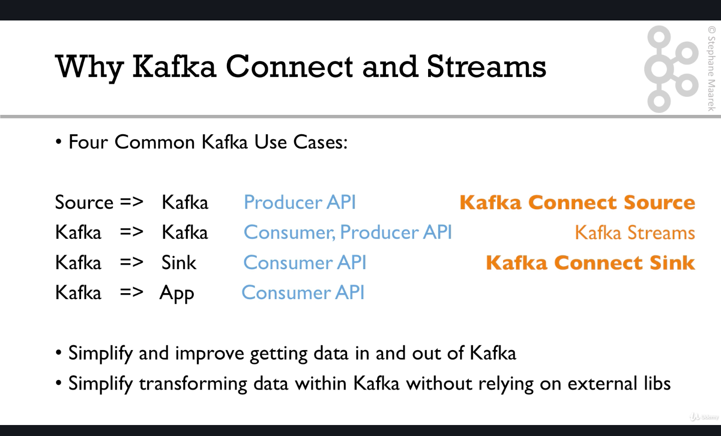

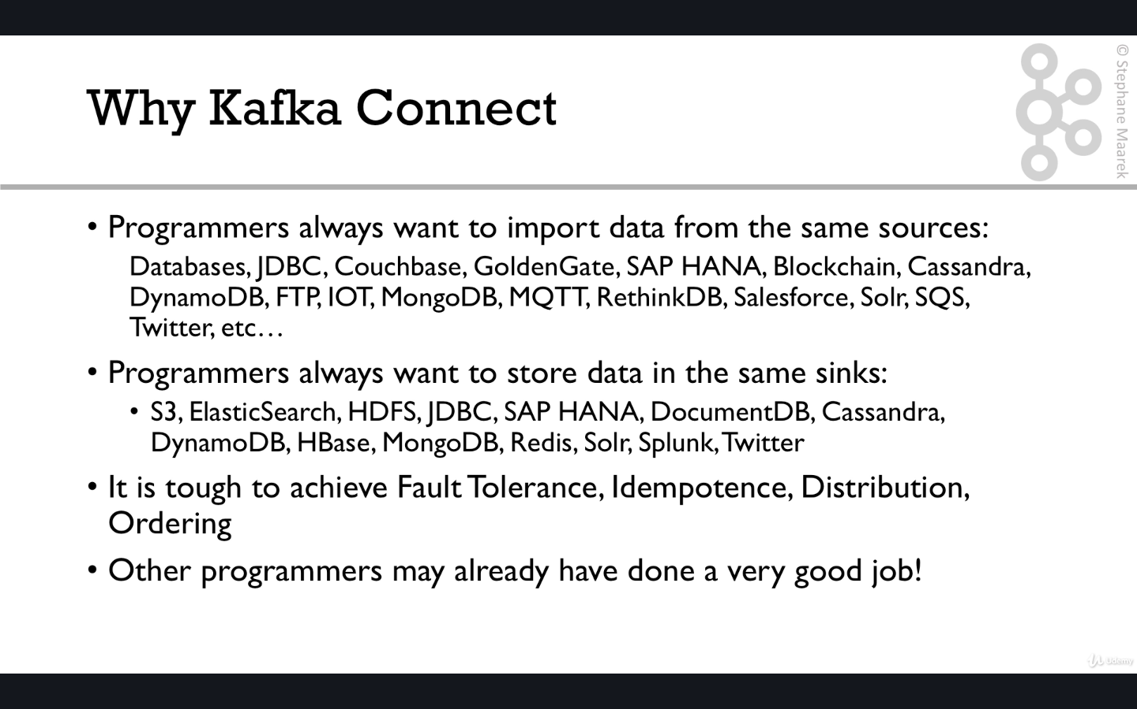

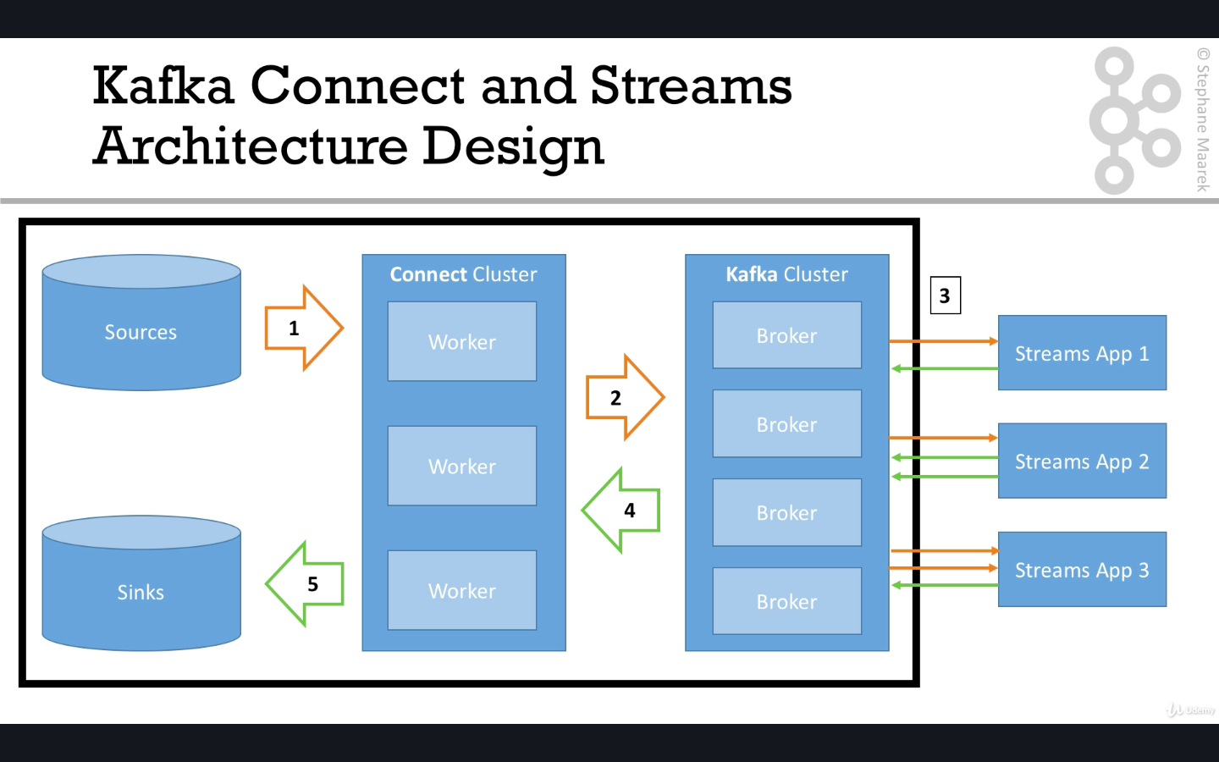

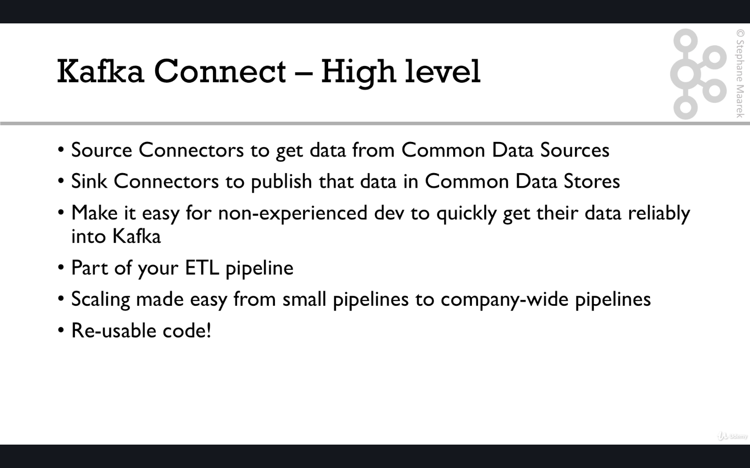

Confluent LINK for kafka connectors list :- <https://www.confluent.io/hub/>

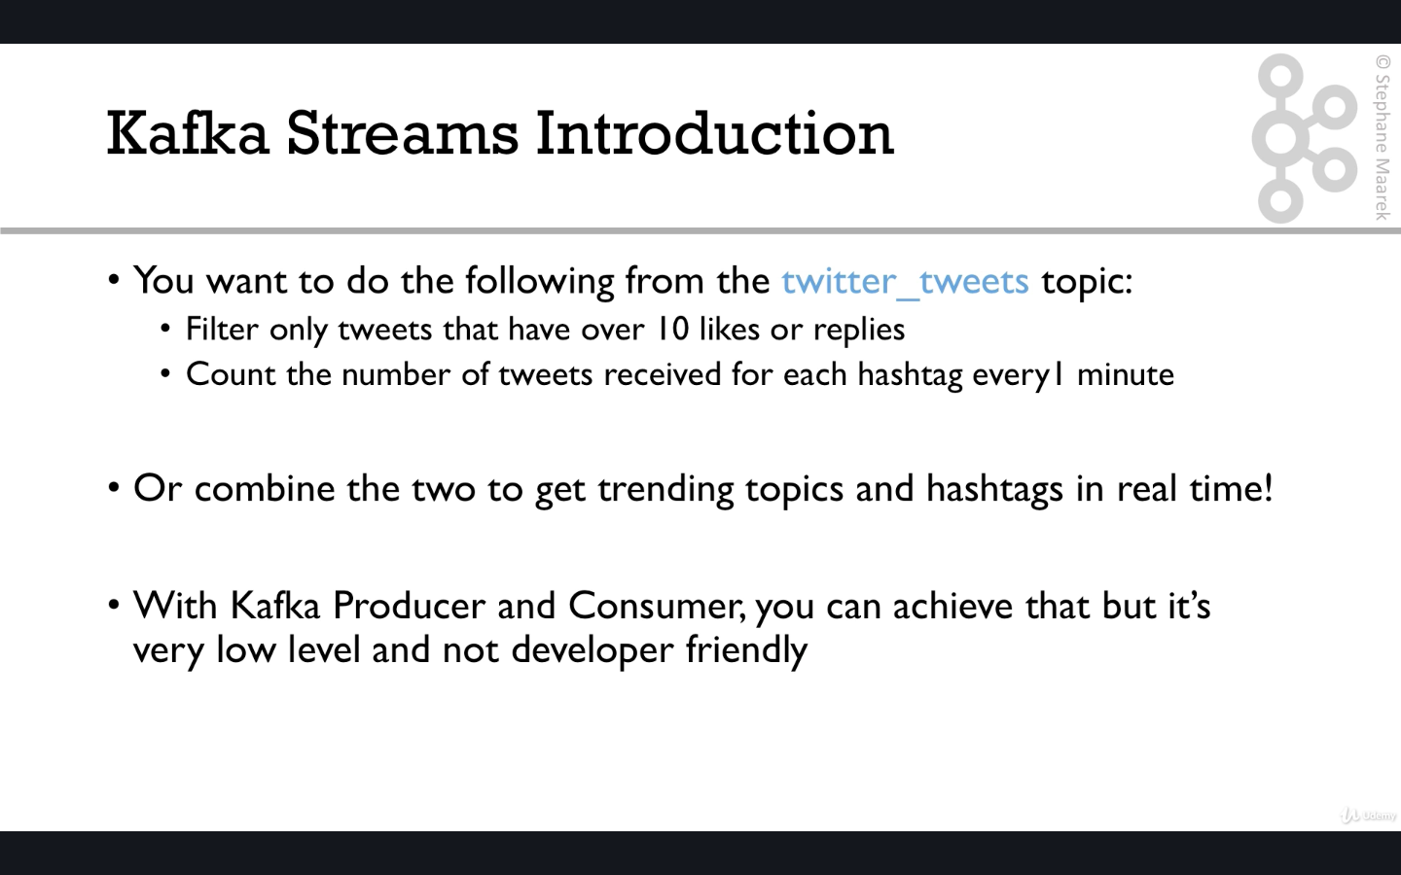

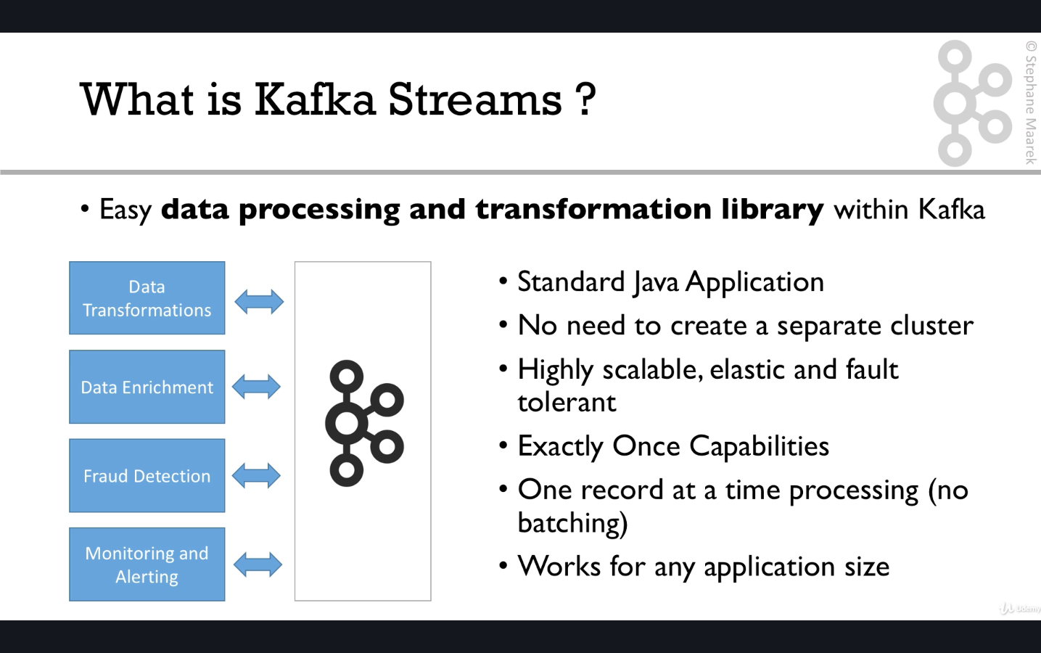

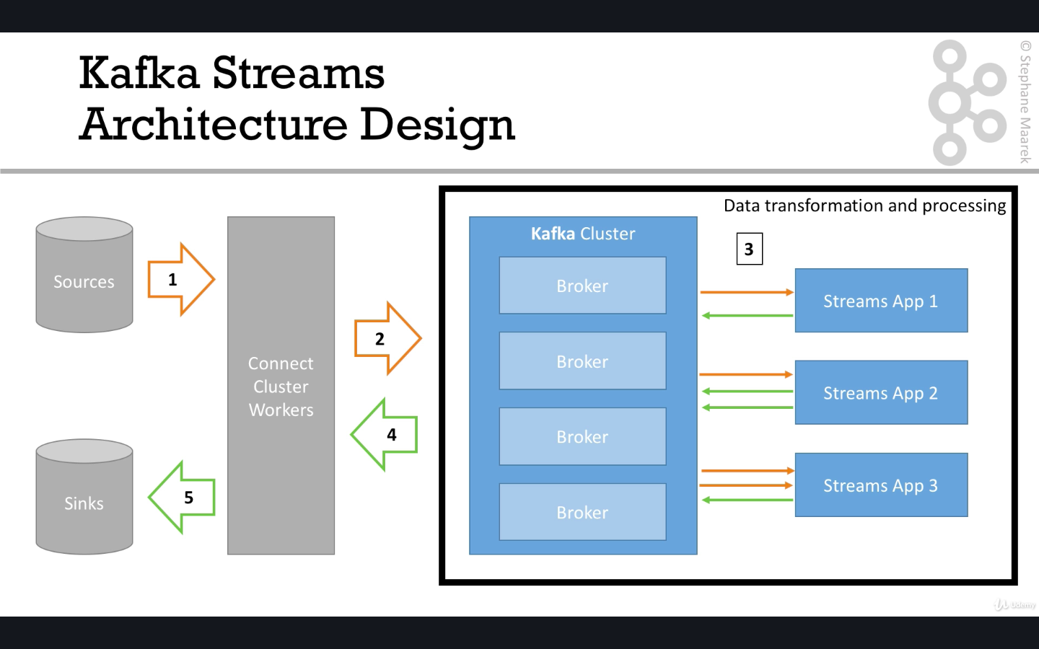

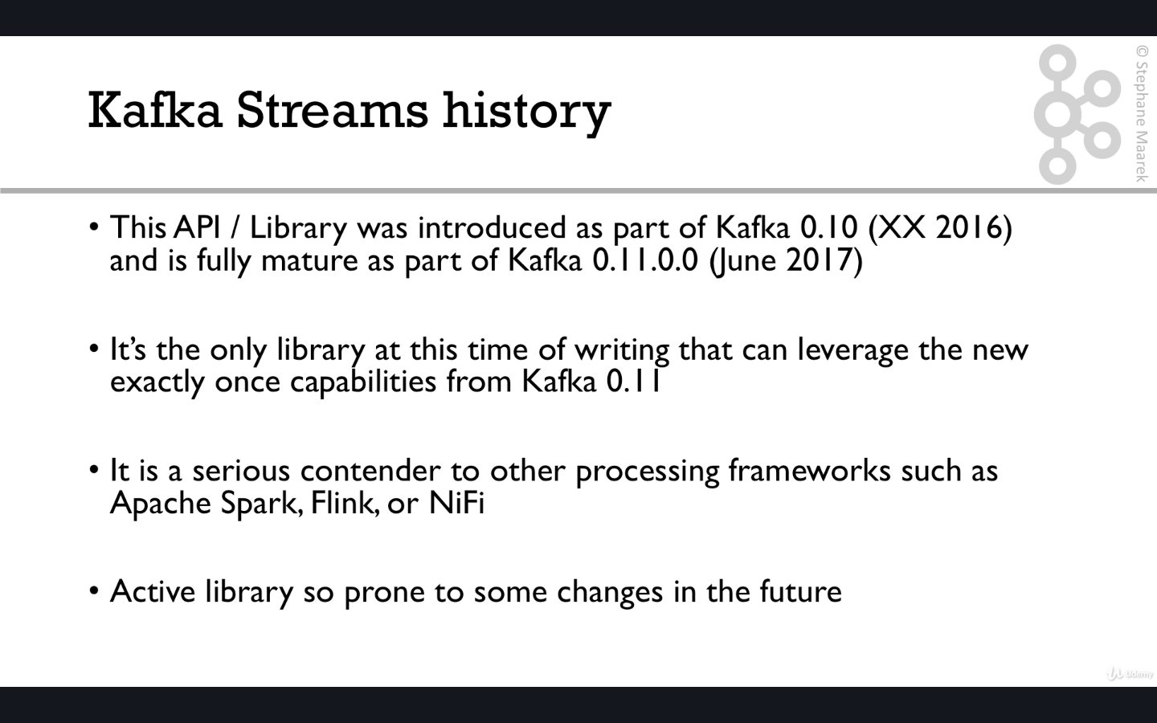

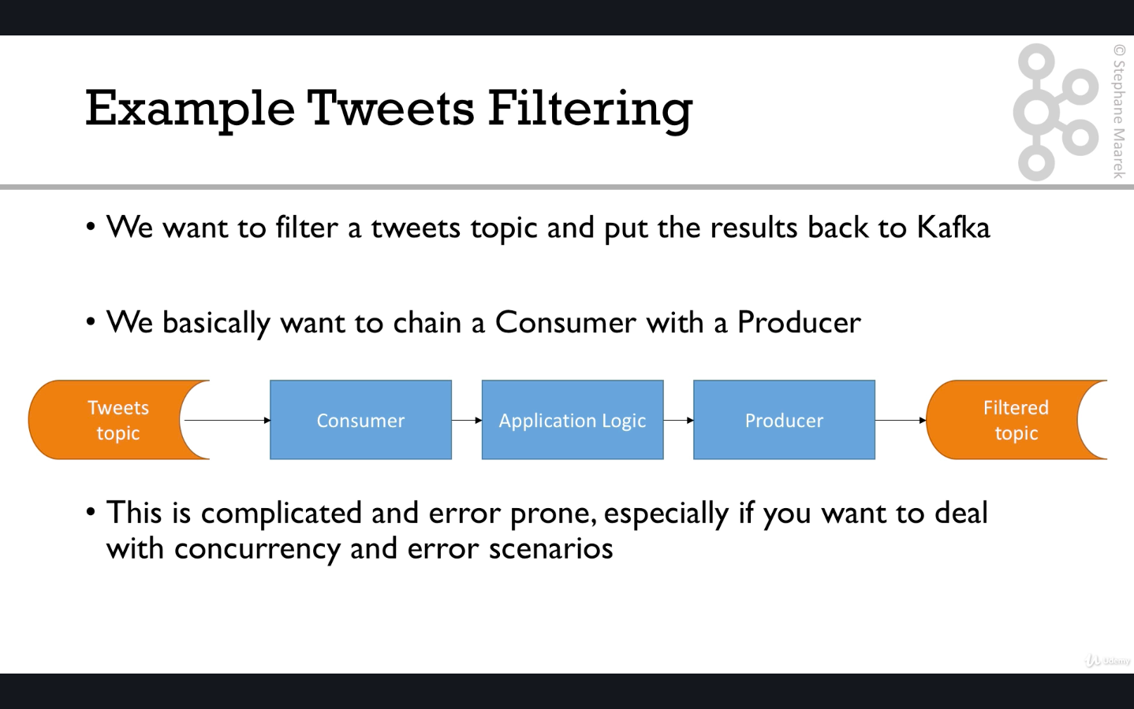

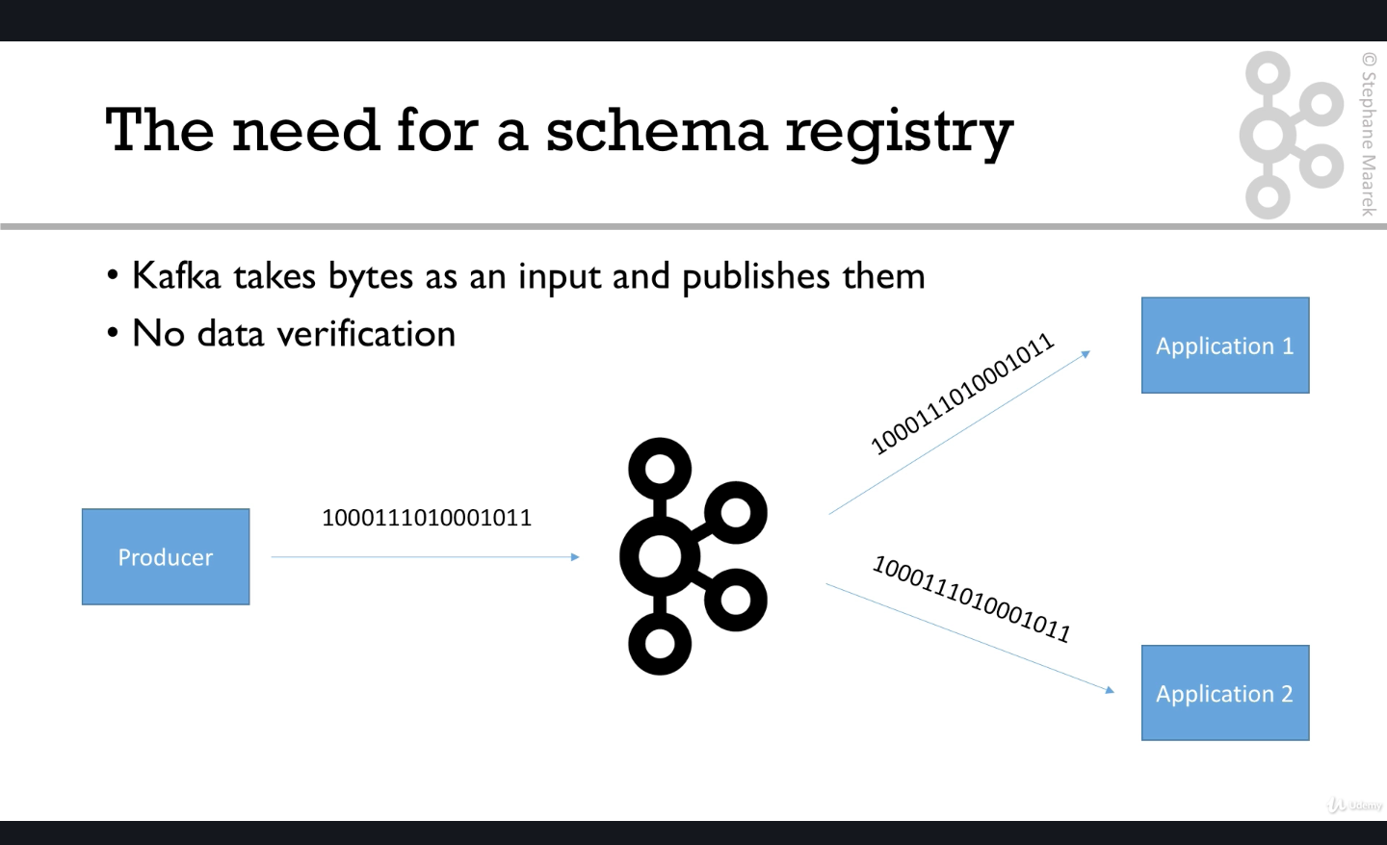

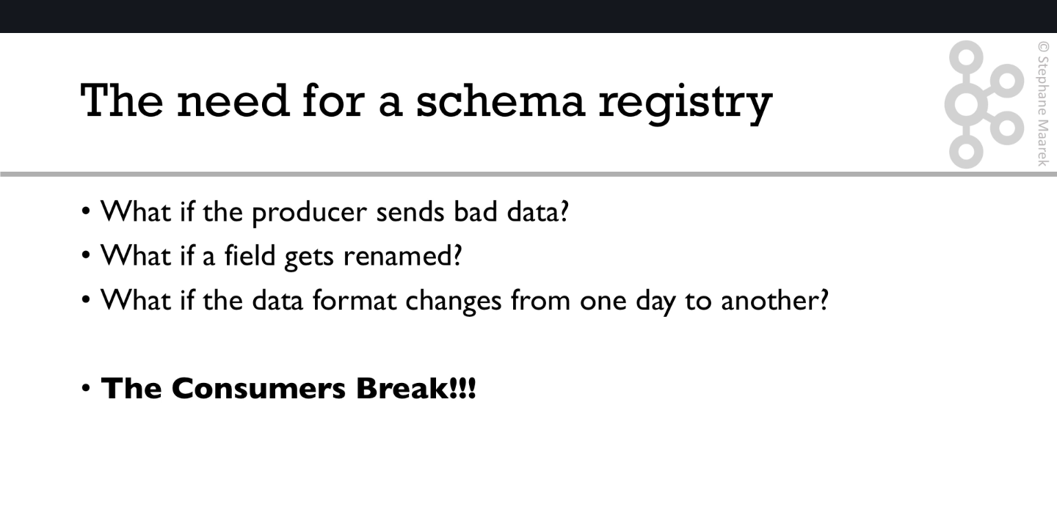

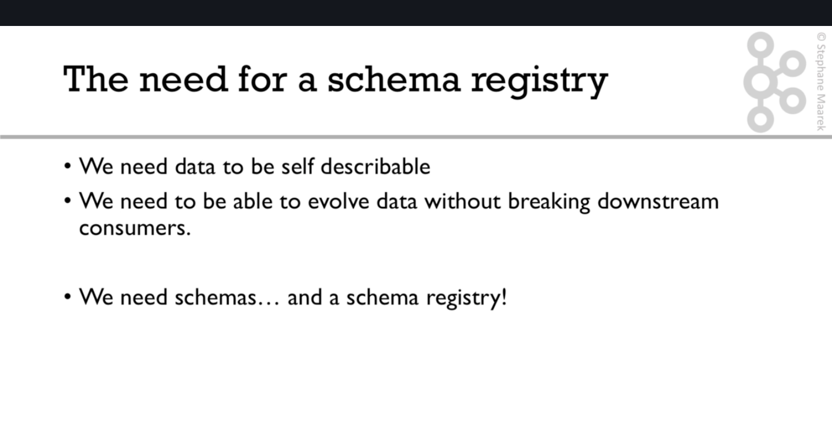

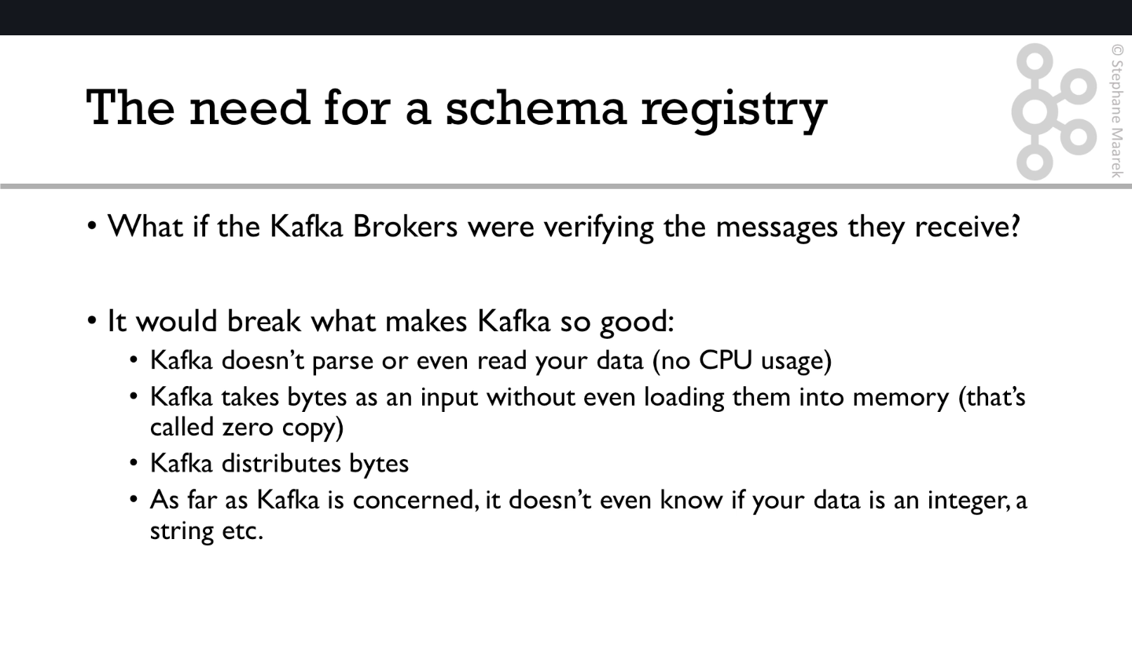

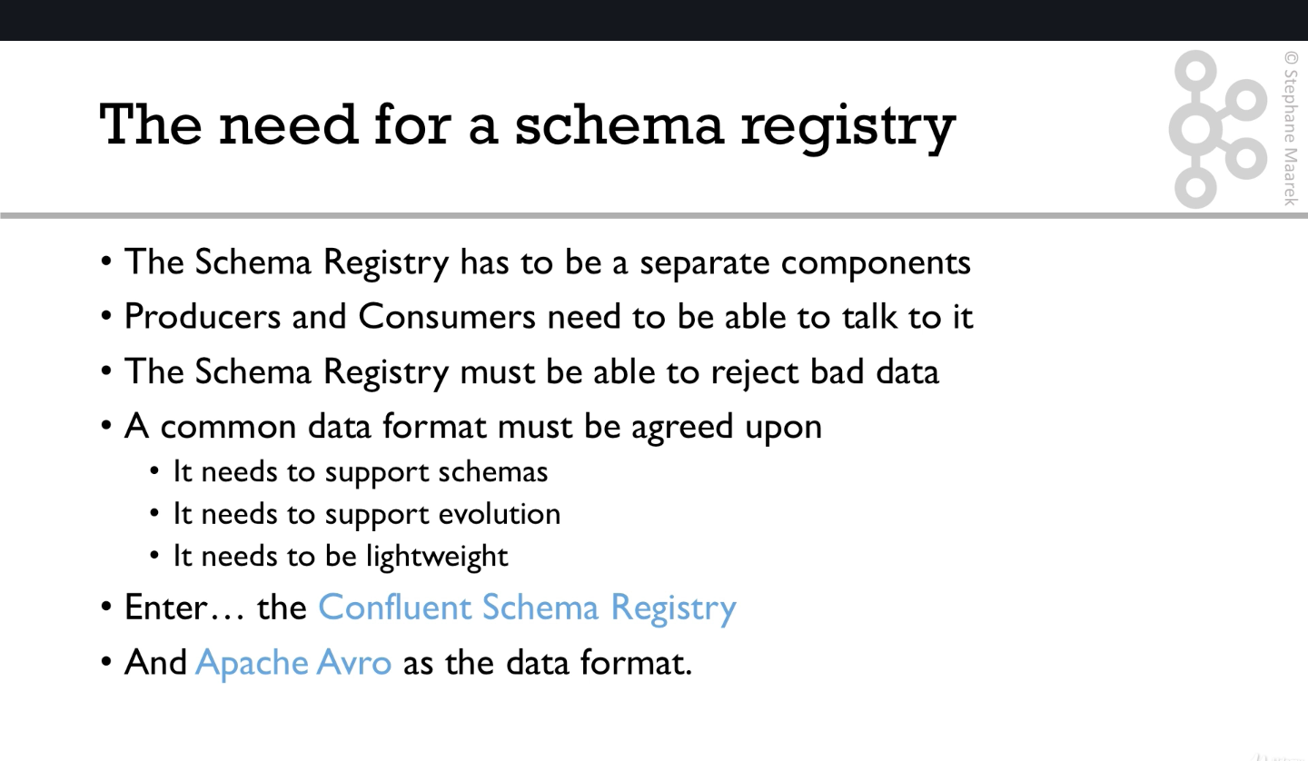

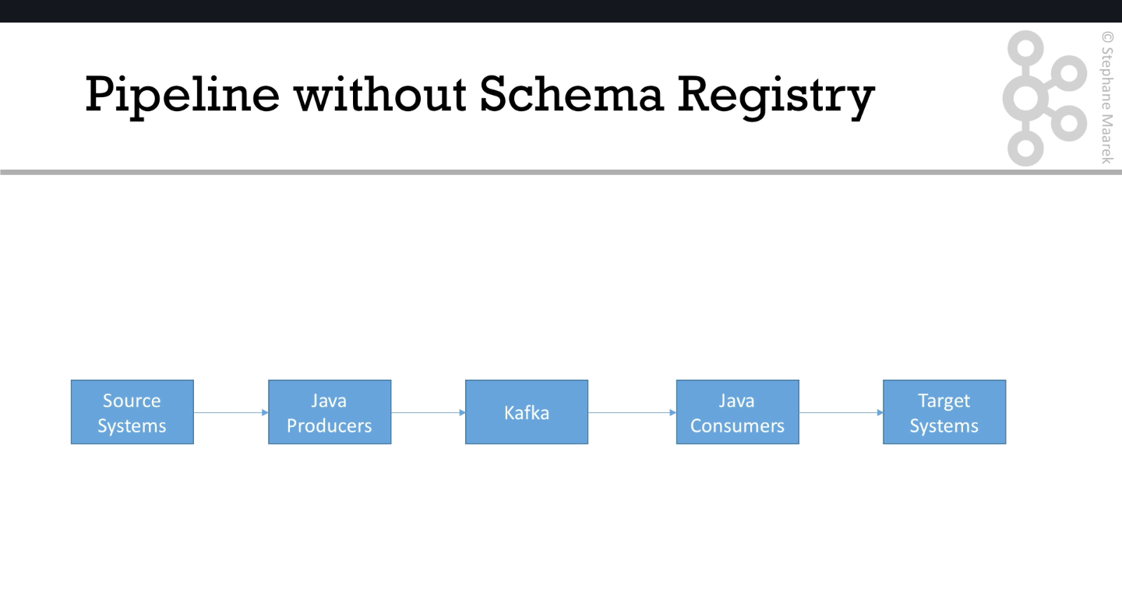

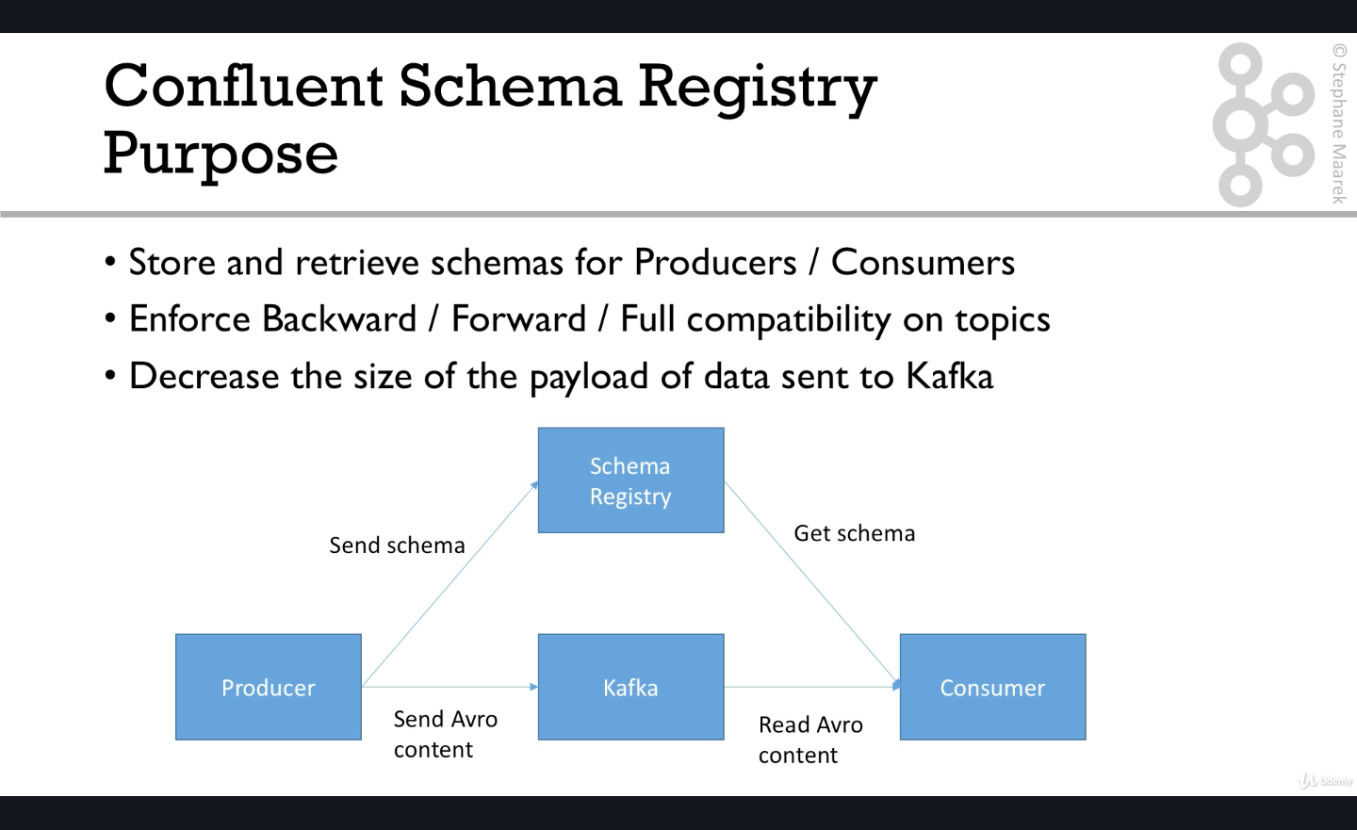

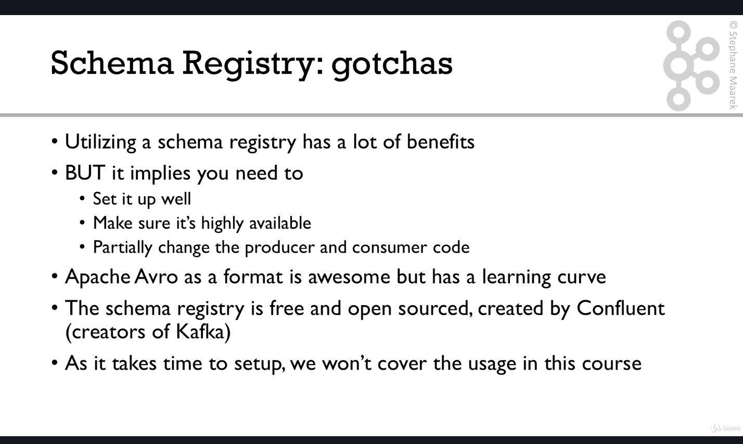

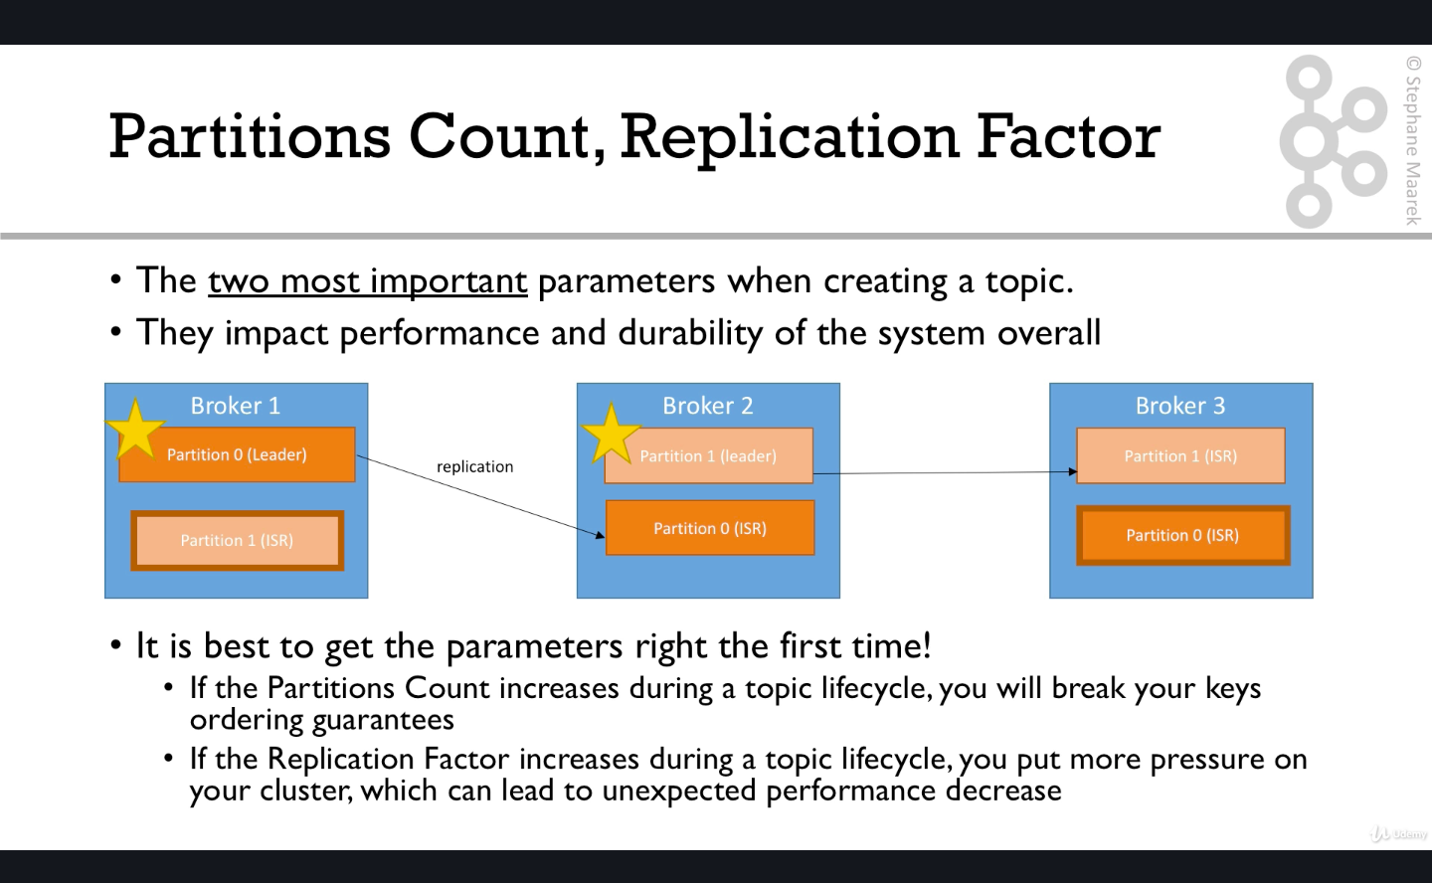

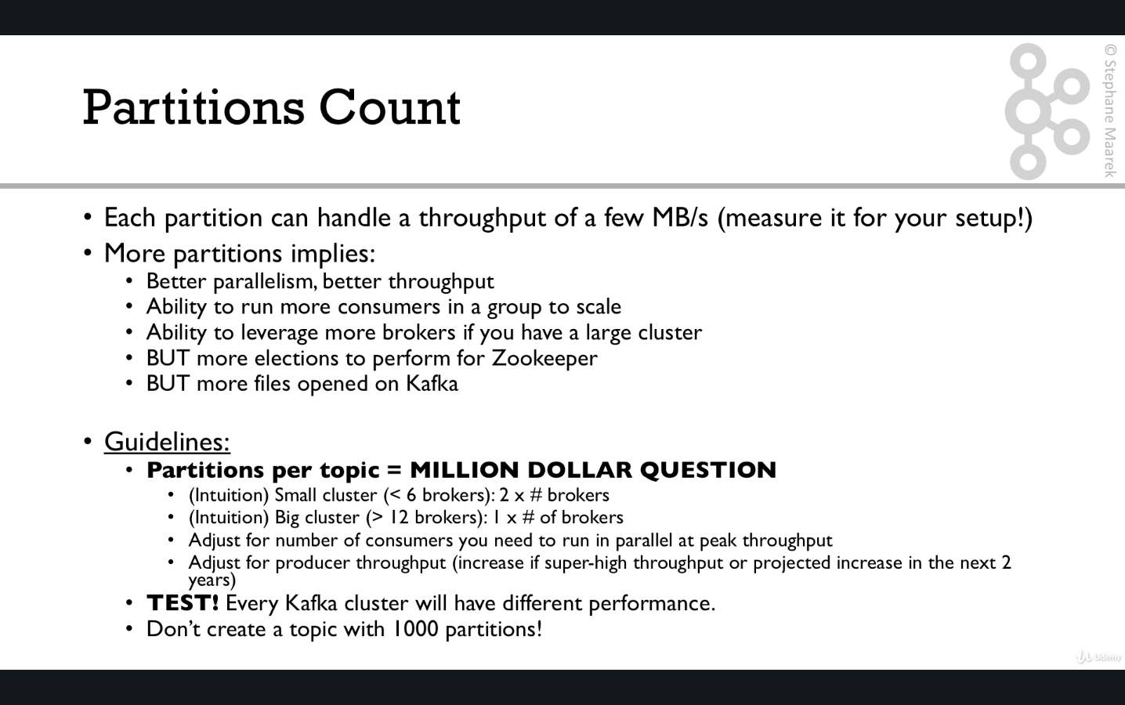

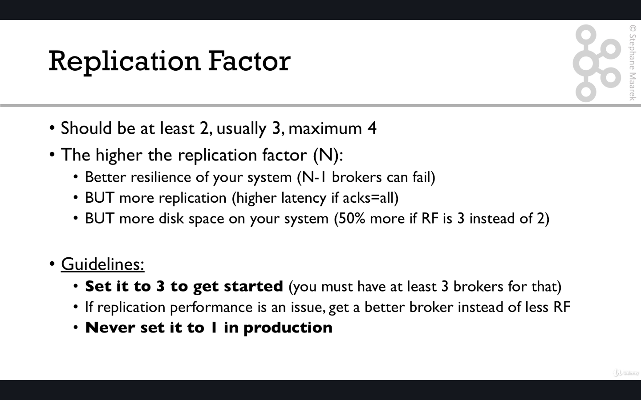

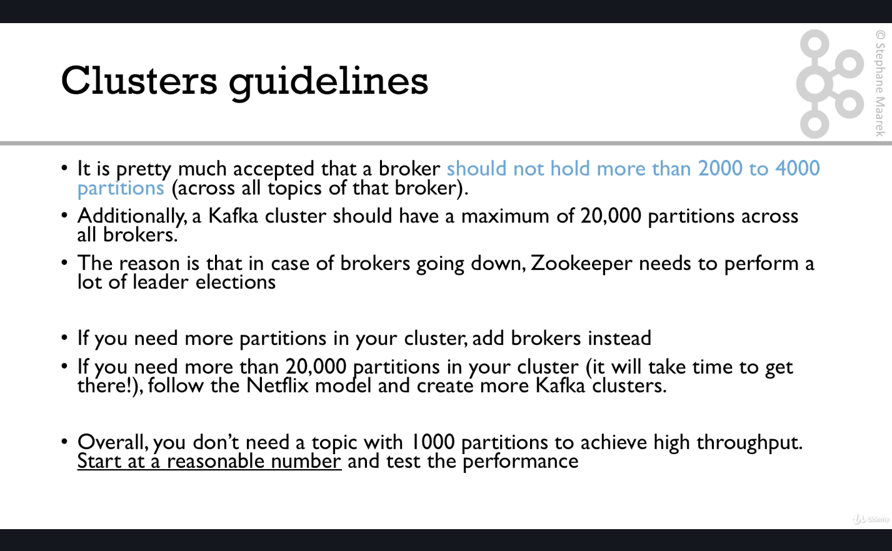

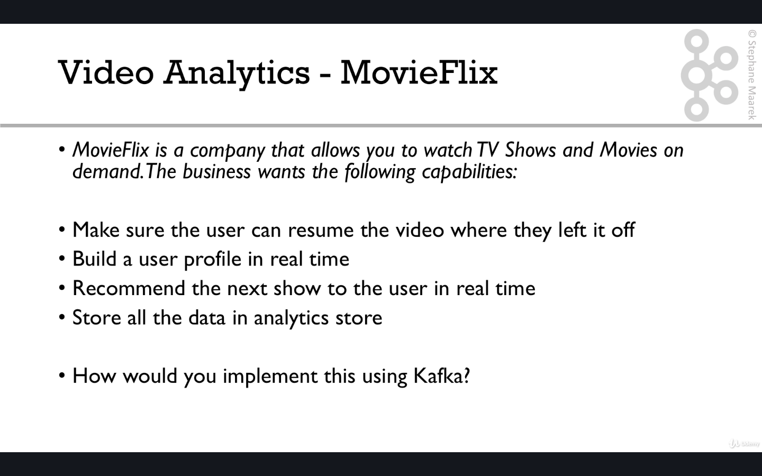

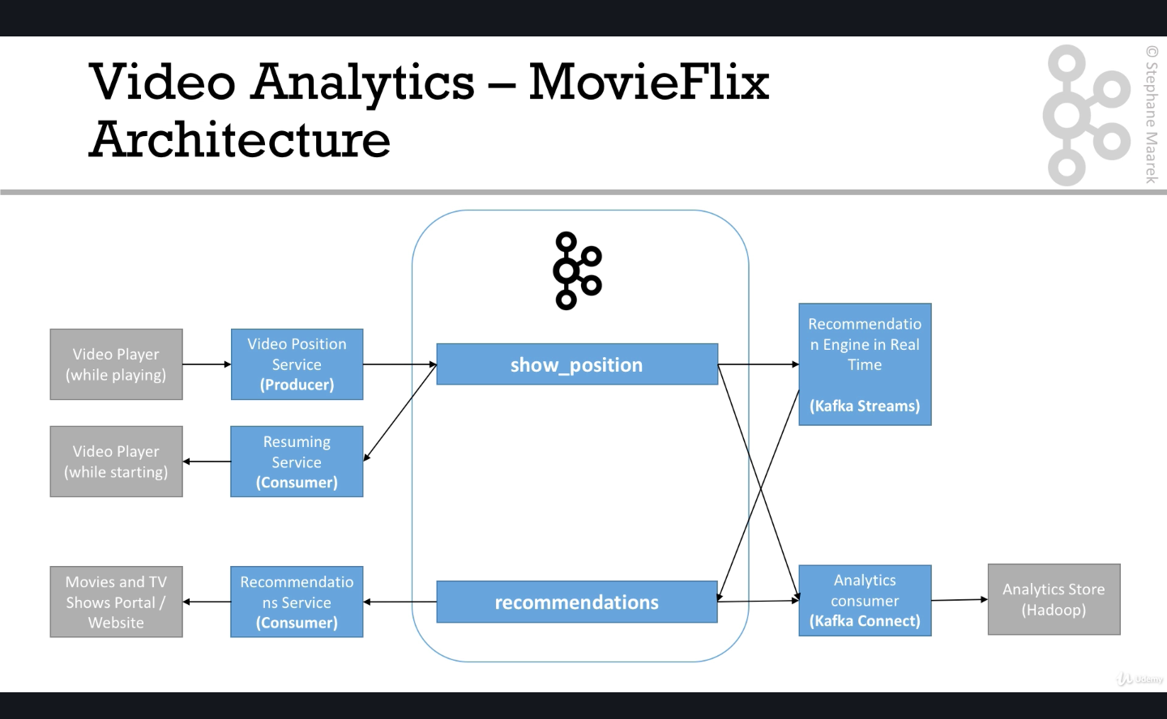

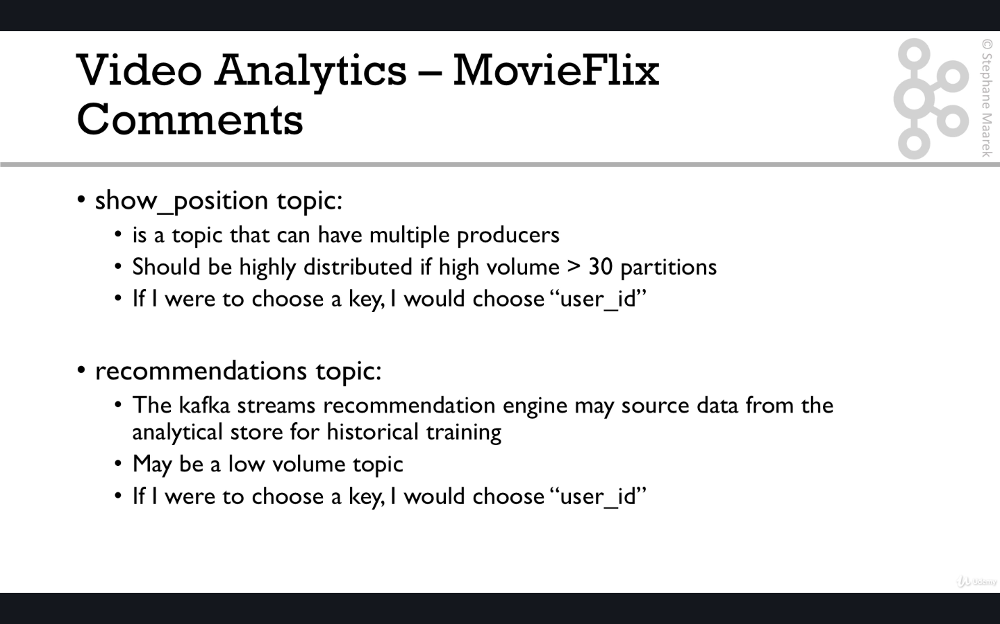

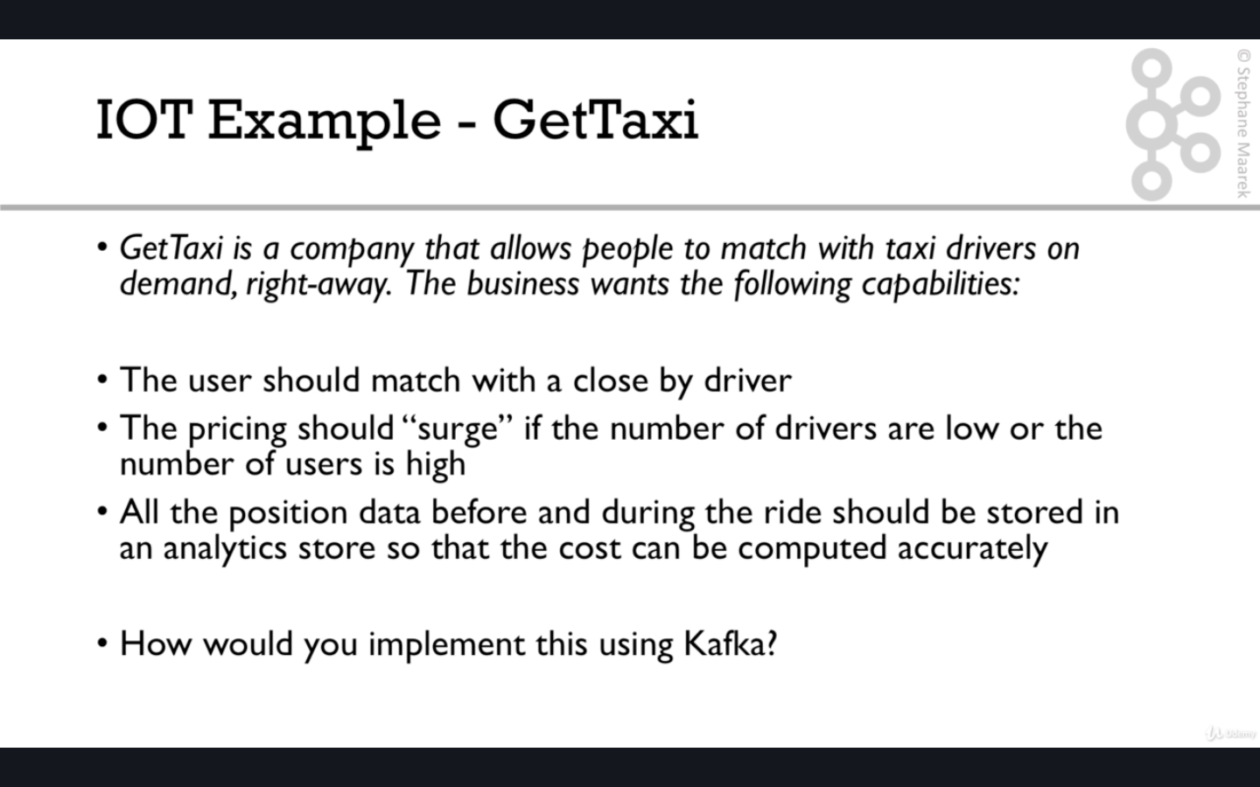

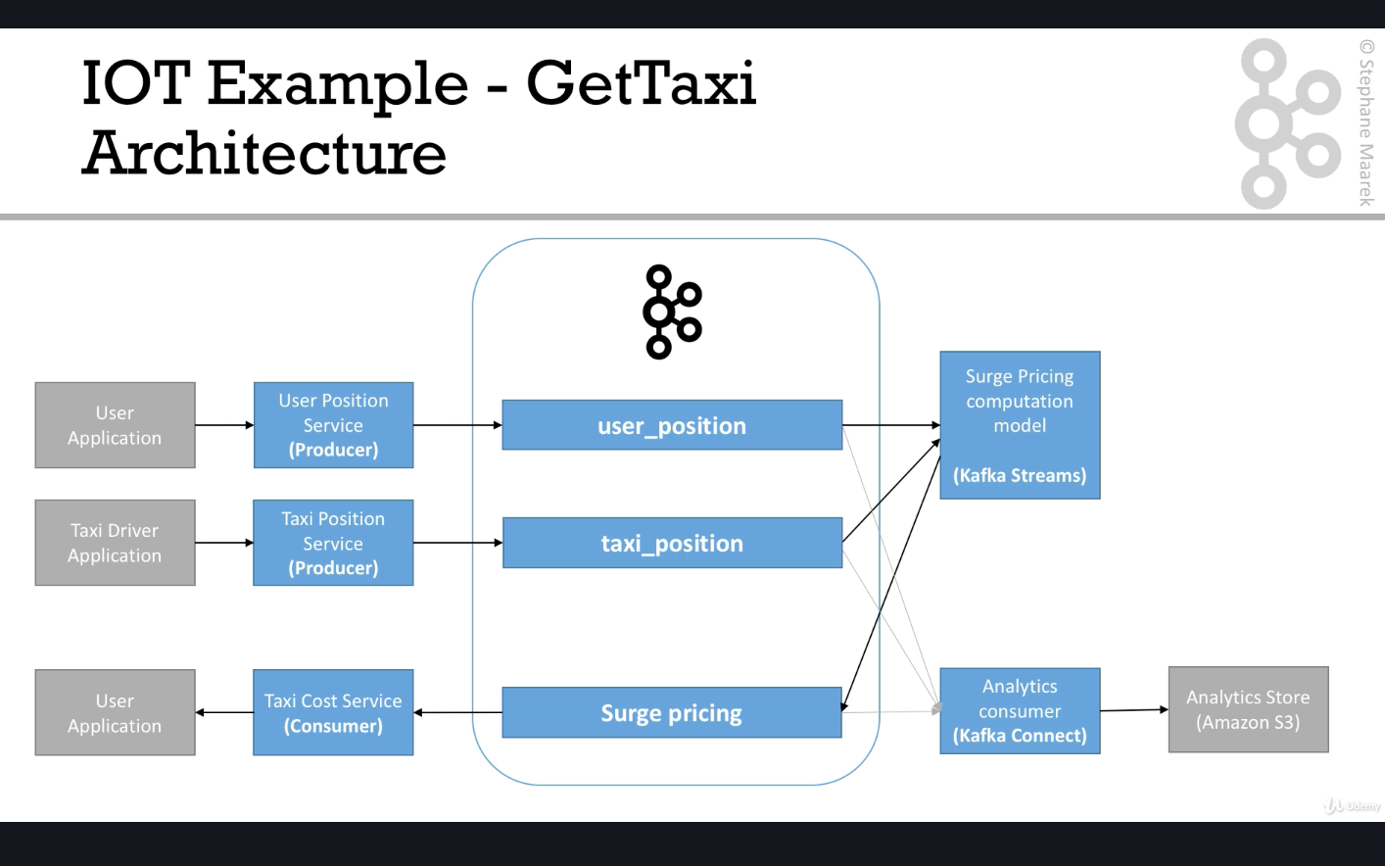

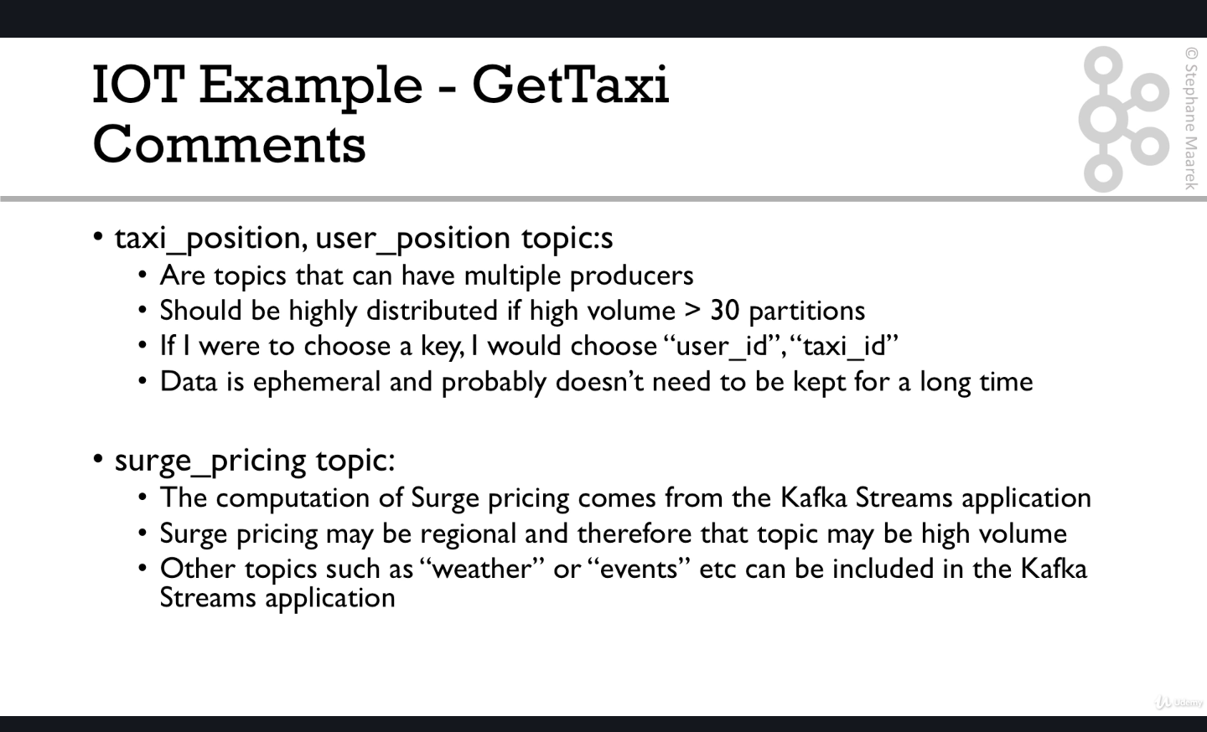

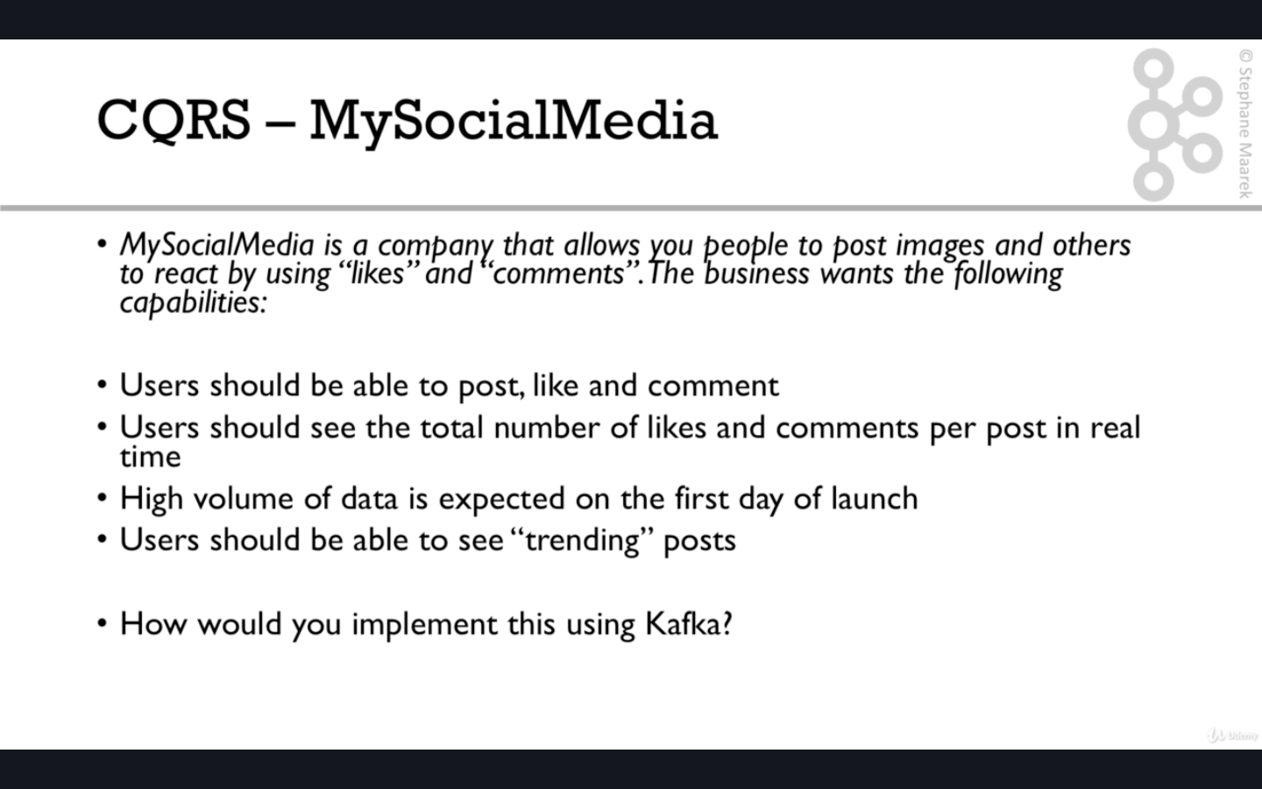

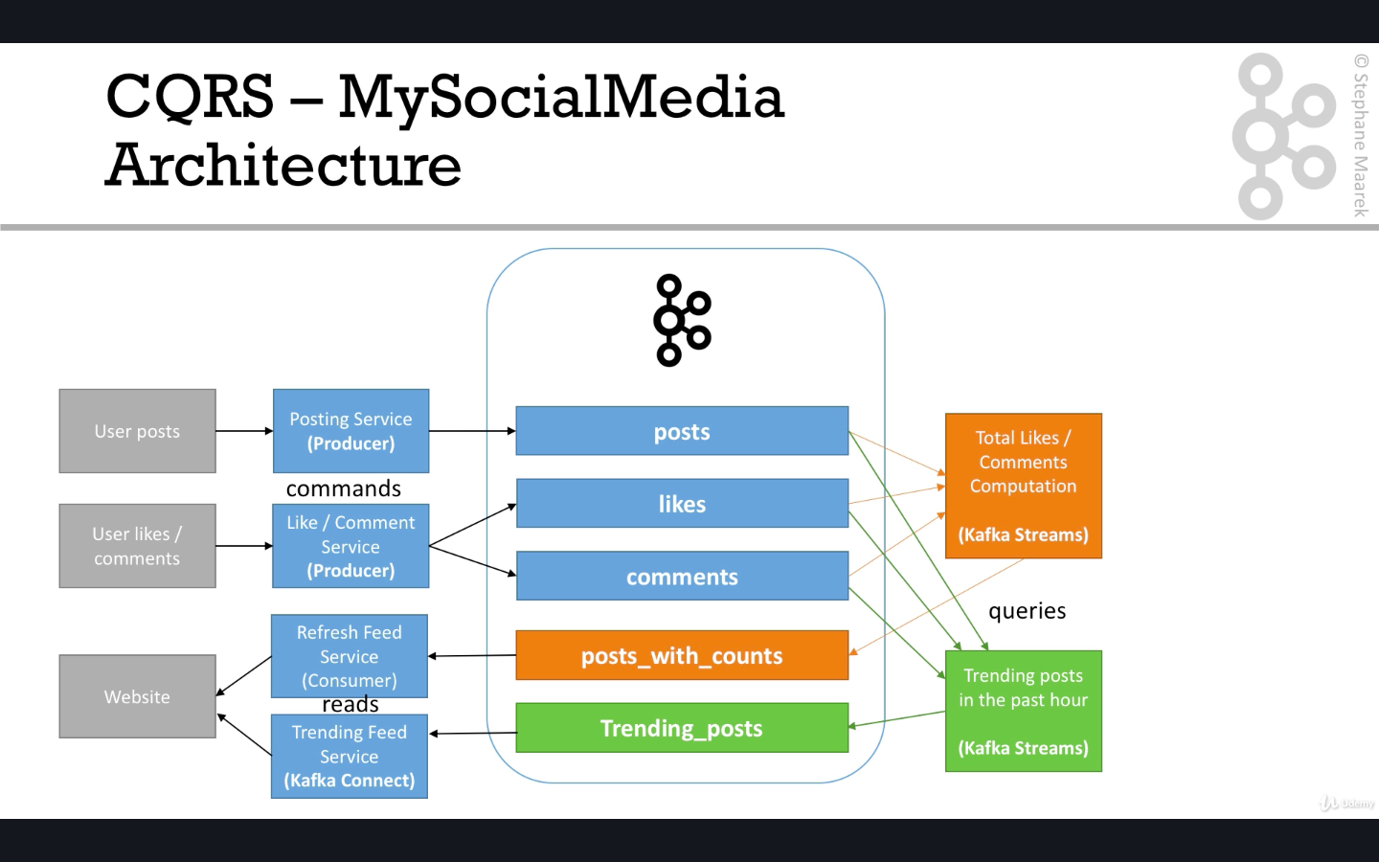

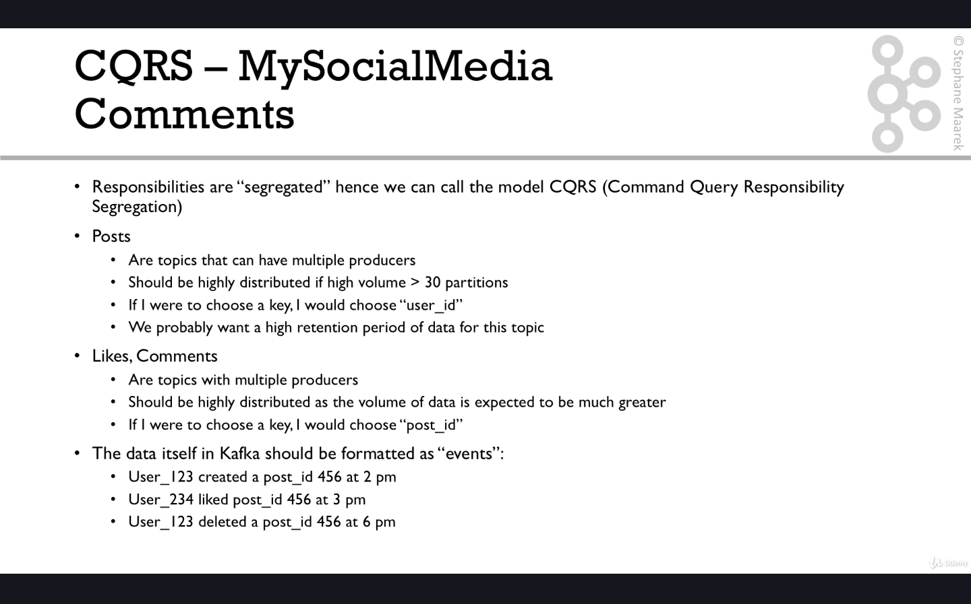

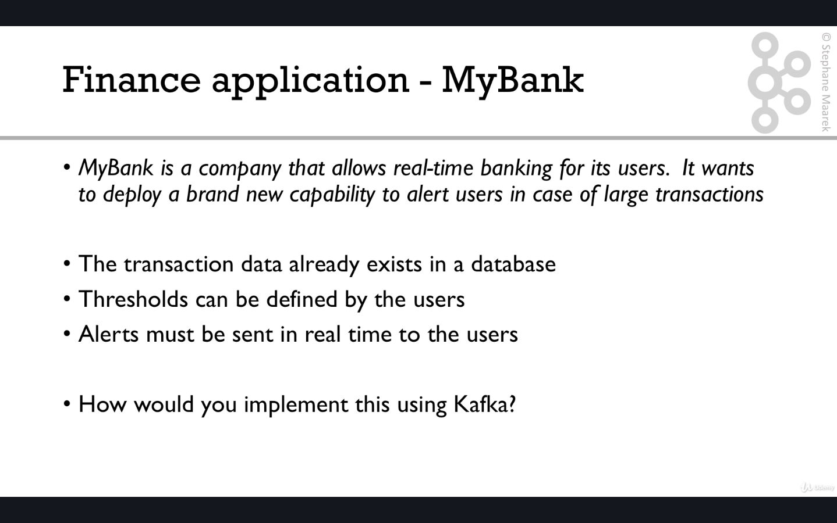

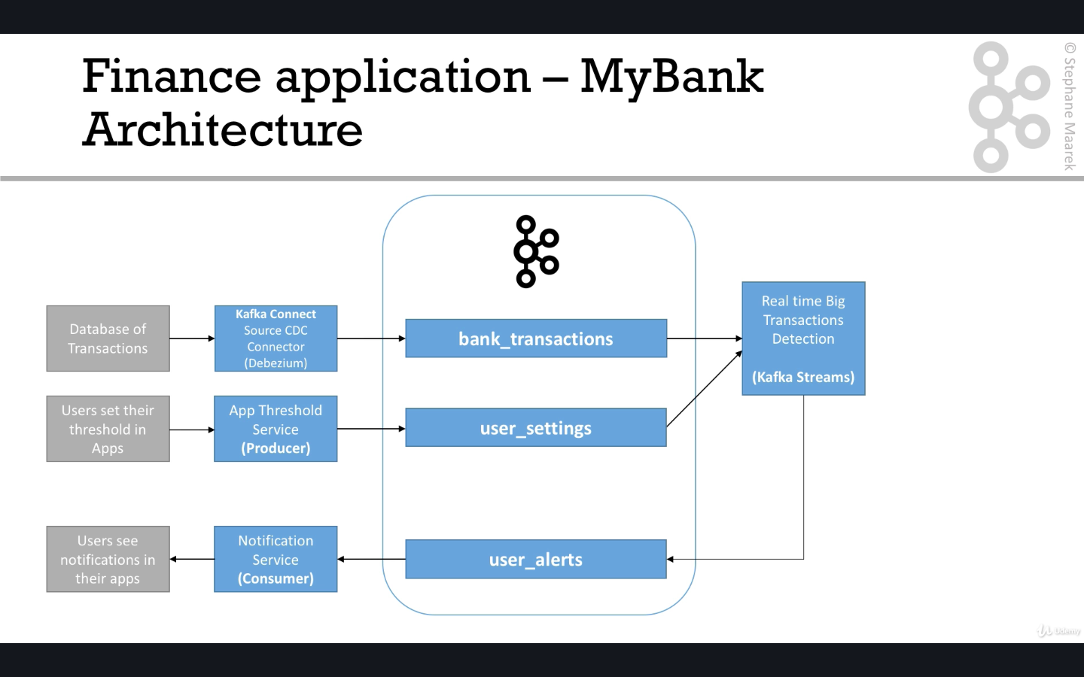

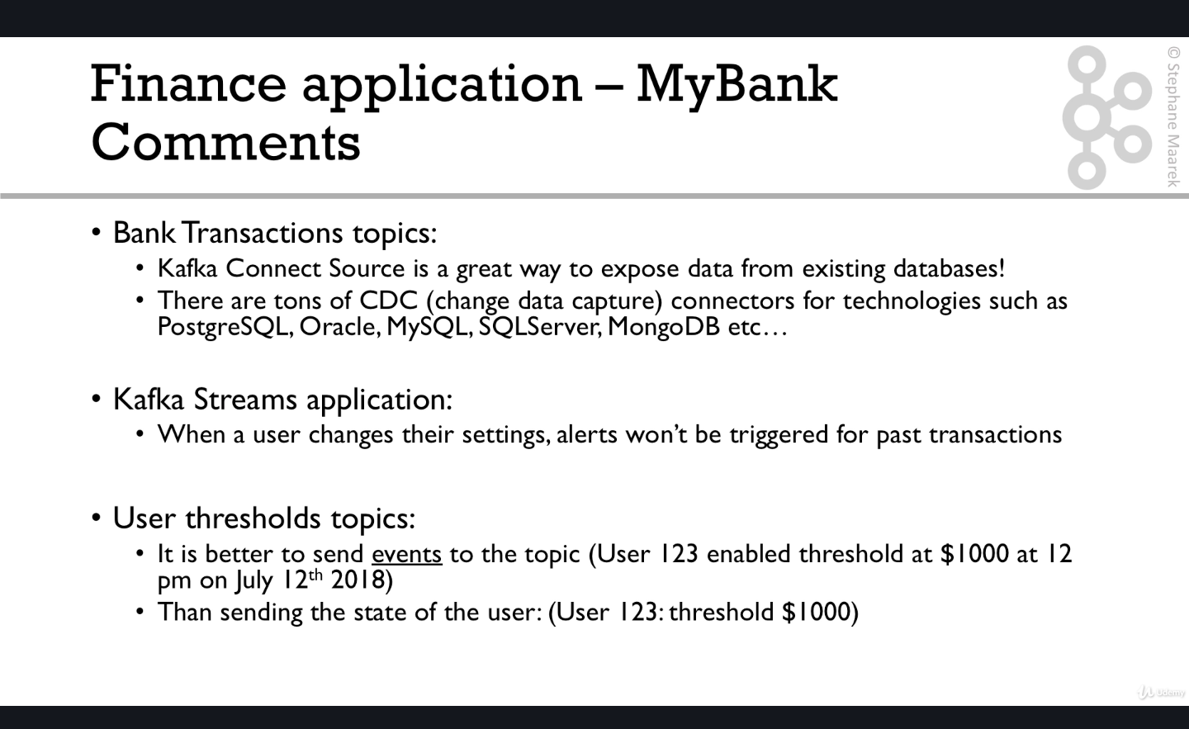

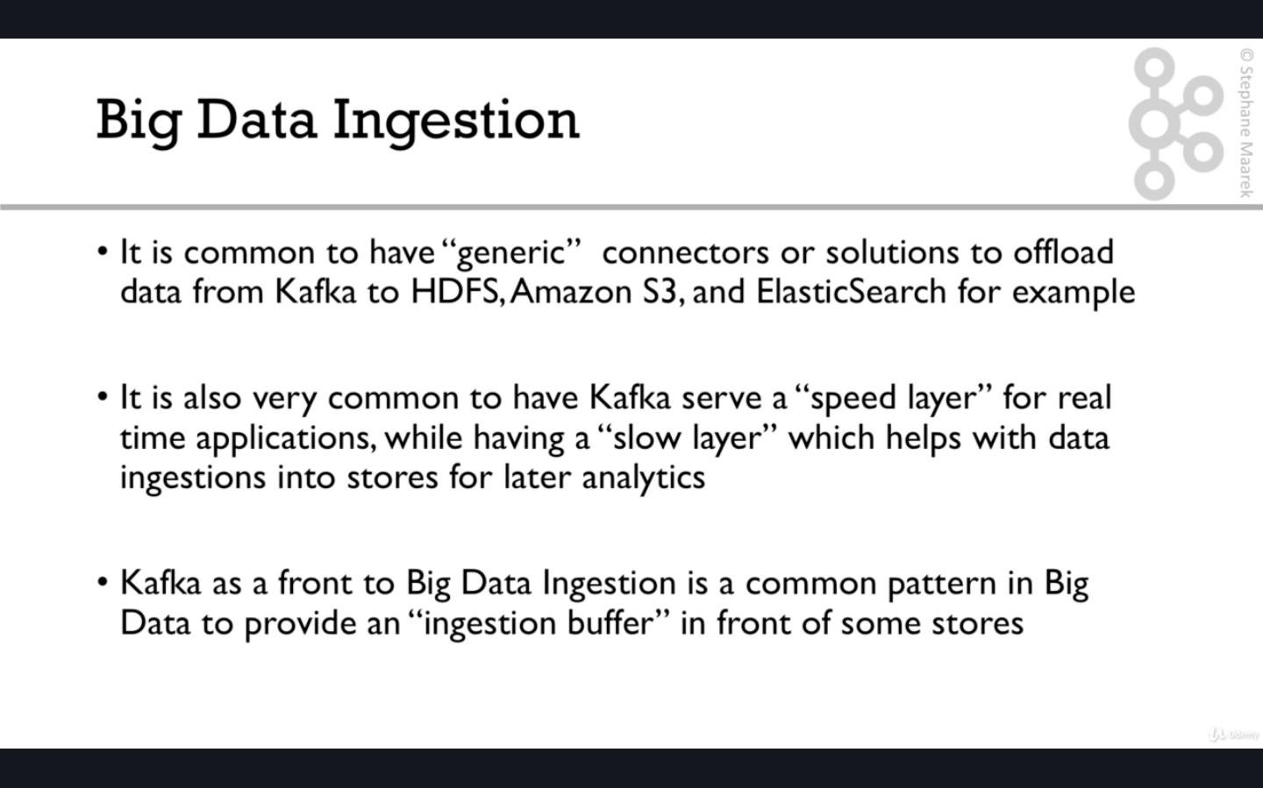

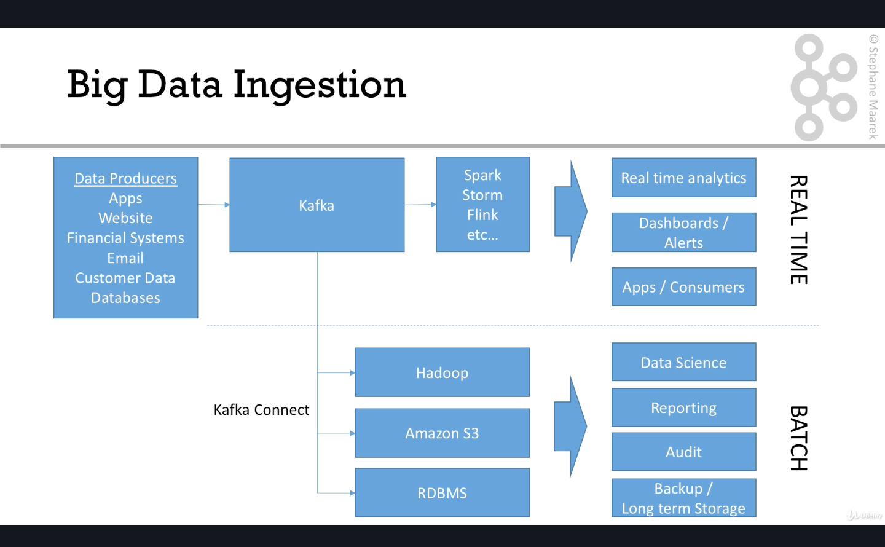

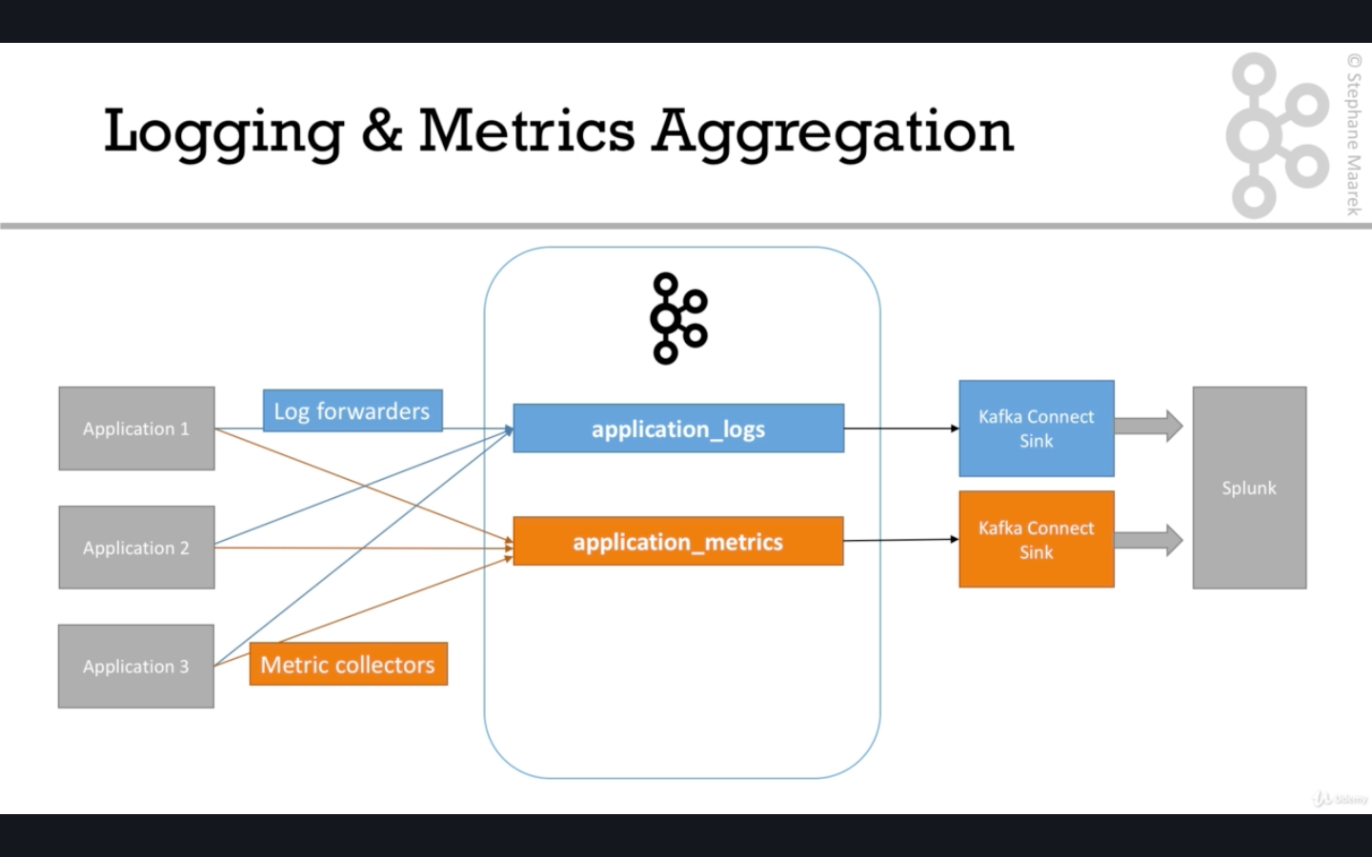

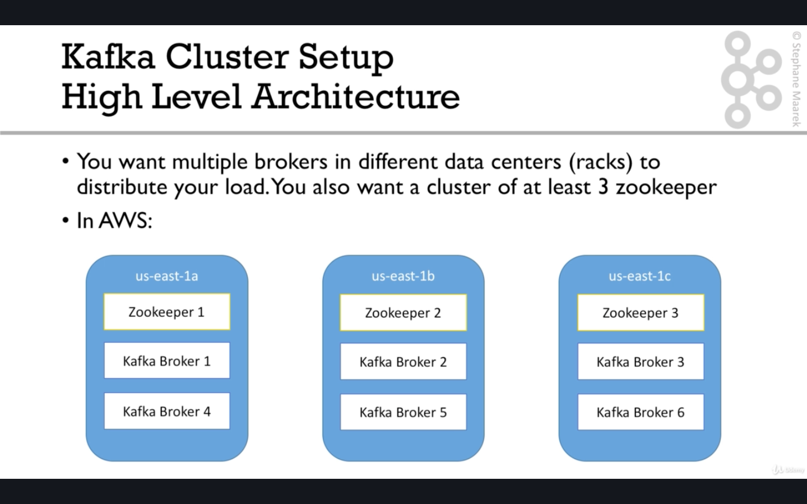

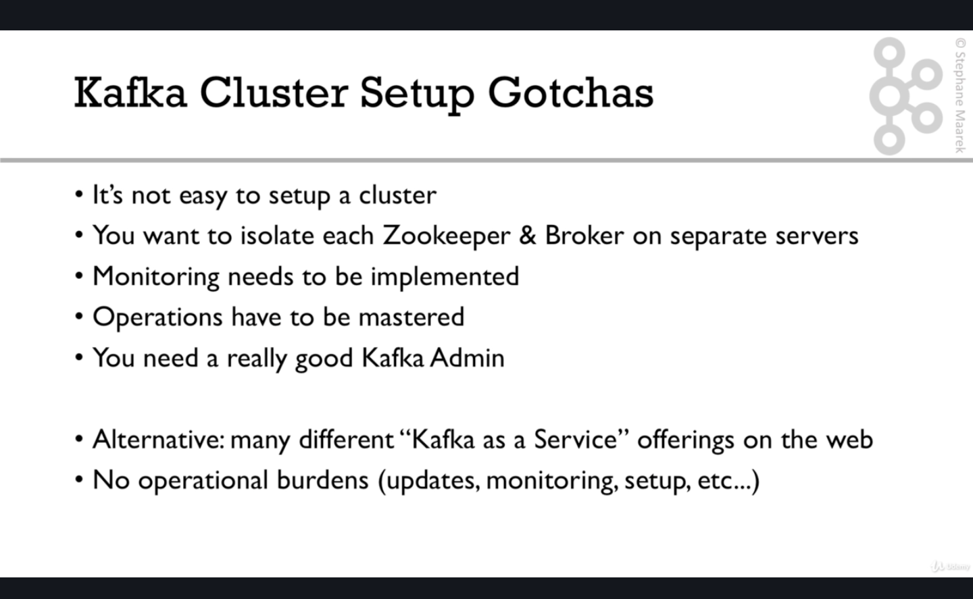

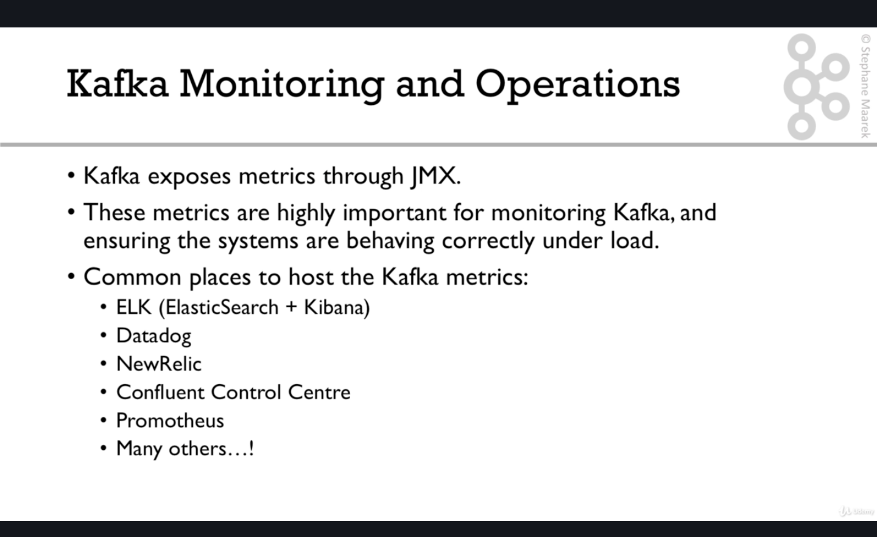

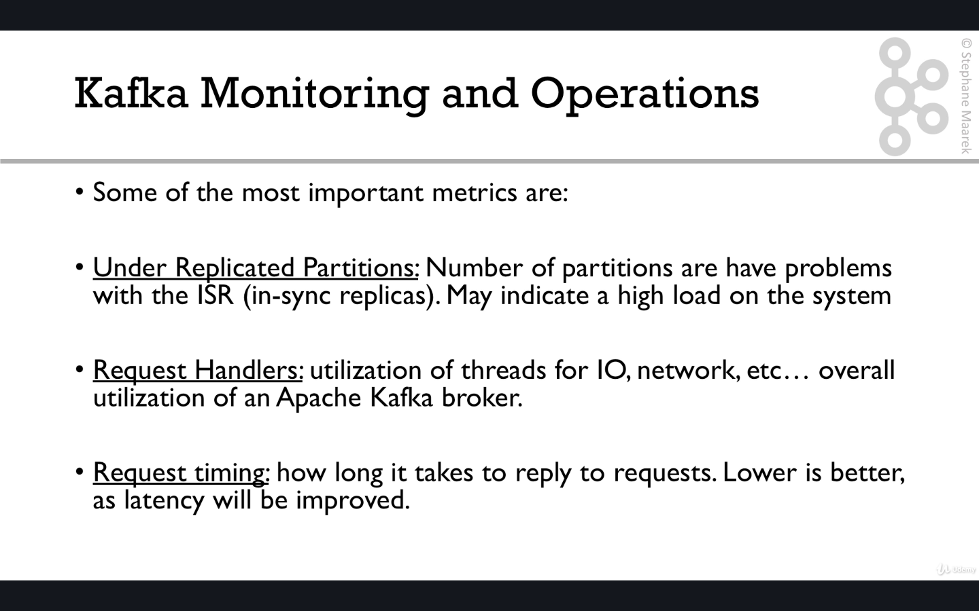

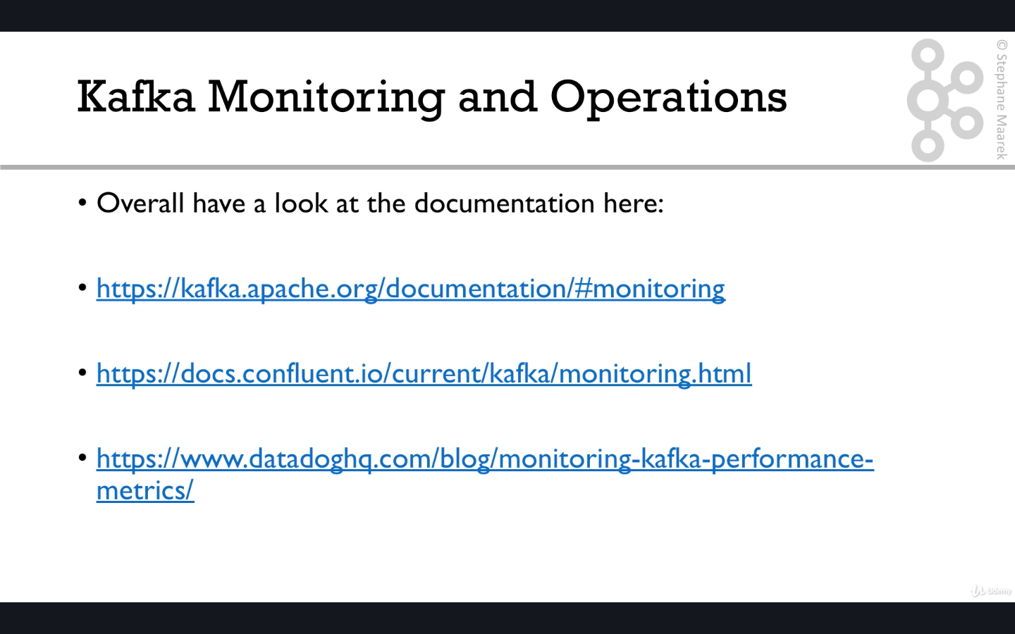

The above links are bookmarked in kafka->kafka monitoring

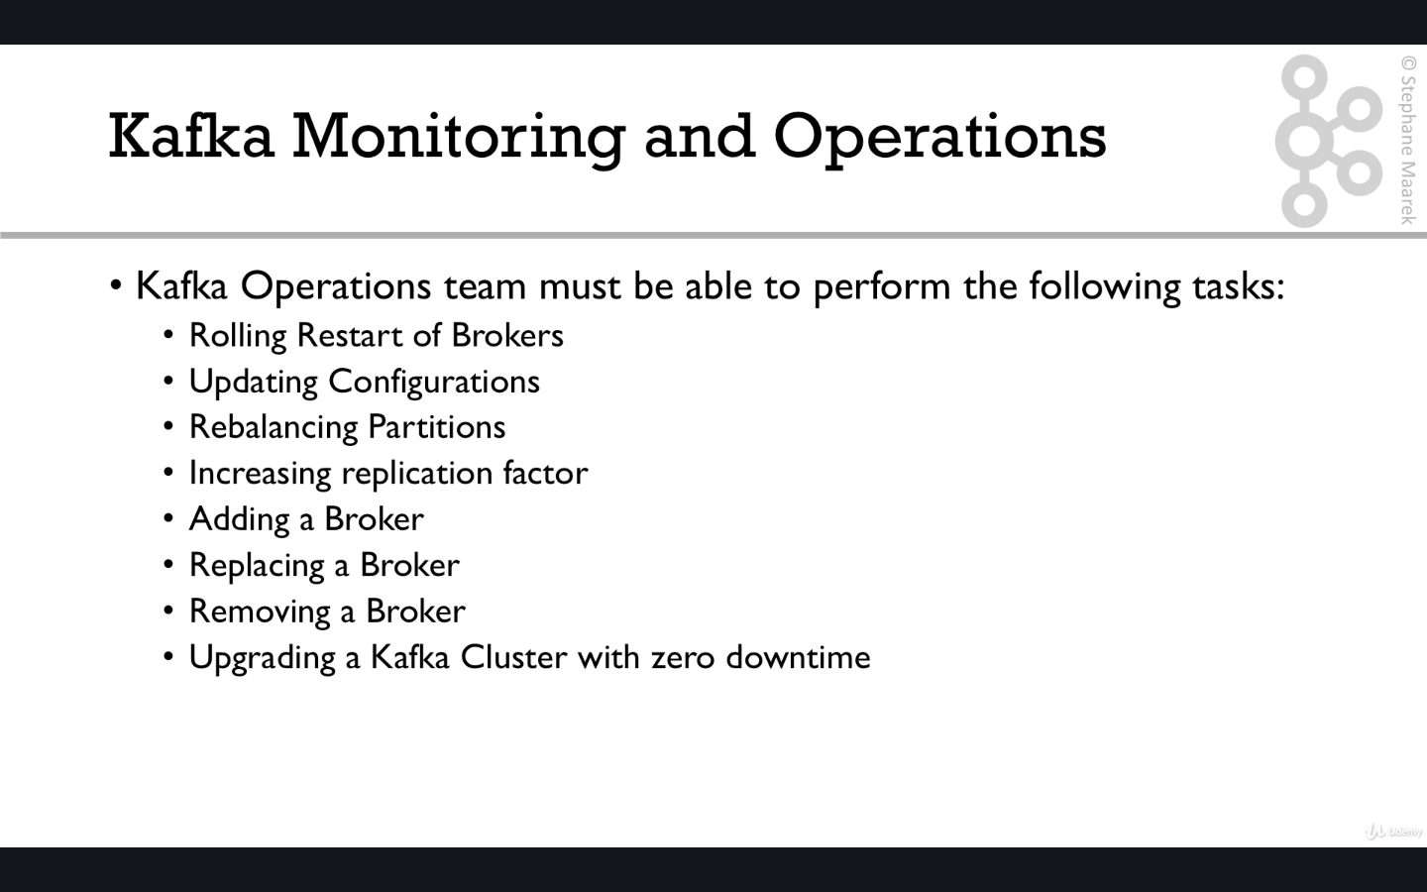

KAFKA SECURITY

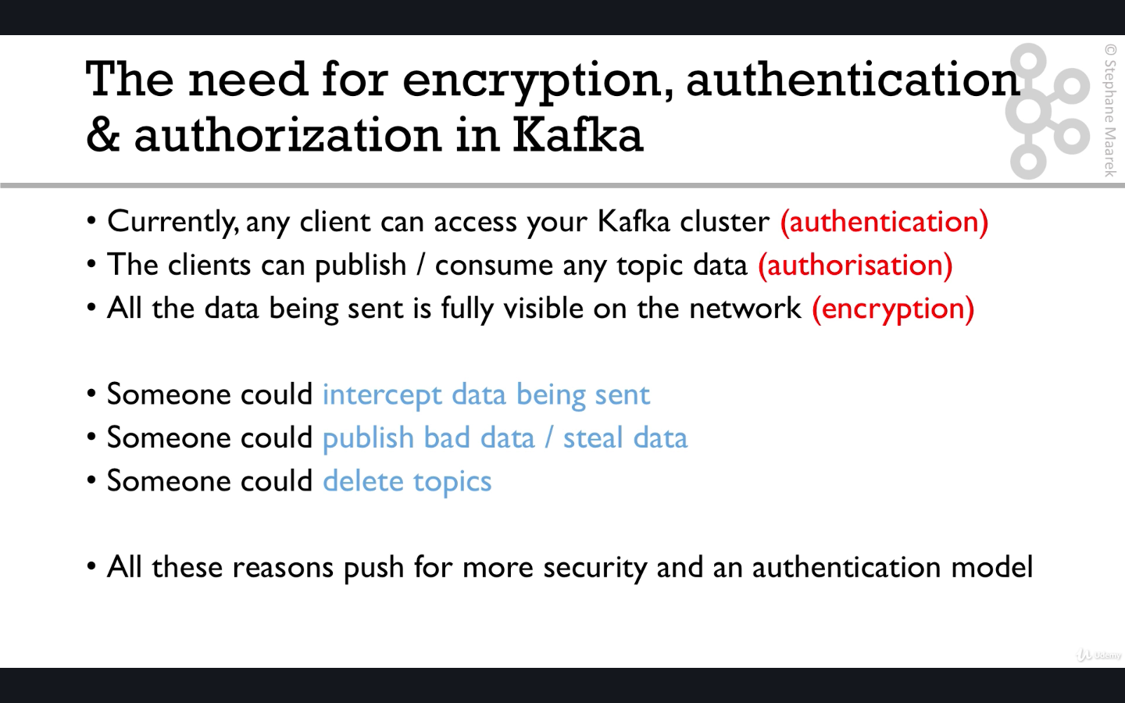

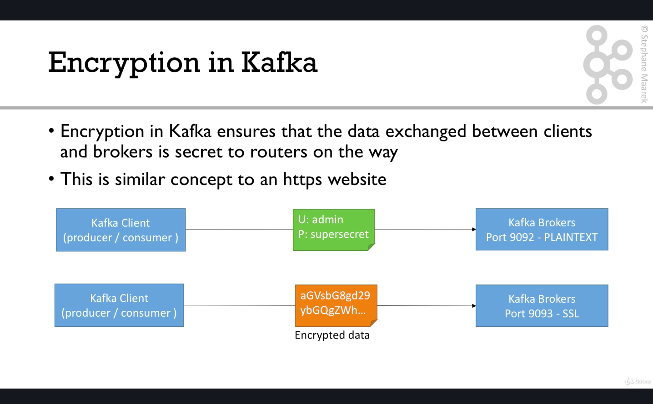

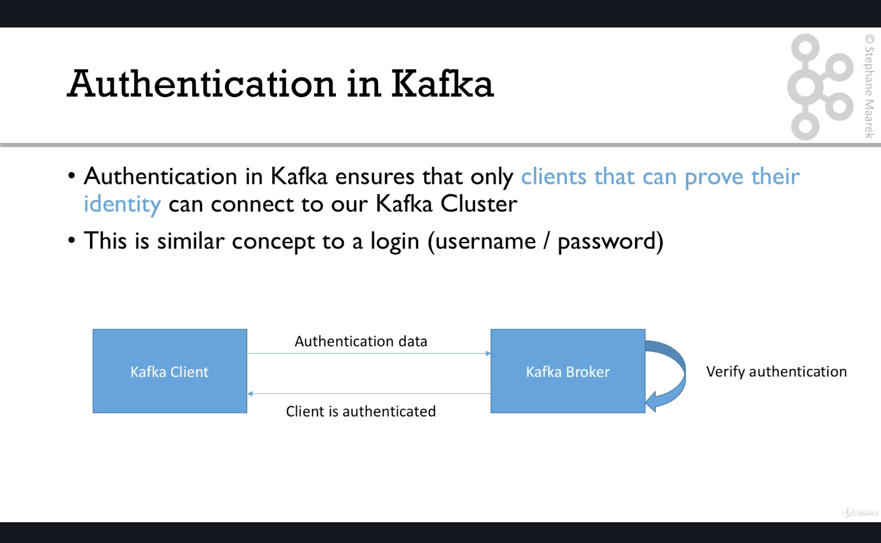

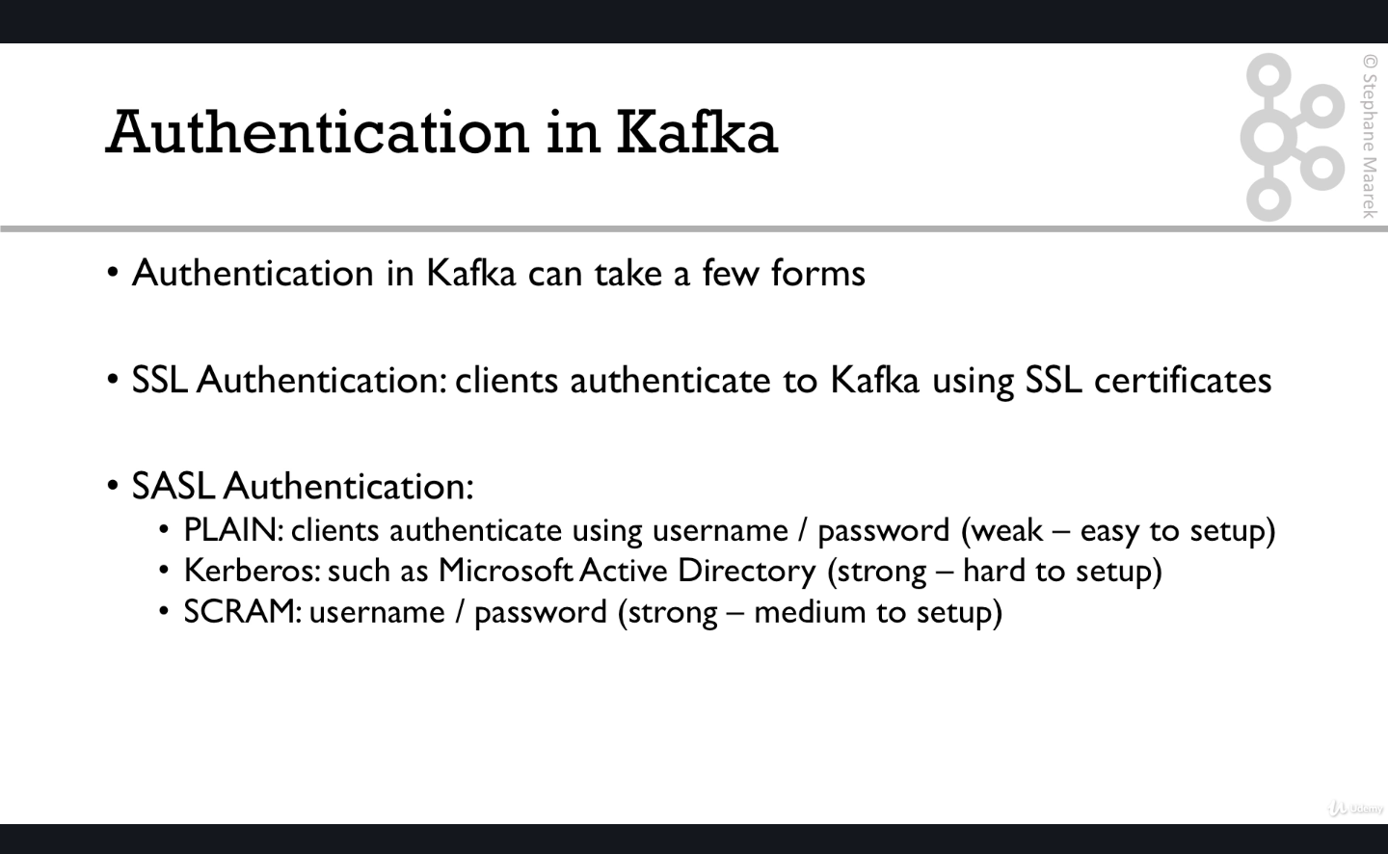

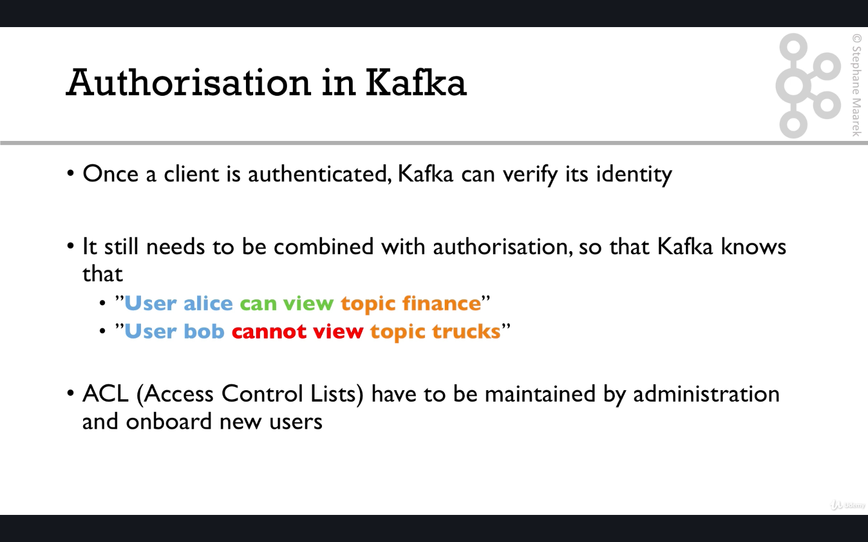

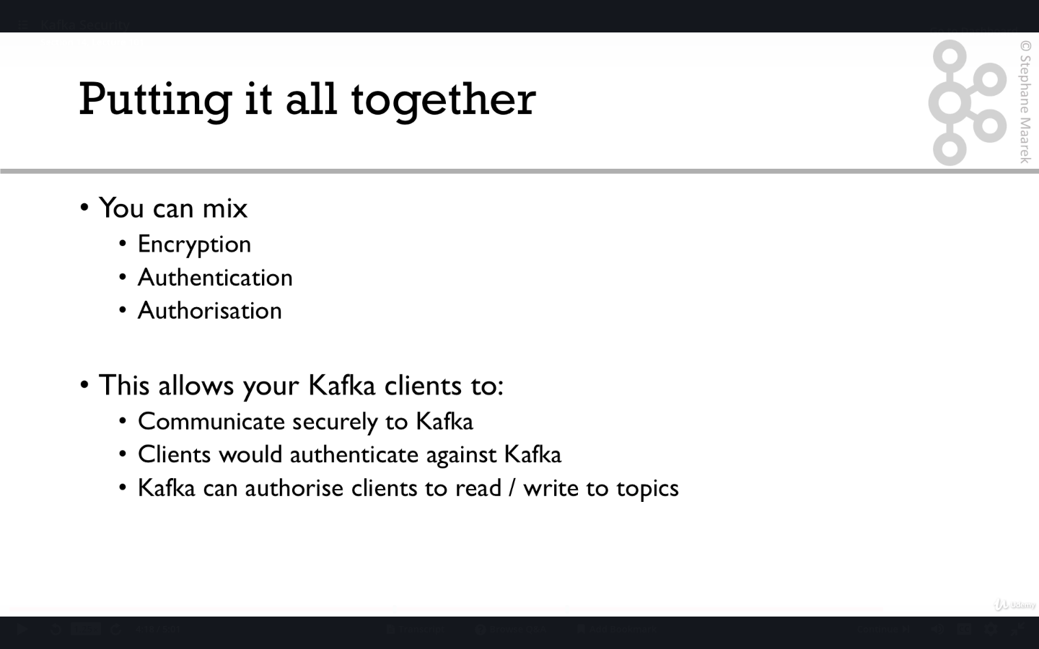

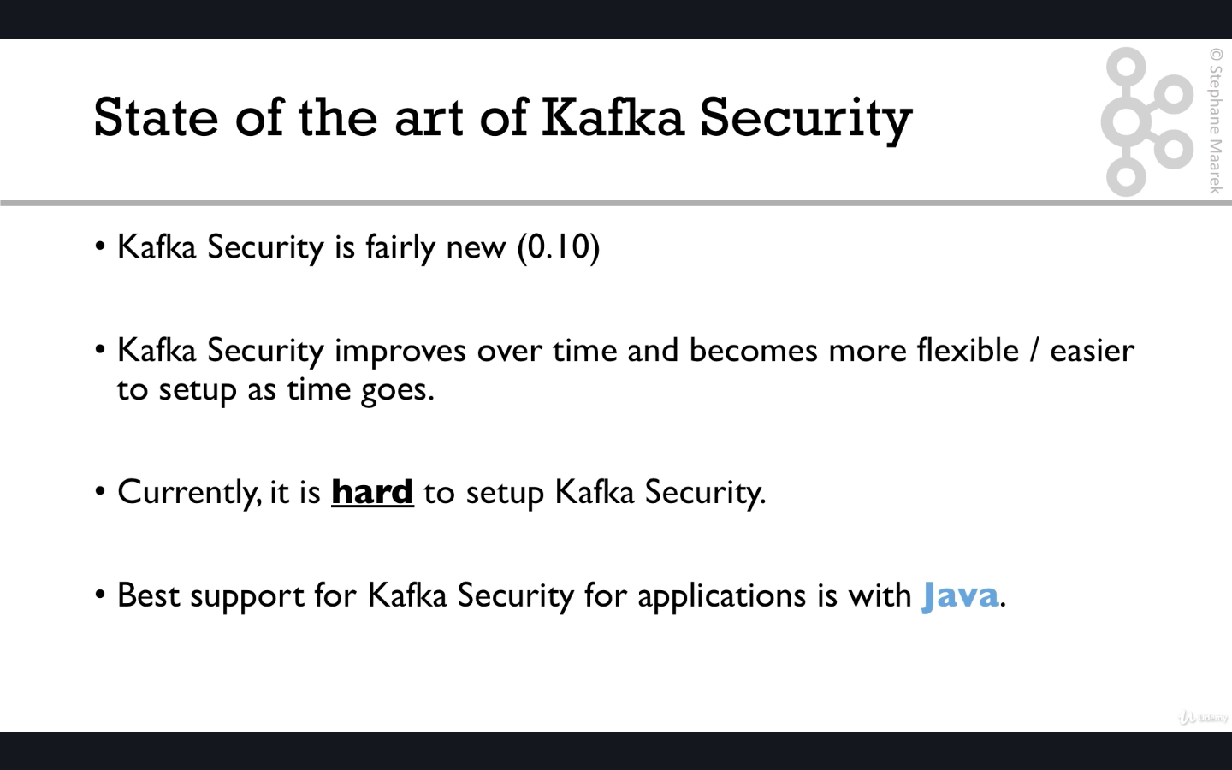

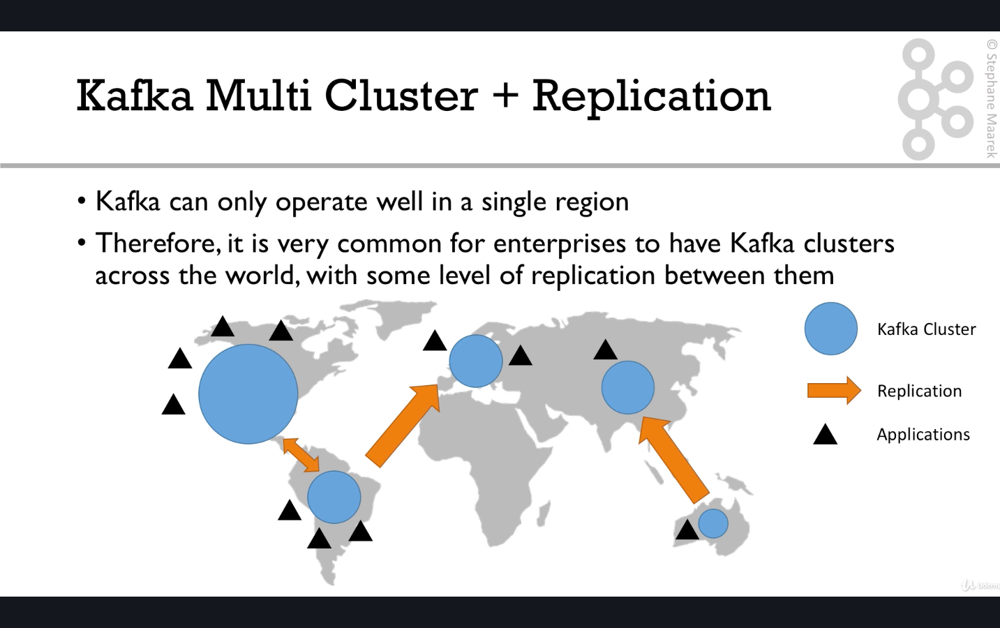

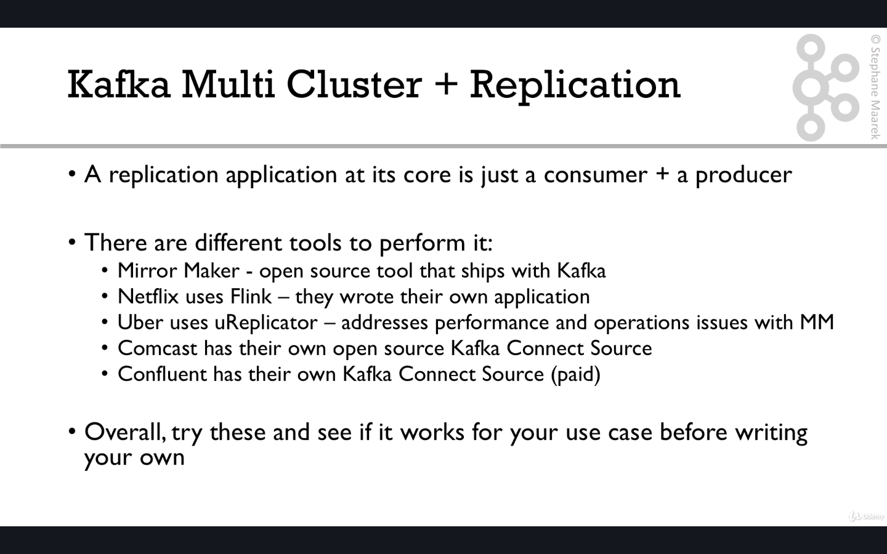

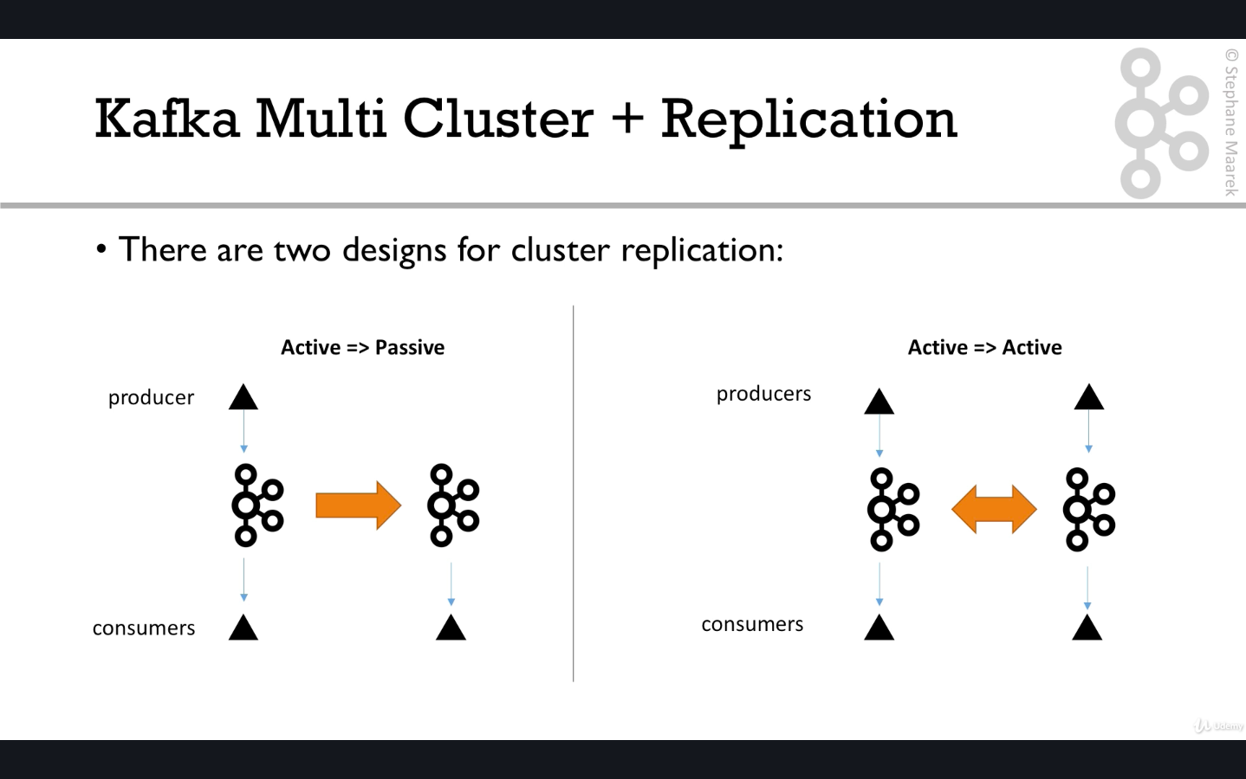

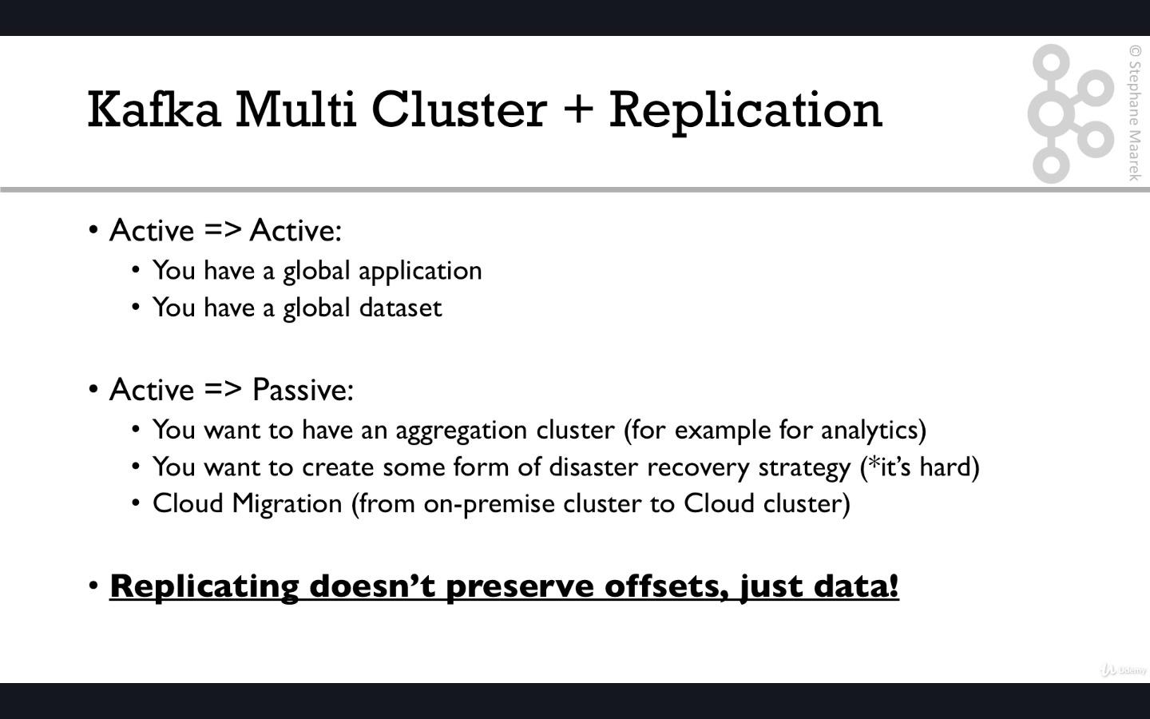

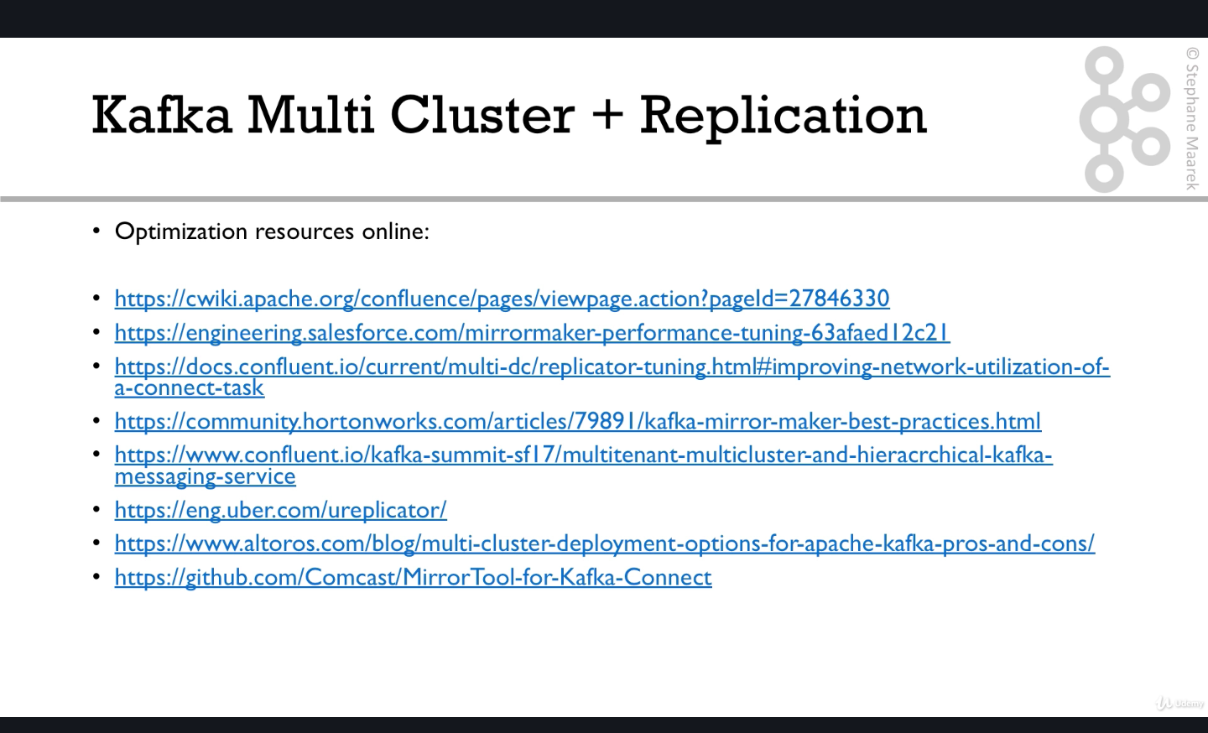

All the above links are bookmarked in kafka ->kafka multi cluster replication

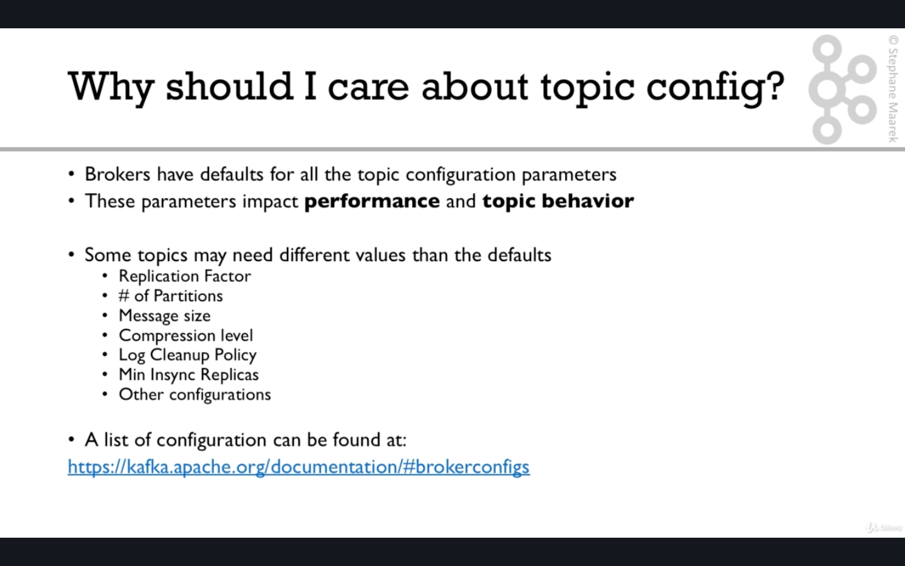

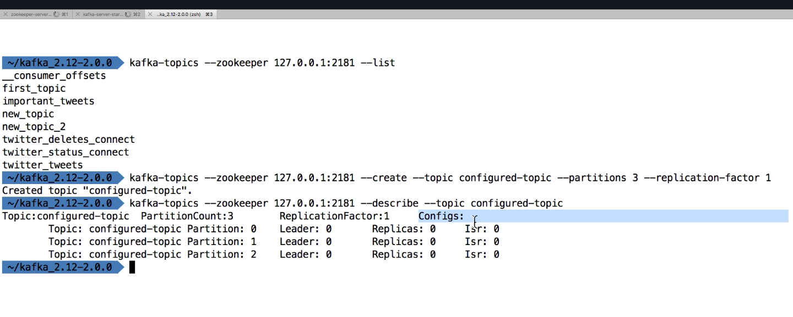

By default you can see above that the configs section is empty.To set the configurations we need to use kafka-configs command .

**Kafka- configs**

**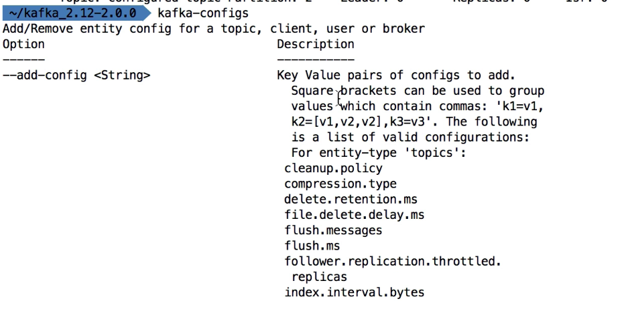**

**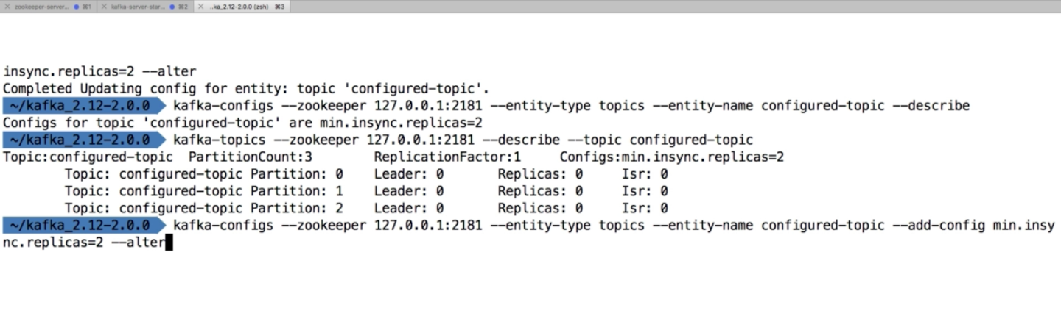**

kafka-configs –zookeeper 127.0.0.1:2181 –entity-type topics –entity-name configured-topic –add-config min.insync.replicas=2 –alter

Need to change alter to delete as follows to delete the configuration

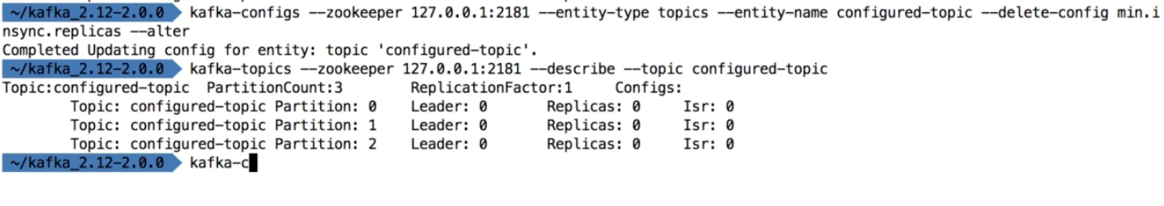

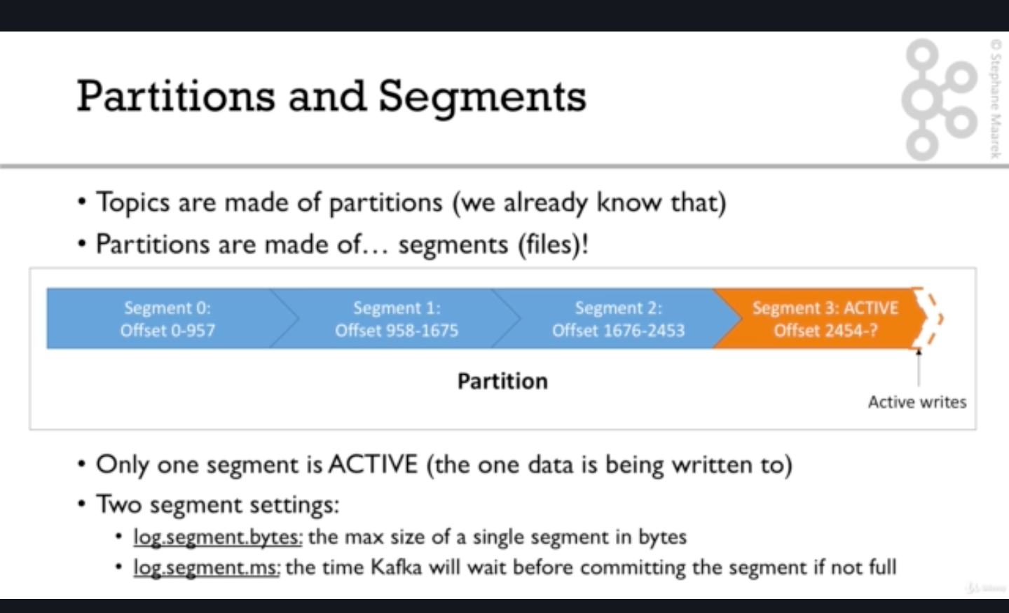

By default the log.segment.ms value is 1 week which means kafka will wait for a week before committing the segment if it is not full otherwise commit will always happen when it gets full which can be define by the configuration log.segment.bytes.

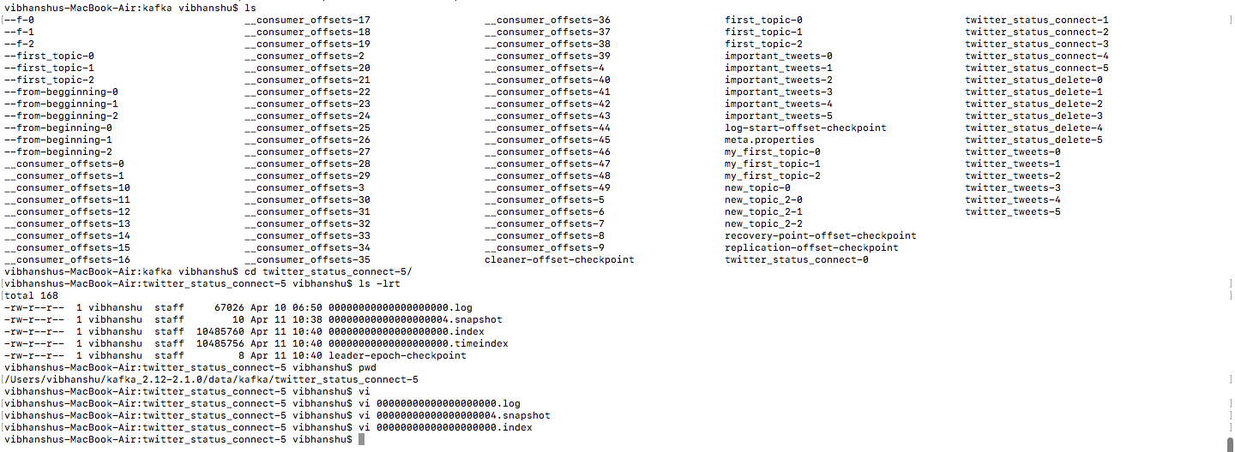

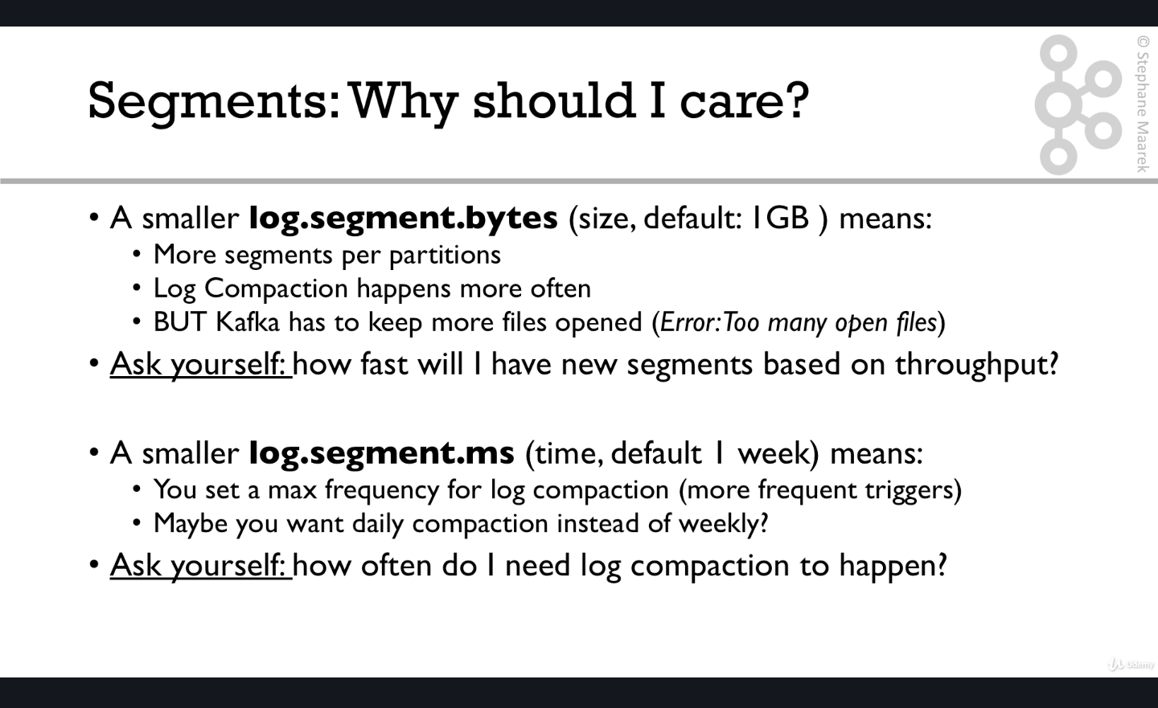

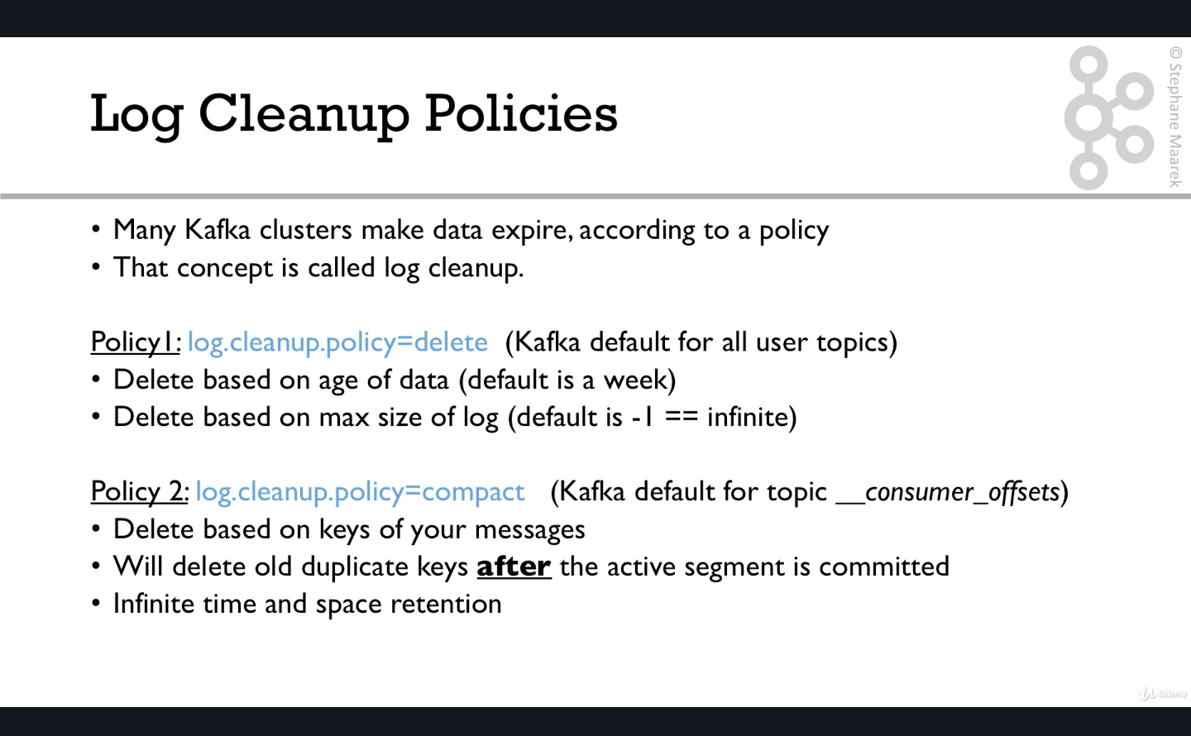

So as mentioned above when you run the command and see the default config for consumer\_offsets topic

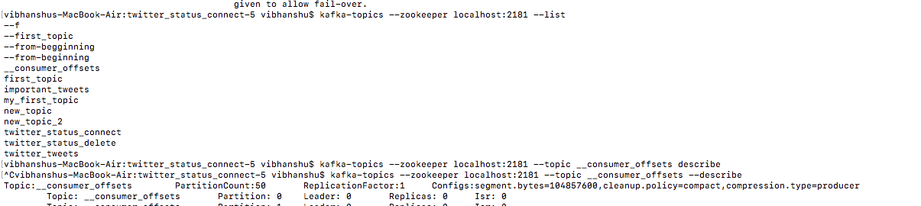

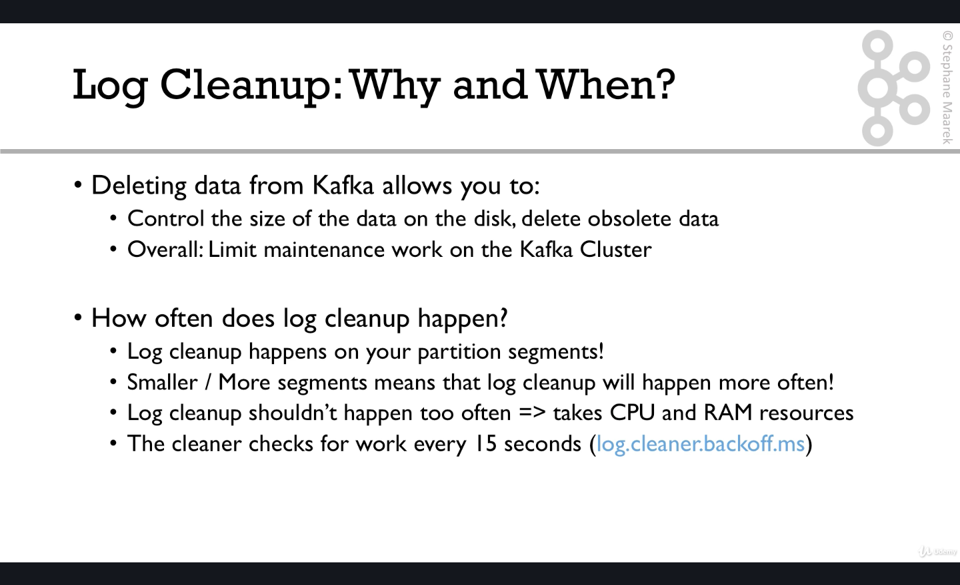

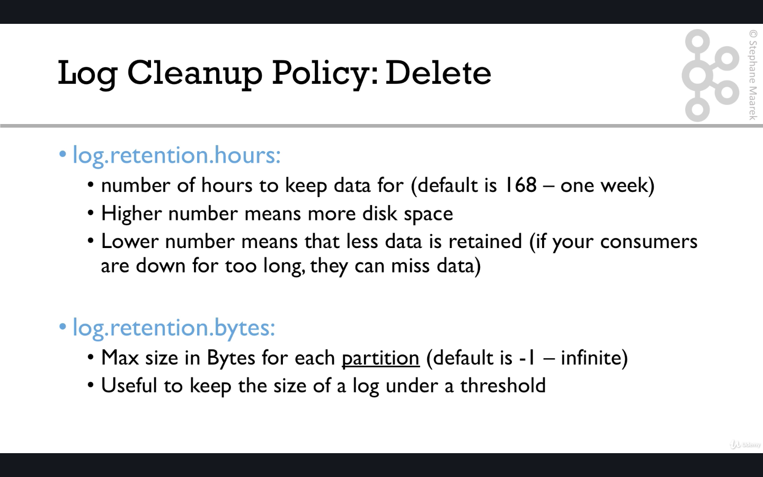

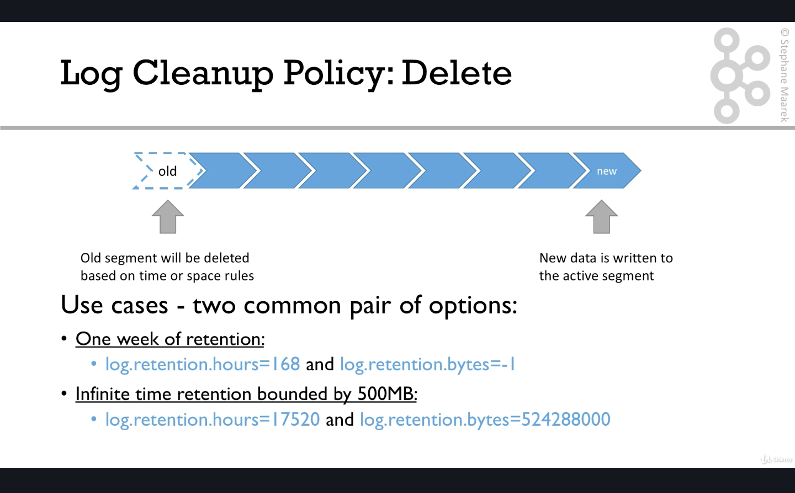

The 1st option above is the more popular one and it’s the default one but we can tweek these values to get the desired results.

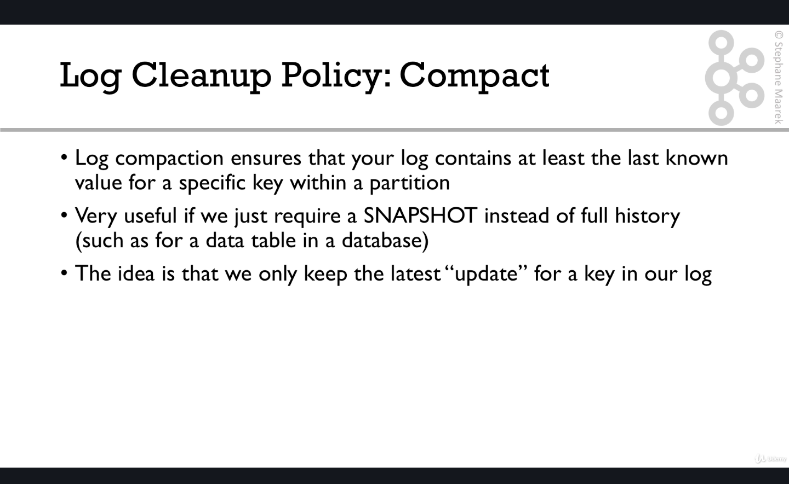

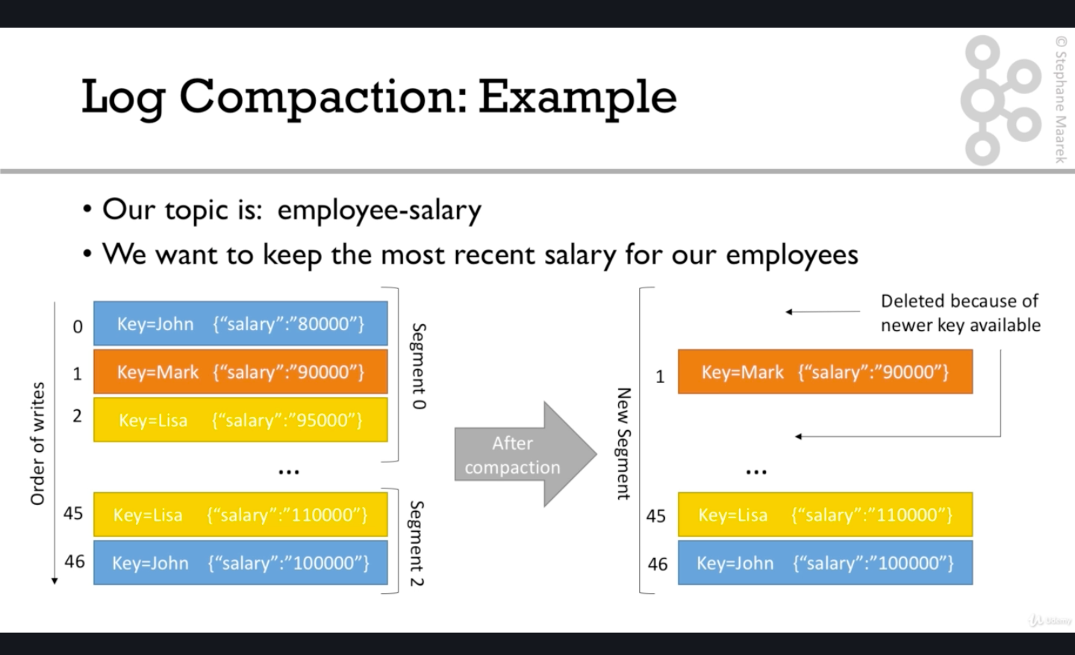

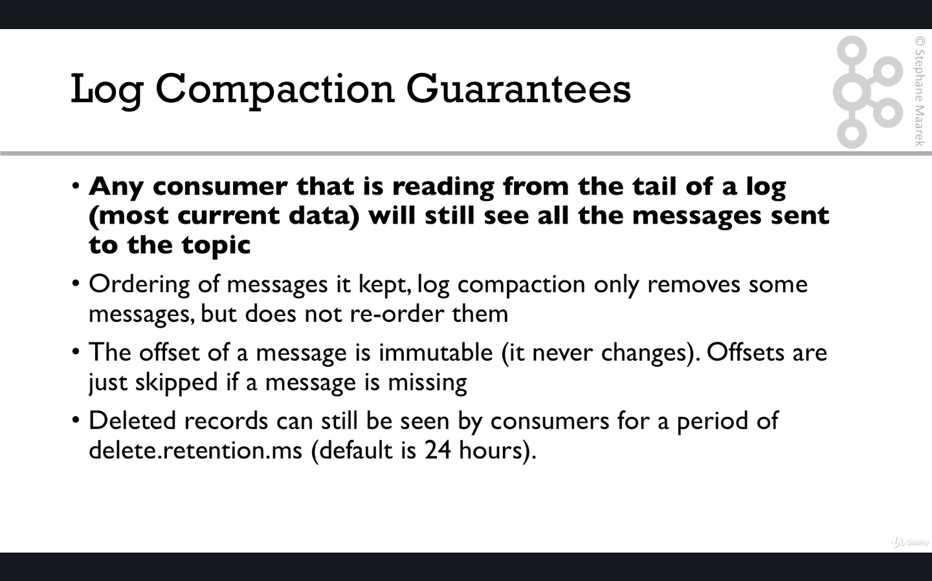

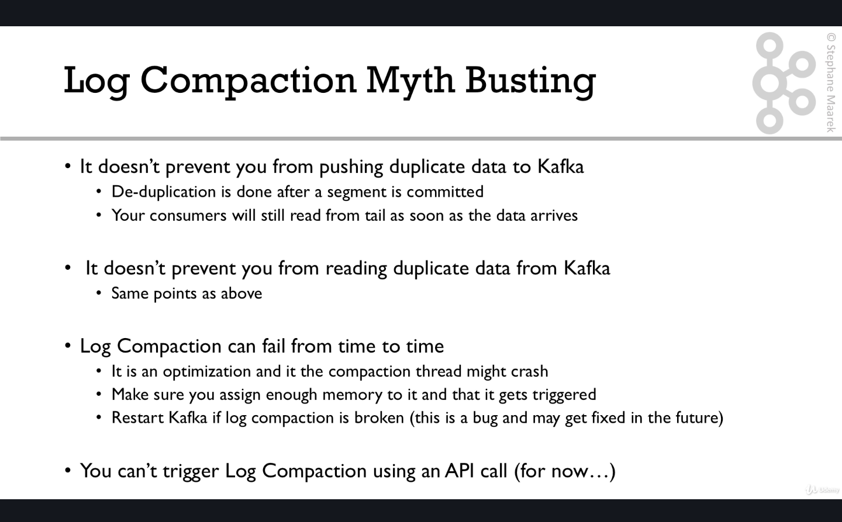

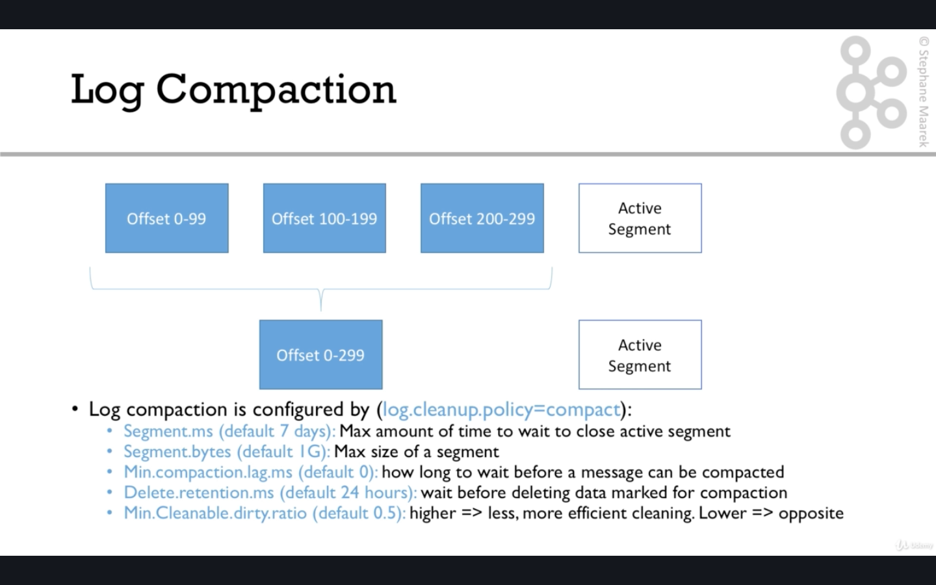

Next we will do practicals on log compaction

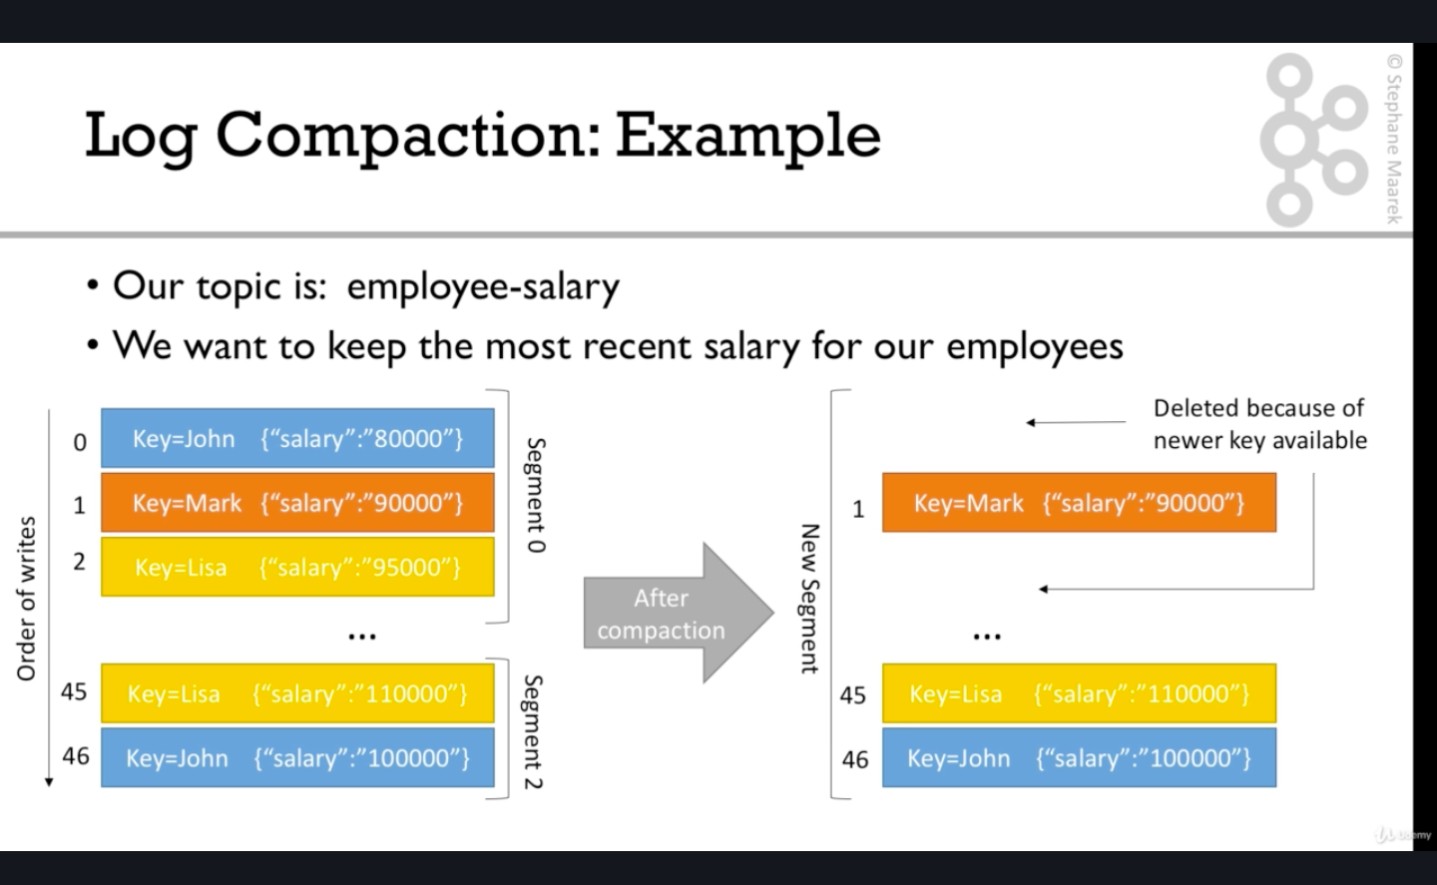

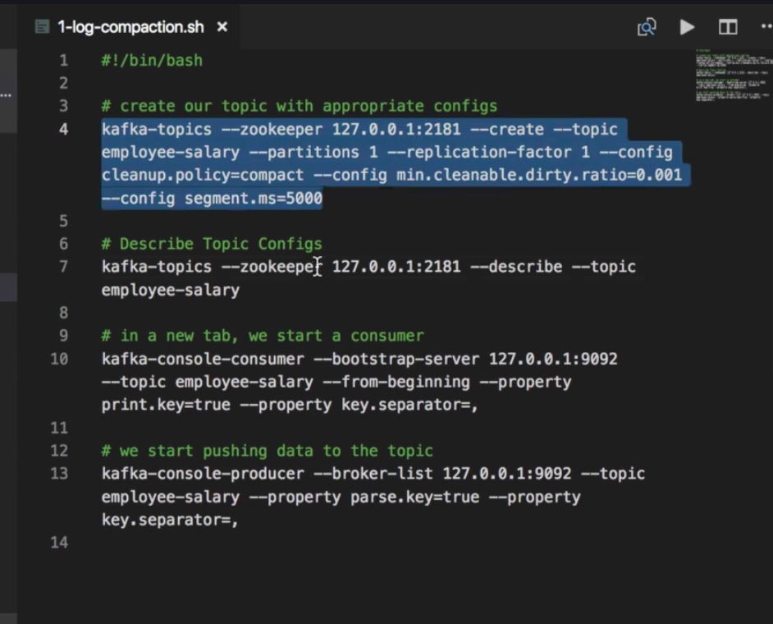

So the 4 commands to simulate log compaction are :-

1. kafka-topics --zookeeper localhost:2181 --create --topic employee-salary --partitions 1 --replication-factor 1 --config cleanup.policy=compact --config min.cleanable.dirty.ratio=0.001 --config segment.ms=5000

min.cleanable.dirty.ratio defaulyt value is 0.5 and it should be left like that but making it 0.001 will mean that log compaction will be triggered all the time.

Also segment.ms will mean that every 5 second new segment will be created which will lead to triggering log compaction every 5 second

1. kafka-topics --zookeeper localhost:2181 --describe --topic employee-salary
2. kafka-console-consumer --bootstrap-server localhost:9092 --topic employee-salary --from-beginning --property print.key=true --property key.separator=,

key.seperator=, will print the data and take key as the string left of , and the string right of , will be taken as value

1. kafka-console-producer --broker-list localhost:9092 --topic employee-salary --property parse.key=true --property key.separator=,

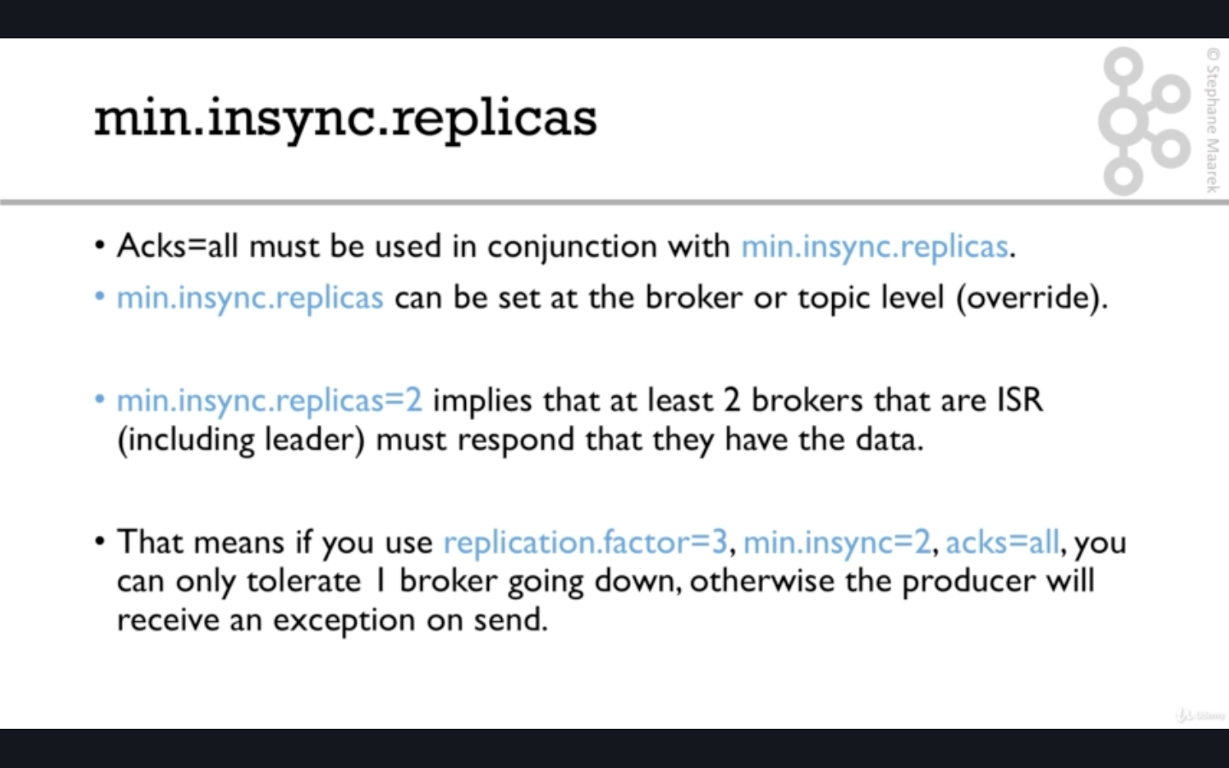

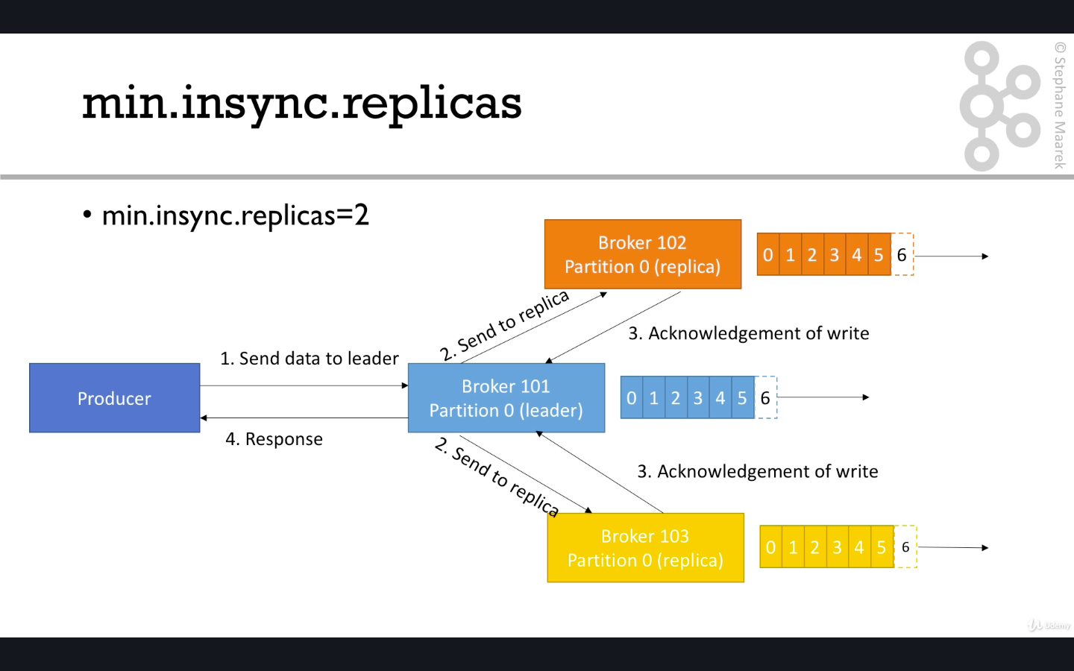

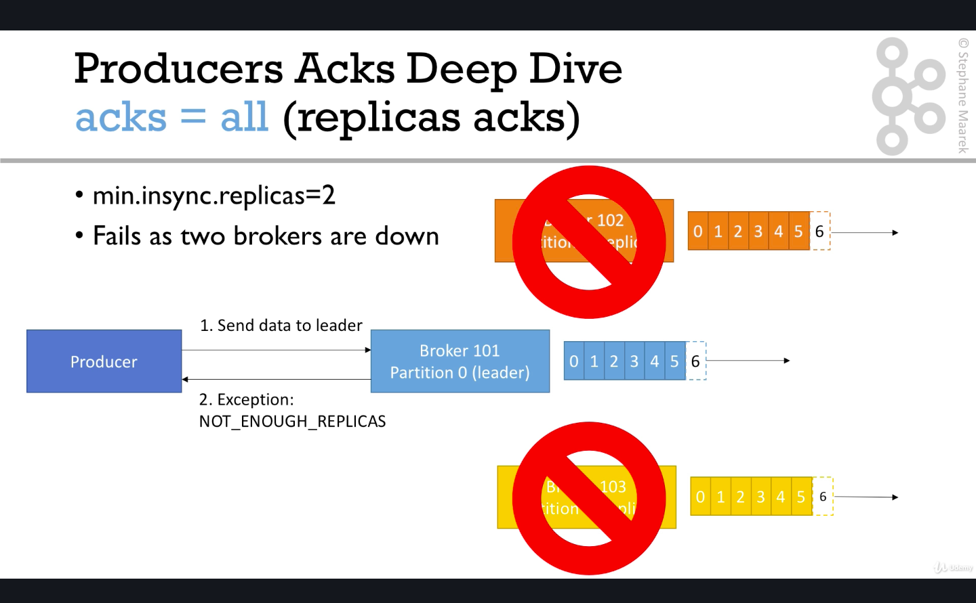

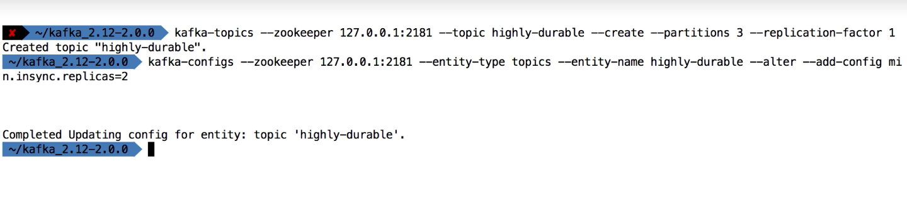

Another way is to go into config/server.properties and add min.insync.replicas=2 at broker level.

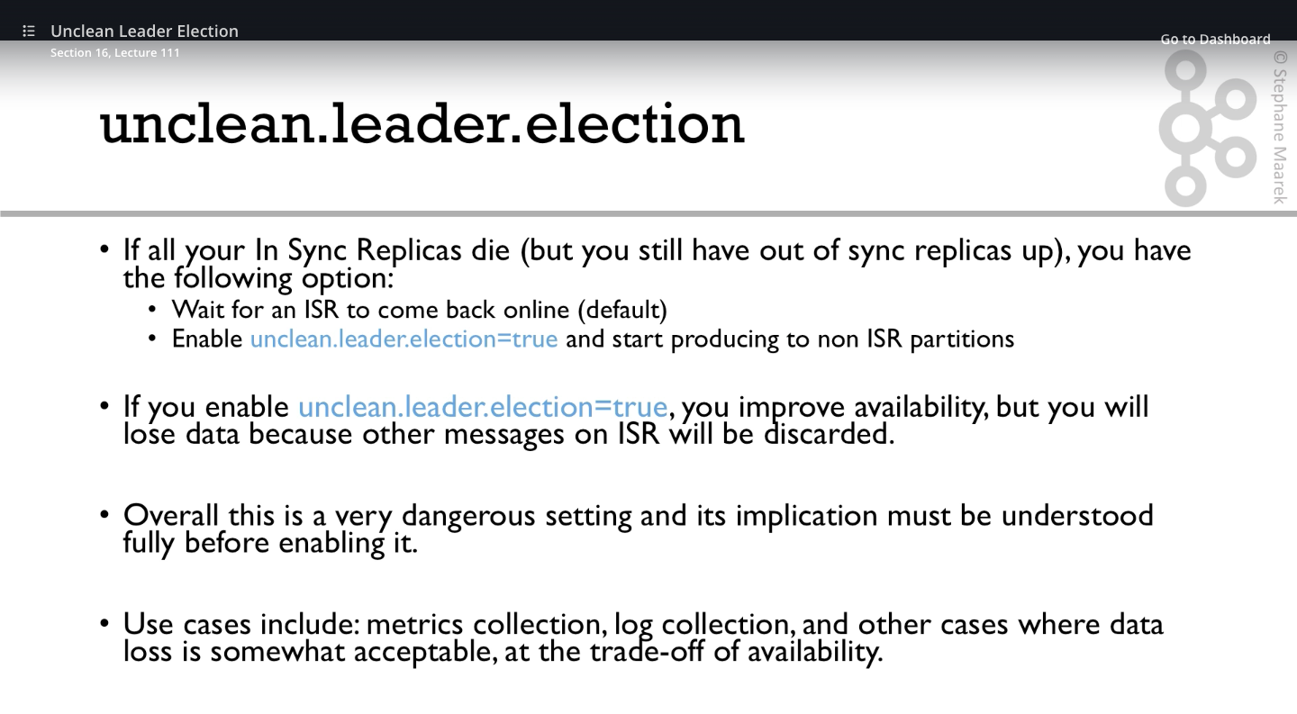

Following are some of the interesting tools which can be useful in future like using docker to star kafka .Confluent cli tool which makes life easier to start /stopall related servers related to kafka eco system. The tools have been saved in bookmark –kafka->kafka tool box.Make sure to go through the last section of videos to create multi broker kafka cluster .Creating multi broker kafka cluster requires creating multi server properties file and changing 2 configuartion -> 1) data folder 2)port number change listeners configuration and then starting the kafka server individually . The way kafka producer and consumer command will work will be adding broker-list or bootstarp-server as all the brokers rather than justa single broker.

